Automated algorithmic stock trading

arun prasath siva thanu pillai

Final Thesis Report

February 2020

# Acknowledgement

I would like to express my gratitude to all those who have guided us in the completion of the project. I record my heart full of thanks and gratitude to my mentor for providing me an opportunity to carry this project, along with purposeful guidance.

I am very grateful to my LJMU faculty member Dr. Manoj Kumar, for being a great guide and teacher and Upgrad learning platform and the support staffs including student mentors. LJMU faculty member has provided immense support, constant encouragement and exemplary guidance at every stage of the project. His expertise in the areas was very insightful and his technical guidance was very thoughtful which lead me to gain more deeper knowledge of the research areas. He has always emphasized in thoroughness and clarity in our approach and we are thankful to him, for helping to put the project in perspective.

Last but not the least, special thanks to my wife Subathra Devi for her moral support extended to me throughout the duration of the project work.

**Table of Figures**

Figure 1 EMA Yahoo and Google chart 19

Figure 2 Polarity of Tweet - Formula 20

Figure 3 Twitter Data and Stock Data in Deep Learning Model 20

Figure 4 Deep Learning System 21

Figure 5 Infy Technical Chart 26

Figure 6 Prediction Model for Sentiment Analysis [12] 31

Figure 7 Sentiment Analysis Tool Overview 32

Figure 8 SDAE Auto Encoder Framework 33

Figure 9 NLP Processing for News and Twitter Data [13] 35

Figure 10 LSTM Cell Diagram [14] 36

Figure 11 LSTM Cell with Unfolded Diagram [15] 36

Figure 12 Machine Translation (RNN Application) 37

Figure 13 Bi-directional RNN vs Deep RNN 38

Figure 14 Types of RNN 39

Figure 15 Mathematical Model of RNN 40

Figure 16 RNN Computation Graphs 40

Figure 17 Gradient Descent 41

Figure 18 RNN with multiple Co-Efficient 42

Figure 19 Gradient Descendant and Vanishing Problem 42

Figure 20 Gradient Flow in RNN 43

Figure 21 Vanilla RNN vs LSTM 44

Figure 22 LSTM Cell with Softmax 44

Figure 23 LSTM with four gates 44

Figure 24 LSTM Forged gates 45

Figure 25 LSTM - Input Gate 45

Figure 26 LSTM - Output Gate 45

Figure 27 LSTM Sentiment Analysis Model [15] 46

Figure 28 LSTM Sentiment Analyser [14] 46

Figure 29 LSTM Sentiment Analysis Output Screenshot 47

Figure 30 LSTM Softmax and Index Processing 47

Figure 31 Stock MAVG for Short and Long 48

Figure 32 Stock Prediction Methodologies 51

Figure 33 Historical Data & Training Data Set Learning Algorithm[69] 60

Figure 34 Stock Data Processing Pipeline 60

Figure 35 Web Crawler Diagram 61

Figure 36 Sentiment Analysis Overview Diagram 63

Figure 37 LSTM Model for Stock Index Processing with Sentiment Analysis[15] 64

Figure 38 Twitter Sentiment Analysis 64

Figure 39 News Processing and Plot sentiment Scoring [13] 65

Figure 40 Sample Historical Data 66

Figure 41 Sample Tweet Graph Model 67

Figure 42 Twitter Use Case Overview 67

Figure 43 Sample Code to read tweet data 68

Figure 44 Investpy Historical Data 69

Figure 45 Apple Stock Yearly chart 69

Figure 46 Top 20 News Catergories 70

Figure 47 Graph Analysis of sentiments 76

Figure 48 Sentiment Classification and subjective measure 77

Figure 49 Polarity Analysis 77

Figure 50 Price Adjusted Dataframe 79

Figure 51SingleNet Data Model Smple Output 79

Figure 52 Correlation Index Output 79

Figure 53 LSTM Prevention. And Prediction Module Diagram 80

Figure 54 MSE, RMSE, MAE, MAPE Formulas 81

Figure 55 LSTM Model for Dense Processing 81

Figure 56 LSTM Network model for prediction [73] 84

Figure 57 LSTM Network Data Processing with Backtest 85

Figure 58 Use Case Diagram 86

Figure 59 Sample Historical Stock Data 87

Figure 60 Data Normalization Code 88

Figure 61 Training and Testing Dataset 89

Figure 62 Stock Closing price for week data 89

Figure 63 UML Diagram 90

Figure 64 LSTM Model creation 91

Figure 65 LSTM with Hidden Layer Diagram [74] 92

Figure 66 LSTM Model Creation Code 95

Figure 67 LSTM Model Training 96

Figure 68 Demo Code Screenshots 1 97

Figure 69 Demo Code Screenshots 2 97

Figure 70 Demo Code Screenshots 3 98

Figure 71 Demo Code Screenshots 4 98

Figure 72 Demo Code Screenshots 5 99

Figure 73 One Epoch Diagram 100

Figure 74 Data Training Workflow 102

Figure 75 UI Workflow 102

Figure 76 Comparison of Tweets and Corpus Stocks 106

Figure 77 Apple Historical Data 107

Figure 78 Apple Historical Data and Twitter Data 107

Figure 79 Apple Historical Data and News Data 108

Figure 80 Apple Historical Data, News Data and Twitter Data 108

Figure 81 Portfolio Value Over Time Trading FB on Test Set 109

Figure 82 Buy/Sell Decisions for FB Test Set 109

Figure 83 FB Test Set 30 Day Lookahead 110

Figure 84 FB Test Set Predictions 110

Figure 85 Portfolio Value Over Time trading for AAPL 111

Figure 86 Buy/Sell Decisions for APPL Test Set 111

Figure 87 AAPL Test Set 30 Day Lookahead 112

Figure 88 AAPL Test Set Predictions 112

Figure 89 Code Snippet for Visualizing the results 115

Figure 90 Google Price Prediction. Vs. Actual 115

Figure 91 Sample Plot with Precition 116

Figure 92 Buy/Sell Decisions for AAPL Test Set 116

Figure 93 Buy/Sell Decisions for AMZN Test Set 117

Figure 94 Buy/Sell Decisions for FFB Test Set 117

Figure 95 Buy/Sell Decisions for Google Test Set 118

**List of Tables**

Table 1 List of Trading Strategies 30

Table 2 List of Portfolio Strategies 30

Table 3 List of Risk Strategies 30

Table 4 List of Risk-Adjusted Returns Ratios 31

Table 5 Bi-Directional RNN vs Deep RNN 38

Table 6 Types of RNN 39

Table 7 Sentiment Scores based on comment 73

Table 8 Feature Engineering with Number of features 74

Table 9 Spearson’s correlation for Historic Stock Data 75

Table 10 Spearson’s correlation for News Dataa 75

Table 11 Spearson’s correlation for Twitter Data 75

Table 12 Dataset with Features Details 76

Table 13 Case 1 LSTM for Stock Data 103

Table 14 Case 2 LSTM for Stock Data News Data 104

Table 15 Case 3 Stock Data, Twitter Data, News Data 105

Table 16 Case 4 Stock Data, Twitter Data, News Data 105

Table 17 Prediction Accuracy vs Feature Combination 106

List of Abbreviations

|  |  |
| --- | --- |
| **Abbreviations** | **Expansion** |
| LSTM | Long Short Term Memory |
| BP | Back Propagation |
| SOFNN | Self-Organizing Fuzzy Neural Networks |
| EMH | Efficient Market Hypothesis |
| MA | Moving Average |
| EMA | Exponential Moving Average |
| ROC | Rate of Change |
| RSI | Relative Strength Index |
| RNN | Recurring Neural Networks |
| BoW | Bag of Words |
| TD-IDF | Term Frequency-Inverse Document Frequency |
| SA | Sentiment Analysis |
| NLP | Natural Language Processing |
| ANN | Artificial Neural Networks |
| MLP | Multi Layer Network |
| AMC | Asset Management Company |
| AR | Auto Regressive method |
| MA | Moving Average |
| ARMA | Auto Regressive Moving Average |
| ARIMA | Auto Regressive Integrated Moving Average |
| SDA | Stacked Denoising Auto Encoder |
| P/B | Price-to-Book Ratio |
| BVPS | Book Value Per Share |
| EPS | Earnings Per Share |
| PEG | Price/Earnings to Growth ratio |
| P/E | Profits to Earnings Ratio |
| RoE | Return on Equity |
| RSI | Relative Strength Index |
| CAPM | Capital Asset Pricing Model |
| CNN | Convolutional Neural Networks |
| SMA | Simple Moving Average |
| NLP | Natural Language Processing |
| LMS | Lowest Middle Square |
| CEFLANN | Computationally Efficient Functional Connection |
| FRPCA | Fuzzy Robust Principal Component Analysis |
| KPCA | Kernel Based Principal Component Analysis |
| PCA | Principal Component Analysis |
| EPCNN | Evolving Partially Connected Neural Networks |
| NN | Neural Networks |
| AFSA | Artificial Fish Swarm algorithm |
| RBFNN | Radial Basis Neural Network |
| ABC-RNN | Artificial Bee Colony-Recurring Neural Networks |
| GRU | Gated Recurrent Units |
| ILDA | Interdependent Latent Dirichlet Allocation |
| NSE | National Stock Exchange |
| NYSE | New York Stock Exchange |
| SENSEX | S&P BSE Sensex index |
| BPNN | Back Propagation Neural Networks |
| KNN | K-Nearest Neighbors |
| RLS | Recursive Least Square |
| NAV | Net Asset Value |
| SVM | Support Vector Machine |
| VWAP | Volume Weighted Average Price |
| DOW | Day of Week |
| RMSE | Root Mean Square |

**Abstract**

The prediction of the share market is of great importance in the recent times in order to help in maximizing the profit of stock purchase while keeping the risk at low. With latest advancement in technologies, the opportunity to gain a steady fortune from the share market is increased, which also helps experts to find out the most critical indicators to make a better prediction. Machine learning has many applications, one of which is to forecast time series.

Unfortunately predicting the stock market is most challenging task due to the high uncertainties and volatility nature of stock market. Stock prices are affected by many other factors other than stock data such as economic, geo-political issues such as trade war or cross-border conflict. Volatility of the stock market is high, or the fluctuation is high because of the above-mentioned factors which in-turn impacts the outcome of the prediction. The factors which impacts the prediction outcome are usually categorized as physical factors (vs) physiological, rational and irrational behavior etc., All these factors combined together makes predicting the share prices with high accuracy becomes very difficult.

Several technical analysis tools have been used by data and finance analysts. The time series analysis is used by most of them while making the predictions. Nevertheless, these methods cannot be trusted fully, so there is a necessity to provide the supportive method for stock market prediction. These tools and techniques need lot of technical details and news flows for individual stock. Even after gathering lot of technical details and analyzing several data points, they still would not give reliable predictions and thereby, causing more confusions among stock traders especially beginners.

Artificial Neural Network (ANN) was found to be the most practical consideration. Neural network models have the features and customizable parameters which makes possible to have wide number of features along with the cross-validation sets. The analysis of historical stock data sets and extracting certain trends would be crucial in figuring out the right prediction methodology to forecast the stock value for a given timeframe. RNN will be fed with a pre-processed historical stock data which will be getting trained based on time series forecasting model. Once training is completed, using neural network layer predictions for next trading day(s) will be done. Based on these predictions a potential Buys and Sells for given stock can be generated for a swing trade.

The motivation for this project arises from the fact that, investors are constantly looking for an advanced model that is accurate and adaptable to market fluctuations. This project is carried out to determine a successful strategy for predicting stock prices based on past financial time series data and also based on domain-specific financial data along with sentimental analysis. The first model discussed here uses the “New York Stock Exchange” on Kaggle and an LSTM architecture.

Table of Contents

Acknowledgement 2

1 Introduction 16

1.1 Problem Statement 16

1.2 The Fuss about Predictability 17

1.3 ‘The Efficient Market Hypothesis” 17

1.4 An Art of Stock Market Predictions 18

1.5 Stock Prediction Methodologies: 18

1.5.1 Fundamental Analysis: 18

1.5.2 Technical Analysis: 18

1.5.3 Sentimental Analysis 19

1.5.4 Deep Learning 20

1.6 Past Works 21

1.7 Recent Trends 22

1.8 Results 22

1.9 Aim and Objectives: 22

1.10 Thesis Structure 23

2 Background and related research 25

2.1 Finance Glossary 25

2.2 Stock Market Prediction Brief 26

2.2.1 Stock Market : 26

2.3 Fundamental Analysis Based Stock Prediction 26

2.3.1 Introduction to Fundamental Analysis 26

2.4 Technical Analysis based Stock Prediction 28

2.5 Sentiment analysis for Stock Prediction: 31

2.5.1 Sentiment classification techniques: 33

2.6 Data Sources 34

2.6.1 Historical Stock Prices Data 34

2.7 Sentiment Detection Algorithm: 35

2.8 RNN (recurrent neural network) : 35

2.8.1 How it is different than other neural network models 36

2.8.2 Few RNN’s Applications: 37

2.8.2.1 Language modelling and prediction 37

2.8.2.2 Machine Translation 37

2.8.2.3 Image recognition and generating description 37

2.8.2.4 Speech Recognition 38

2.8.3 Training RNN 38

2.8.4 RNN extension 38

2.8.5 Different types of RNN 39

2.8.6 Mathematical formulas of RNN 40

2.8.7 RNN: Computation Graphs 40

2.8.8 Problems with RNN 40

2.8.8.1 RNN suffers from Gradient flow problem 40

2.8.8.2 Mathematical procedure 41

2.8.8.3 Solutions to the vanishing gradient problems 42

2.8.8.4 Gradient flow in RNN 43

2.9 LSTM (Long Short-Term Memory) 43

2.9.1 LSTM Model in Sentiment Analysis 46

2.10 Trading 47

2.10.1 Momentum Strategy 48

2.10.2 Reversion Strategy 48

3 Literature Review 49

3.1 Introduction 49

3.2 Problem Statement 49

3.3 Stock Market Prediction Methodologies 51

3.3.1 Stock market prediction Methodologies Classifications: 51

3.3.1.1 CNN based prediction techniques : 52

3.3.1.2 HMM-based prediction techniques 52

3.3.1.3 Neural Network based prediction techniques : 53

3.3.1.4 RNN based prediction techniques 54

3.3.1.5 SVM based prediction techniques 54

3.3.2 Clustering techniques 54

3.3.2.1 Filtering based prediction techniques 54

3.3.2.2 K-means based clustering technique 55

3.3.3 Research gaps and issues 58

4 Research Methodology 60

5 Models and Strategies 78

5.1 Data 78

5.2 The SingleNet model: 79

5.3 Model Architecture 80

6 Software Tools 82

7 Implementation Details: 83

7.1 LSTM Network for Sentiment Analysis: 83

7.2 LSTM Network Input Processing : 84

7.3 LSTM Sentiment Analysis Implementation Algorithm: 84

7.4 End to End Use Case Diagram: 86

7.5 Dataset Preparation: 86

7.5.1 Downloading the stock data from quandl.com: 87

7.5.2 Pre-processing the data: 87

7.5.3 LSTM Data Preparation 87

7.5.3.1 Transformation Process: 88

7.5.4 Normalizing the Stock Data: 88

7.5.5 Training Set and Testing Set 89

7.5.6 UML Diagram 90

7.5.7 Neural Network Creation 91

7.5.8 The Stock Price Neural Network Design: 92

7.5.9 LSTM Network Model (with Hidden Layers) 92

7.5.9.1 LSTM Network Model Implementation Considerations: 93

7.5.10 LSTM Network Model Training Process: 94

7.5.11 One Epoch 100

7.5.12 Testing the Neural Network 101

7.5.13 Training Workflow 101

7.5.14 UI Workflow: 102

8 Evaluation and Test Results 103

9 Conclusions and Learnings 113

10 Expected Outcomes 114

11 Summary 119

12 Future Work 120

Bibliography 121

# Introduction

In the recent years, artificial neural networks (ANNs) have become predominant in machine learning predictions (Makeshwar et al. 2010) [1]. Historically, they are also examples of directions in which functional challenges like estimation, grouping, clustering, optimization, etc. can be addressed and resolved (Hertz et al. 1991) [2]. The neural multilayer network (MLP) is the common feed-forward feed network. It was widely used in the estimation of time sequences. The primary objective of this research is to use dynamic neural networks to predict and classify time series details.

The prediction method is used to identify potential values or occurrences depending on certain past and present data information such as temperature prediction, stock levels prediction, earthquake forecast, publicity and revenue forecast. Artificial neural networks are well known for optimal performance and can be used as a prediction tool. The Classification techniques that classify a collection of data into groups of items that share similar actions into small subsets of training sets. Kohavi (1995) [3] describes the classifier algorithm which has a feature capable of mapping data to the label type. Classification approaches were deemed to be the most effective decision-making tools and are commonly used for data processing. Typically, time series are considered as spontaneous behaviour pattern which has certain trends associated with it, while taking into account various internal and external factors affecting such time series.

Various research methodologies were used to study the behavioral aspect of the time series prediction in terms of accuracy on the basis of the data collection. Nevertheless, the time-series are so complicated that no specifics on the device are known to produce these time-series, such even conventional approaches cannot solve such problems.

# Problem Statement

* Analyze various machine learning techniques used in the prediction of stock prices or stock market index.
* To understand and apply Algorithmic Trading strategies and generate good enough returns.

# The Fuss about Predictability

The predictability of stock market is a highly controversial topic over many years. Bachelier (1900), Cootner (1964) and Fama(1965) [5] have observed that, the stock market nature is of independent of past and present information and hence unpredictable, thus proving the efficient-market hypothesis. People who trade and make investment in stock market directly by purchasing shares or indirectly by making investments through Mutual Funds AMCs have a very staunch desire to make large money. As the technology is advancing, the opportunity to gain a steady fortune from the share market is increased.

The Stock market is highly volatile because of several factors which can be of physical or psychological as well. All these factors combined together makes predicting the share prices with high accuracy becomes very difficult.

Several technical analysis tools have been used by data and finance analysts. Even after gathering lot of technical details and analyzing several data points, they still would not give reliable predictions. The analysis of historical stock data sets and also by extracting certain trends would help to predict the future value of the stock. Based on these predictions a potential *Buys* and *Sells* for given stock can be generated for a potential swing trade.

# ‘The Efficient Market Hypothesis”

The efficient market hypothesis postulates that stock prices are a function of information and rational expectations, and that newly revealed information about a company’s prospects is almost immediately reflected in the current stock price. As per “Efficient Market Hypothesis (EMH)”[3], the market prices are driven by new information and follow a random walk pattern. This hypothesis is widely accepted by the research community as a central paradigm governing the markets in general, several people have attempted to extract patterns in the way stock markets behave and respond to external stimuli.

Burton Malkiel, in his seminal 1973 work “A Random Walk Down Wall Street” stated, “a blindfolded monkey throwing darts at a newspaper’s financial pages could select a portfolio that would do just as well as one carefully selected by experts” or in simpler terms stock prices prediction by looking at price history is not feasible.

Malkiel claimed that variations in stock prices correspond to a statistical process called a "random walk" , which states that each day’s deviations from the central value are completely random and unpredictable.

# An Art of Stock Market Predictions

A supervised learning model is to predict stock movement direction can combined along with the model based on technical analysis and sentimental analysis from news and social media. Technically two categories of predictions are available

* **Econometric models:** This includes classical econometric models for predicting the future stock prices. Some of the common methods are the auto-regressive method (AR), the moving average model (MA), the auto-regressive moving average model (ARMA), and the auto-regressive integrated moving average (ARIMA).
* **Soft computing-based models:** The term soft computing covers artificial intelligence. These techniques include artificial neural networks (ANN), fuzzy logic (FL), support vector machines (SVM) and others. Deep Neural to extract abstract features from the data have been developed.

# Stock Prediction Methodologies:

# Fundamental Analysis:

This approach, carried out by fundamental analysts, is not about individual stock, but about the business. The analysts use various information about company’s business model , revenue model and their balance sheet and year-on-year turn-over, company's previous results, the income projection, etc., to decide to buy/sell that stock.

# Technical Analysis:

The technical analysts are determining market prices on the basis of the past market trends (using time-series analyses). Using hybrid prediction models, most efficient forecasting or recommendation model can be built/developed.

* + - 1. **Indicator Functions:** Indicators functions helps in identifying technical analysis

1. **Moving Average (MA):**  The average of the past n values till today.
2. **Exponential Moving Average (EMA):** Gives more weightage to the most recent values while not discarding the older observation entirely.
3. **Rate of Change (ROC):** The ratio of the current price to the price n quotes.

The technical analysis charts below [6] show how the EMA models the actual Stock Price.

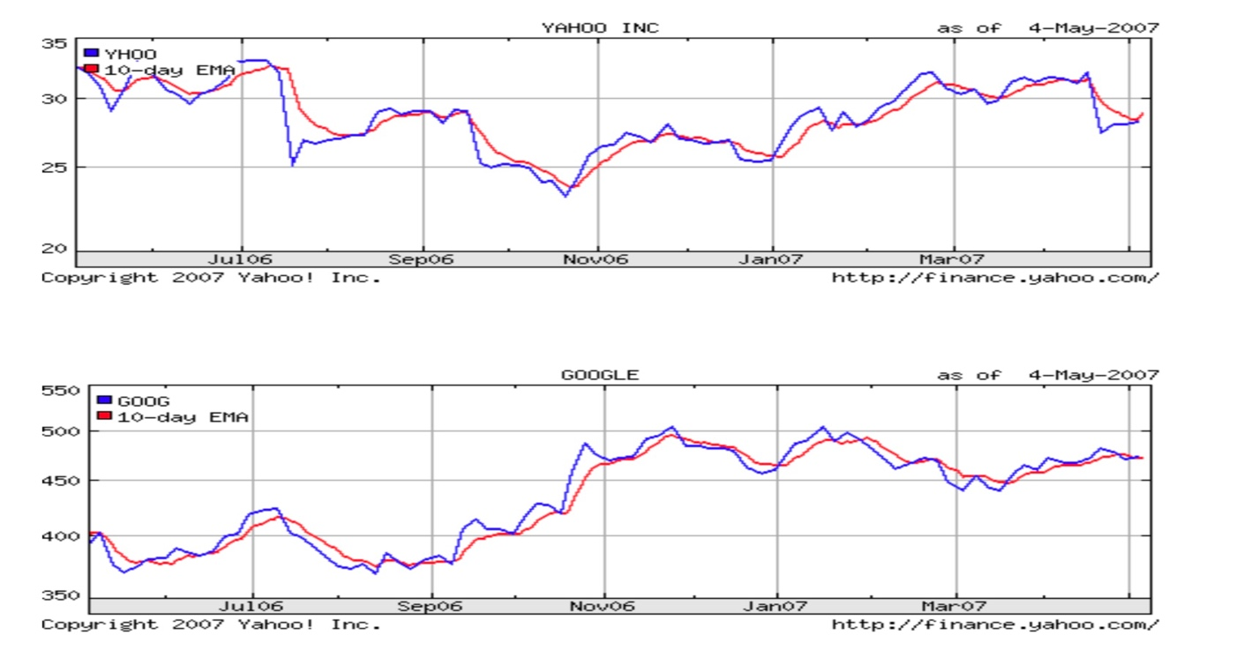

Figure 1 EMA Yahoo and Google chart

# Sentimental Analysis

Major challenge in consuming sentimental data for prediction stock market is due to the nature of textual format off sentimental data instead of numerical format which makes prediction process difficult. The solution to this problem can be approached by combing time series data along with mining of text documents to extract the meaningful information which includes sentiments and also news data about the stock or company. It is a technique of analyzing the sentiment of a given set of input generally in the form of text.

Rui Ren, Desheng Dash & Tianxiang Liu (2018) mention in their paper that, the twitter data is split into sentences which will help in getting better polarization instead of a collective document of a given day. As per the literature work, the comparison between parsing the tweets individually (have better determinant value) and tweet documents as a whole. The polarity of each tweet in the entire day is calculated as per below formula.



Figure 2 Polarity of Tweet - Formula

where pi is the ith positive tweet, ni is the ith negative tweet and ti is the ith tweet.

# Deep Learning

* It is a subset of ML based on artificial neural.
* **Two Phase Approach :**

1. **Training phase :**

* Training the model on existing data with mean-squared error as the error metric.
* Back propagation of the mean squared error multiplied by a stochastic gradient used to rectify the errors.

1. **Prediction phase**

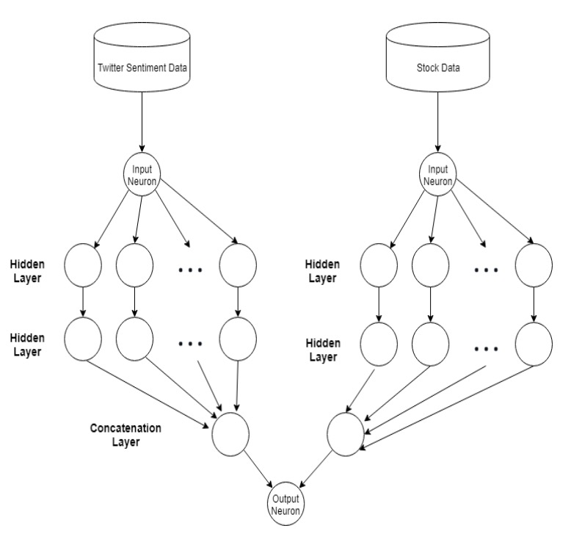

Figure 3 Twitter Data and Stock Data in Deep Learning Model

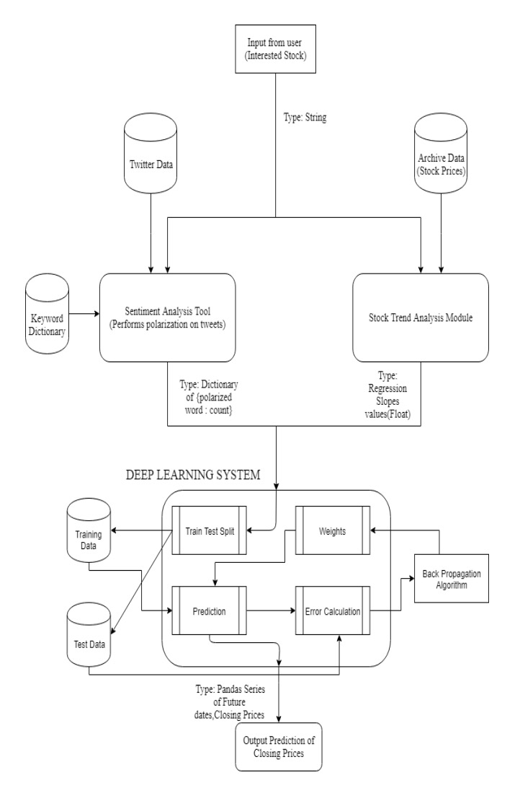

Figure 4 Deep Learning System

# Past Works

Researchers used various statistical methods such as vector autoregression, “autoregressive moving average (ARMA)”[4] and “autoregressive integrated moving average (ARIMA)”[4] that seems to be efficient in evaluating the relationships between variables in statistical domain. Universal Approximation Theorem which states that any finite and continuous function could be approximated.

As per Wang and Leu(1996), they created hybrid model by combining two techniques such as using ARIMA model for extracting input features and RNNs (Recurrent Neural Network) for training mid-term stock market trend prediction system. The computational results of such fusion models outperformed the single econometric models and other individual forecasts. This encouraged further hybrid models, by combining different models such as per Patel, Shah, Thakkar and Kotecha (2015) [8]

# Recent Trends

Recently LSTM (Long Short-Term Memory) networks have been used to find the trends in time series predictions. They are structured to identify and learn temporal patterns. LSTMs are an improvement of conventional RNNs, since they are better at learning long-term dependencies and also overcome the problem of gradient descent. They automatically detect suitable patterns in the given data. LSTMs have evidently yielded better results than many baseline models like multi-layer perceptrons, random forests etc. LSTM-based models have also been found to provide lower risks in trading strategies. Li, Bu and Wu (2017)[9] have mentioned in their paper that, other sequential data can also be fed into LSTM networks such as investor sentiment data.

# Results

The different models applied and tested for stock prediction in this project have been evaluated on the basis of minimum squared error or mse of the model on test data. The predictions and actual data are compared by plotting against the time axis and hyper parameter tuning is done to achieve better performance.

# Aim and Objectives:

The main aim of this research is to propose an algorithm-based approach for stock trading or prediction for sizing of their trading positions. The current challenges in the conventional prediction model such as not so good accuracy due to high volatile nature of stock market and the correlation between the stock price movement and sentiment or news data are addressed in this research thesis. This thesis proposed a hybrid model implemented using LSTM which consumes historical stock data along with sentiment data in the form or polarity (from various news articles and twitter data)

The research objectives are as follows:

* Analyze the data-set available for learning process
* To identify the learning methodology for prediction using LTSM
* Predict the stock price using the LTSM based RNN model
* Evaluate the performance of the model in terms of accuracy and the trading position with maximum profit (sell at high, but at low)
* Future trend of a stock will be analyzed from news articles as primary source of information.

# Thesis Structure

Chapter 2 will discuss the **“Background and related research Research”.** This chapter explains details about Stock Market and its domain specific details like Technical Analysis and Fundamental Analysis and also Sentimental Analysis too are well described. This chapter starts with explanation about the various data sources and how these data sources can be used for predicting stock price movement. Eventually more details on various prediction methodologies and the various techniques used to make prediction more efficient like RNN and then followed by LSTM.

Chapter 3 will give a brief description about various **Literature Review** happened around stock market price prediction in the past and also the recent research work in this domain. The literature review starts with review of the stock market fundamentals along with various prediction methodologies documented in various literatures. Eventually focus is more on LTSM and sentiment analysis and also the impact of market sentiments (news data and twitter data) which impacts the stock price over period of time.

Chapter 4 will describe more about the research methodologies used in the research thesis. The briefing of methodologies starts with Weka and YALE framework for data processing. Also explains in detail about the data gathering and pre-processing methodologies used to make the final DataFrame with meaningful data for feature extraction. Sentiment analysis helps in identifying the polarity of the twitter or stock news data which is used as one of the feature while forecasting the stock price based on historical data.

In Chapter 5 description about Model strategies used while predicting the time series data and the intricacies in various model strategies. This chapter also explains more about the advantages of different model architectures and the appropriate reason for choosing LSTM for stock price prediction in this thesis.

Chapter 6 describes about the various software tools/libraries used for forecasting stock prices based on various features which includes polarity and subjectivity of the stock news and twitter data. Most commonly used deep learning libraries like Keras and Tensorflow are used for building models and model fit function to forecast the stock price.

Chapter 7 describes more about the implementation details. This chapter explains in detailed about the LSTM network creation and Model building until data visualization off predicted outcomes. This is one of the most interesting chapter which briefs with the help of UML diagram about the use case and also more details about each step in the LSTM based stock prediction. This chapter begins with LSTM Network creation with the help of MATLAB and then various support/utility functions required for data processing, feature engineering and finally the stock price prediction.

Chapter 8 describes about the outcome of the prediction model and evaluating the performance metrics of the implemented algorithm. Performance metrics can be in terms of the right buy/sell signal indicated by the algorithm and various metrics like accuracy RMSE, LMS.

Chapter 9 describes more about the conclusions based on the previous chapter (where-in the outcome of the prediction model is evaluated based on performance metrics like accuracy of prediction. This chapter explains more about the assumptions, challenges faced while constructing this prediction model and also explains the learning associated with the challenges

Chapter 10 describes the expected outcome of the model and the comparison against various performance metrics. This chapter is trying to cover the impact of stock news and twitter data (sentiments) on stock price. The outcome of the model clearly indicates that, twitter sentiments has significant impact on stock price prediction in a short term as well long term as well. The model is benchmarked based on the accuracy at which it triggers buy and sell signals for the given timeframe.

Chapter 11 describes the overall summary of the thesis, starting from the literature survey and then finally the performance metrics of the implemented model. This chapter also explains about the future work . It is observed based on the implementation is that, best result is obtained when combination of Stock, Twitter and News Data are used.

Chapter 12 describes about the limitation and the challenges in the current model and how the outcome of the model can be improved in the Future Work section. Also there is an opinion about building UI model for portfolio management. based on the prediction outcome.

# Background and related research

# Finance Glossary

To get a better understanding of all this let’s get done with the basic terminologies first

**Share:** A unit of ownership that entitles the holder to an equal proportion of the company’s capital.

**Stock**: A collection of shares owned by a member that signifies his/her ownership of the company. Unlike shares, stocks can have different denominations.

**Stock Trading:** Buying and selling of stocks in the stock market with the stock trading plan which can achieve the best returns on their investment. There are many types of stock trading including Short-term, Intra-day, Long-term, swing trading etc.

**Algorithmic Trading:** The application of automated pre-programmed algorithms to execute orders in stock trading using various strategies like estimated moving averages, mean reversion.

**Back-testing:** The process of applying an analytical method or a trading strategy to real-time or historic data in order to check the efficiency of the strategy or method.

**Time Series data:** A sequence of data points recorded at regular time intervals, over a given period of time. Time is hence the primary axis here. For example, tracking applications and the Financial trading systems render time series data.

**Sharpe Ratio:** The term is coined by William F. Sharpe. This ratio helps investors to understand the return of an investment in an algorithmic trading.

**Buy and Sell:** Buy means buying stock(s) and Sell means selling stock(s). Investors take help of different algorithmic trading strategy to take decision when to Buy or Sell. Ultimate motive is to make profit though these.

**Portfolio:** Portfolio is collection of different financial assets such as stocks, commodities, bonds, currencies, cash equivalents etc.

**Uptrend and Downtrend:** Uptrend is basically when a company’s stock return is increasing day by day. And Downtrend is just the opposite

# Stock Market Prediction Brief

# Stock Market :

A Stock market is a regulated platform for the sale at an negotiated price of commodities and derivatives; they are shares and only exchanged secretly. It is managed in accordance with a regulatory authority and participants dealing in the securities are registered with SEBI. The equity market, which includes trade between two creditors, is sometimes considered the secondary market. Share exchange puts together creditors to acquire and sell business stock. Share market rates are dependent on demand and availability. A strongly needed product will raise prices whereas a poorly marketed product would decrease prices.

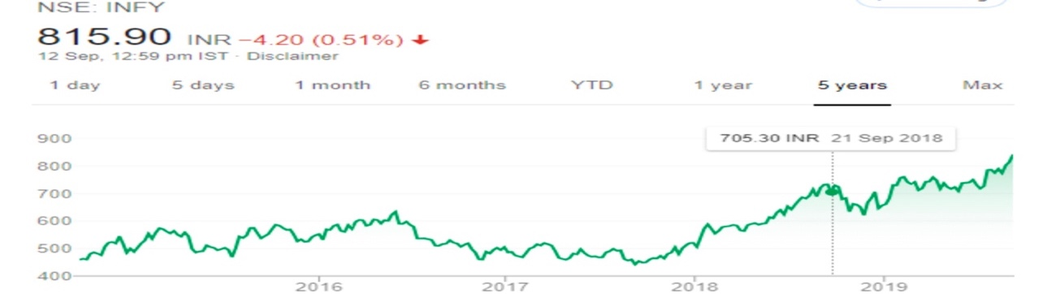

Figure 5 Infy Technical Chart

# Fundamental Analysis Based Stock Prediction

# Introduction to Fundamental Analysis

Fundamental analysis discusses supply and demand-related variables. This information is to be collected and interpreted and used in stock prices before the information is included. There is a trading gap between the time between an incident and the subsequent consumer reaction. Fundamental forecasting is focused on business economic statistics which aims to estimate economies with economic records, such as yearly which quarterly accounts, accounting accounts and earnings statements, which businesses are expected to post annually.

**The advantages of fundamental analysis**:

* Its systematic approach and its ability to predict changes before they show up on the charts.
* Fundamental analysis is a superior method for long-term stability and growth.

**Disadvantages of fundamental analysis:**

* It becomes harder to formalize all this knowledge for purposes of automation (with a neural network for example), and interpretation of this knowledge may be subjective.
* It is hard to time the market using fundamental analysis.
  + 1. **Important Ratios for fundamental analysis:**

Several ratios can decide the main principle of stock evaluation. Each has its own meaning. Any share not representing all these conditions as safe would not be a successful buy. The definition for each ratio are referred from Investopedia.com

* **The Price-to-Book Ratio (P/B):**. “Companies use the price-to-book ratio (P/B ratio) to compare a firm's market capitalization to its book value. It's calculated by dividing the company's stock price per share by its book value per share (BVPS). An asset's book value is equal to its carrying value on the balance sheet, and companies calculate it netting the asset against its accumulated depreciation.”

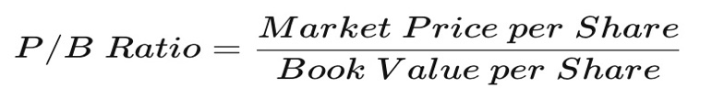

* **Price-to-Earnings Ratio (P/E):** “The price-to-earnings ratio (P/E ratio) is the ratio for valuing a company that measures its current share price relative to its per-share earnings (EPS). The price-to-earnings ratio is also sometimes known as the price multiple or the earnings multiple. P/E ratios are used by investors and analysts to determine the relative value of a company's shares in an apples-to-apples comparison. It can also be used to compare a company against its own historical record or to compare aggregate markets against one another or over time”
* **The PEG Ratio:** “The price/earnings to growth ratio (PEG ratio) is a stock's price-to-earnings (P/E) ratio divided by the growth rate of its earnings for a specified time period. The PEG ratio is used to determine a stock's value while also factoring in the company's expected earnings growth and is thought to provide a more complete picture than the more standard P/E ratio.”
* **Dividend Yield:** “The dividend yield is the ratio of a company's annual dividend compared to its share price”.
* **Returns on Equity (ROE):** “Return on equity (ROE) is a measure of financial performance calculated by dividing net income by shareholders' equity. Because shareholders' equity is equal to a company’s assets minus its debt, ROE is considered the return on net assets. ROE is considered a measure of how effectively management is using a company’s assets to create profits.”
* **Debt to Equity Ratio:** “The debt-to-equity (D/E) ratio is calculated by dividing a company’s total liabilities by its shareholder equity. These numbers are available on the balance sheet of a company’s financial statements. The ratio is used to evaluate a company's financial leverage. The D/E ratio is an important metric used in corporate finance. It is a measure of the degree to which a company is financing its operations through debt versus wholly-owned funds”

# Technical Analysis based Stock Prediction

* + 1. **Introduction to Technical Analysis:**

It is based on mining rules and patterns (using charts) from the past prices of stocks which are called mining of financial time series. The basic principles include concepts such as the trending nature of prices, confirmation and divergence, and the effect of traded volume. Many methods for prediction of stock prices have been developed and are still being developed on the ground of these basic principles. Technical analysis looks for patterns and indicators on stock charts that will determine a stocks future performance.

In recent years, neural networks have been widely implemented to boost multi-variate prediction efficiency with time series issues. Neural networks have a strong capacity to generalize input and output values through mapping of defined patterns. Neural networks are typically reliable in time series prediction problems against noisy or incomplete data which are highly desirable properties for the stock market research, several neural network models have already been created.

**The advantages of technical analysis:**

* Mostly used for short term investment and intra-day traders who usually follows technical analysis.

**Disadvantages of technical analysis**

* Major drawback on technical analysis is that, there is no standard evidence on chart reading.
* Each analysts interprets the charts on their own especially when analysts reviewing charts using Elliot Wave theory, interpretation keeps changing per analysts resulted in wrong entry and wrong exit in market.
  + 1. **Important Parameters for technical analysis:**

There are close to 52 different technical metrics/indicators are available. These metrics are sometimes called as indicators or oscillators which has been traditionally used by technical analysts to make short term investment prediction or intra-day trading purpose. Therefore, the parameters (the feature vectors of financial data) that most strongly predict the movement's existence need to be defined without the device complexity[5][6]. Definitions of various indicators are referred from Invesopedia.com

1. **Moving Average (MA):** “A moving average (MA) is a widely used indicator in technical analysis that helps smooth out price action by filtering out the “noise” from random short-term price fluctuations.”
2. **Exponential Moving Average (EMA):** “Exponential moving averages (EMAs) are also weighted toward the most recent prices, but the rate of decrease between one price and its preceding price is not consistent. The difference in the decrease is exponential”
3. **Relative Strength Index (RSI):** “The relative strength index (RSI) is a momentum indicator that measures the magnitude of recent price changes to evaluate overbought or oversold conditions in the price of a stock or other asset. The RSI is displayed as an oscillator (a line graph that moves between two extremes) and can have a reading from 0 to 100”
   * 1. **List of Trading Strategies:** Each with appropriate market environments and risks inherent in the strategy. Trading strategy is a technique of buying and selling in the markets that is based on predefined rules used to make trading decisions.

|  |  |
| --- | --- |
| Trend-following Strategies | Algorithmic Trading Strategies |
| Statistical Arbitrage | Arbitrage Opportunities |
| Trading Range (Mean Reversion) | Technical Analysis |
| Swing Trading Strategy Scalping (Trading) | Day Trading |
| Trading the Signals Social Trading | Value Investing |

Table 1 List of Trading Strategies

* + 1. **List of Portfolio Strategies:** Portfolio strategies is an investment method for investors to use their assets to achieve their financial goals.

|  |  |
| --- | --- |
| Long-term Investment | Capital Asset Pricing Model (CAPM) |
| Short-term Investment | Momentum Investment |
| Buy and Hold | Portfolio Optimization |
| Rebalance Portfolio | Dynamic Asset Allocation |
| Value Investment | Portfolio Allocation |

Table 2 List of Portfolio Strategies

* + 1. **List Type of Risks:** Risk measures are statistical method to define the individual stock or together to perform a risk assessment.

|  |  |
| --- | --- |
| Trade Risk | Position Size Risk |
| Liquidity Risk | Overnight Risk |
| Market Risk | Volatility Risk |

Table 3 List of Risk Strategies

* + 1. **List of Risk-Adjusted Returns Ratios Measurement:** An investment's return by measuring how much risk is involved in producing that return.

|  |  |
| --- | --- |
| Calmar Ratio | Gain Loss Ratio |
| Martin Ratio | Sharpe Ratio |
| Modigliani Ratio | Pain Ratio |

Table 4 List of Risk-Adjusted Returns Ratios

# Sentiment analysis for Stock Prediction:

The social mood plays a significant role in the price movement, in addition to historical prices. The general social sentiment about a company is now seen as a significant aspect influencing its stock price.

**Sentiment analysis** (SA) is a common method which is increasingly used to assess the feelings of social media users towards a subject. The most popular approach performing sentiment analysis is using data mining. The central idea is to adopt Deep Learning to determine investors’ expectations about the price of stocks and the overall market based on their messages. A Crawler service can be used to read news articles or news data continuously about a specific stock and index those news polarity data for further correlation analysis. News Classifier can be used to segregate news data based on their associated sentiments as good (positive), bad(negative) and Neutral.

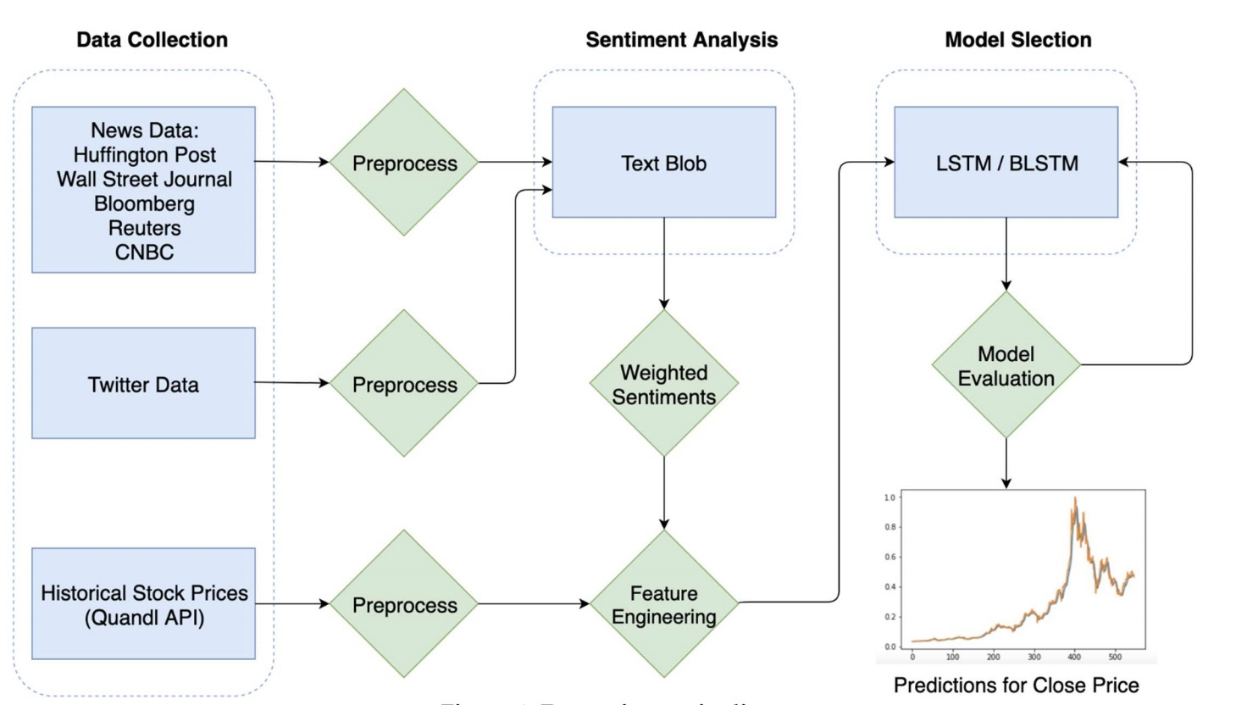

Figure 6 Prediction Model for Sentiment Analysis [12]

Geo-political and economic sentiments can have strong impact on Stock Exchange such as any trade war related news or sanctions on a particular country are considered as negative news which can impact respective country specific stock exchange.  Supply and Demand is the business philosophy which can impact the rise/fall of a stock market. Regardless of shifts in supply and demand the market markets are rising and dropping every second. Machine learning can help to address issues related to portfolio and commodity values with greater accuracy, efficiency and accuracy. In large amounts of social network results, the representation of moods and emotions is extremely significant in calculating investors' opinions.

In forecasting equity values dependent on popular opinions, Twitter data recently acquired an impetus. The explanation is that Twitter data is now available and therefore affects market sentiment immediately and rapidly. Good reports and tweets regarding a business on social media will certainly inspire people to invest in the company's securities, thus increasing the company's stock price. A prediction model can be built using machine learning to define and evaluate the association between tweet material, product prices and predictive predictions.

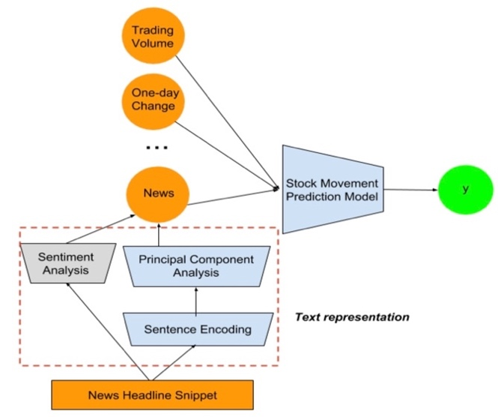

Figure 7 Sentiment Analysis Tool Overview

# Sentiment classification techniques:

Three broad categories of sentiment classification techniques are:

* **Rules-based techniques:** Based on a pre-built dictionary of words and their polarities. Sentiment of the text is then defined by counting positive and negative words in the text.
* **Machine learning- based classifiers:** do not rely on deterministic rules. They transfer text to numerical representations (feature mapping) and map to sentiment labels.
* **Bag of Words (BoW):** In this method, text is represented as a bag of words (unigrams) or a collection of words (n-grams). Each word is mapped to a frequency in the document (Term Frequency-Inverse Document Frequency (TF-IDF) approach).
* **Word embedding** technique that maps each word, or collection of words, to a vector. The mapping is done in a way where semantically similar words are positioned closer to each other in the vector space, thus providing the to capture their relationship to one another.
* **Language modelling:** Used to initialize a first layer of neural network provides a shallow representation of the language. The network should still learn how to drive meaning from a sequence of words and relate them to sentiment labels through layers and embedding layer.
* **SDA (Stacked Denoising Auto Encoder)** is applied to reduce the dimension of features which is not sensitive to the noise. [11] An autoencoder is a type of artificial neural network used to do unsupervised learning of data coding. The aim of an auto encoder is to learn higher-level representation for a set of data, typically for dimension reduction.

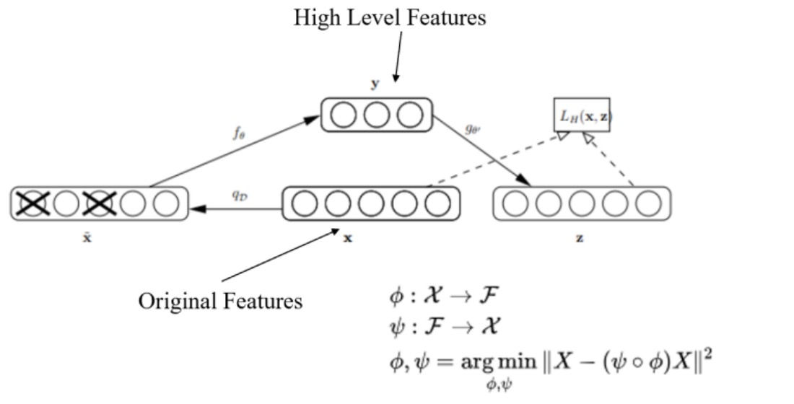

Figure 8 SDAE Auto Encoder Framework

# Data Sources

# Historical Stock Prices Data

Historical stock prices data can be availed through Quandl API and Yahoo Financials wrapper to get the data. The dataset contains following fields: Date, Open, High, Low, Close and Volume.

**Twitter** - Twitter is an online social networking and microblogging service that enables users & organizations to send/read messages, called "tweets". Users/organizations are free to post their content (tweets) to their followers(listeners) read them.

Twitter sentiments are generated classified according to the emotions associated with the tweet such positive, negative and neutral. Depending on the areas of application we can even make advanced classifications and judge if the user is angry, happy or sad. Twitter provides a unique functionality to access their tweets with the help of their APIs to filter out the required data.

**Twitter Data**

* twitter data from Internet Archive collection of twitter stream.
* It contains the tweets in a nested structure as: Year → Month → Date → Hour → Minute.

**News Data**

* News Dataset from Kaggle News Category Dataset and Kaggle US Financial News Articles.
* Kaggle News Category Dataset contains approximately 200k news articles of various categories from 2012 to 2018 obtained from Huffington posts.
* The fields in this dataset include date, authors, category, headline, short description and link. Since the headlines and the short description fields did not provide enough information regarding the articles. The news articles are from the following news publishers: Bloomberg.com, CNBC.com, reuters.com, wsj.com, fortune.com.

# Sentiment Detection Algorithm:

# 

**Dictionary Based Sentimental Model:**

Two kinds of terms sets, i.e. positive terms and negative terms are used to create the polarity dictionary. The score (polarity words of positive and negative polarity ) for this text is determined by checking the occurrence of the terms in the dictionary.

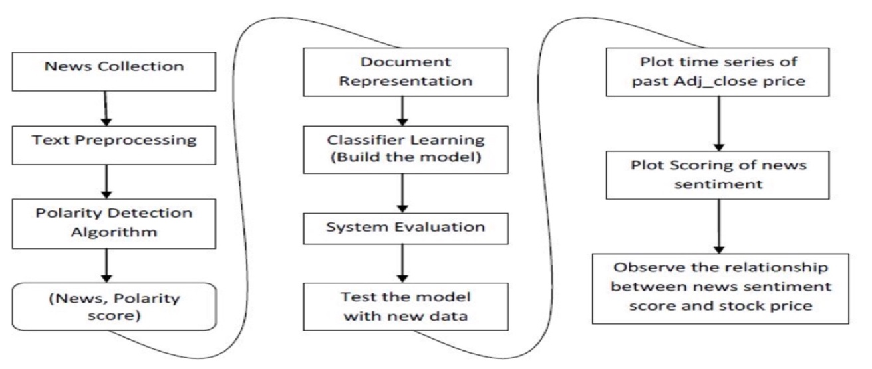

Figure 9 NLP Processing for News and Twitter Data [13]

# RNN (recurrent neural network) :

Definition of RNN is referred from Wikipedia as follows

“A recurrent neural network (RNN) is a class of artificial neural networks where connections between nodes form a directed graph along a temporal sequence.”[13]

* It can exhibit temporal dynamic behaviour.
* Since this is possessing feed-forward neural networks nature, RNN can use their memory to process variable length of inputs esp. useful for speech recognition and stock market prediction.
* Its deep learning model that is mostly used for analysis of sequential data (time series data prediction).
* RNN is a recursive function since for all data inputs it conducts the same function, although the output of the present input is based on the last one.
* **There are different application areas that are used:** Language model, neural machine translation, music generation, time series prediction, financial prediction, etc.

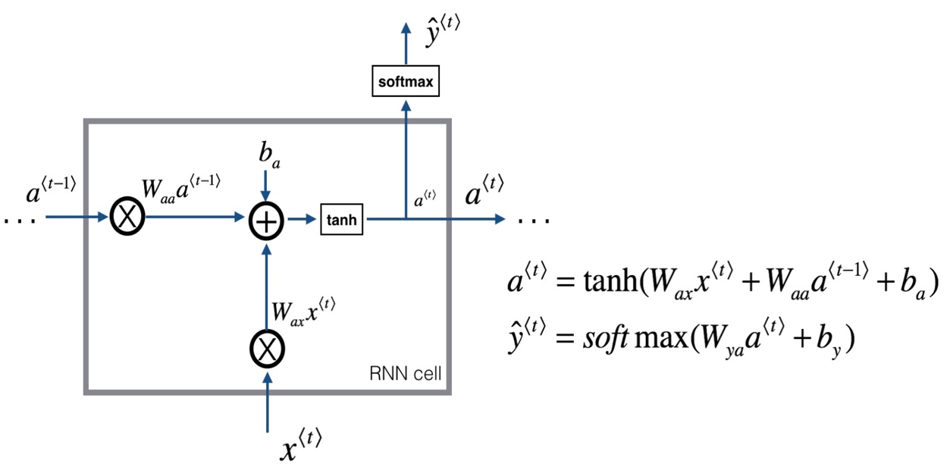

Figure 10 LSTM Cell Diagram [14]

# How it is different than other neural network models

* Traditional neural network input’s is not dependent on output.
* Suppose if we want to predict a day’s return of a stock market, then it is necessary to know previous days’ return index.
* What ‘recurrent’ means in RNN is repeating the same task for all the element in the sequence. RNN has ‘memory cell’, which store the information about the previous elements.
* RNN works best in field of Natural Language Processing and time series data.

Here unfold means unrolling i.e. expanding into the full network. For example, if an RNN is to be used in a 10-word sentence, the RNN could be unrolled into 10 layered neural networks, each layer represents one layer.

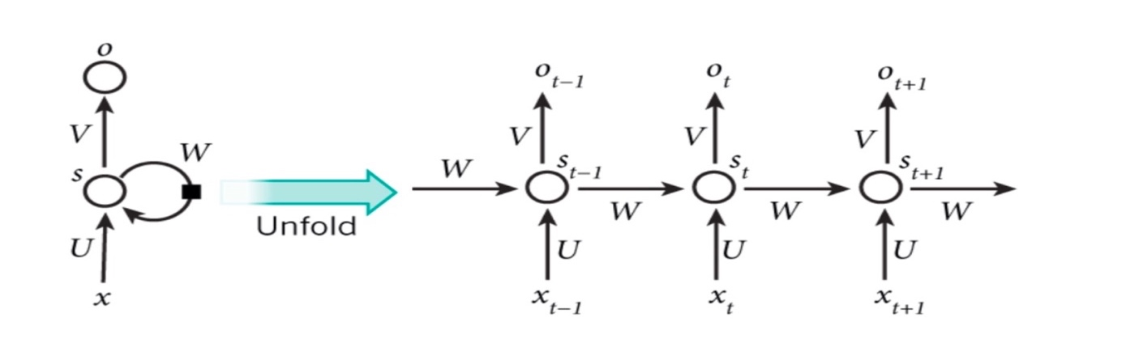

Figure 11 LSTM Cell with Unfolded Diagram [15]

# Few RNN’s Applications:

# Language modelling and prediction

* the probability of a word occurring in a sentence in a particular position with respect to other words is considered.
* In language modelling, a sequence of words is the model and the output will be a sequence of predicted words by the model. The model basically computes how likely a sentence can be, which is an important step for machine translation module.
* Predicting the next word is the motive of generative model, which tries to generate new text by sampling from the output probabilities of the given input text.
* One of the methods for language modelling is using one hot encoding.

# Machine Translation

In this one language is the input and output will be any other target language. The difference between machine translation and language modelling is that the output starts after the model sees the input completely as shown in the figure.

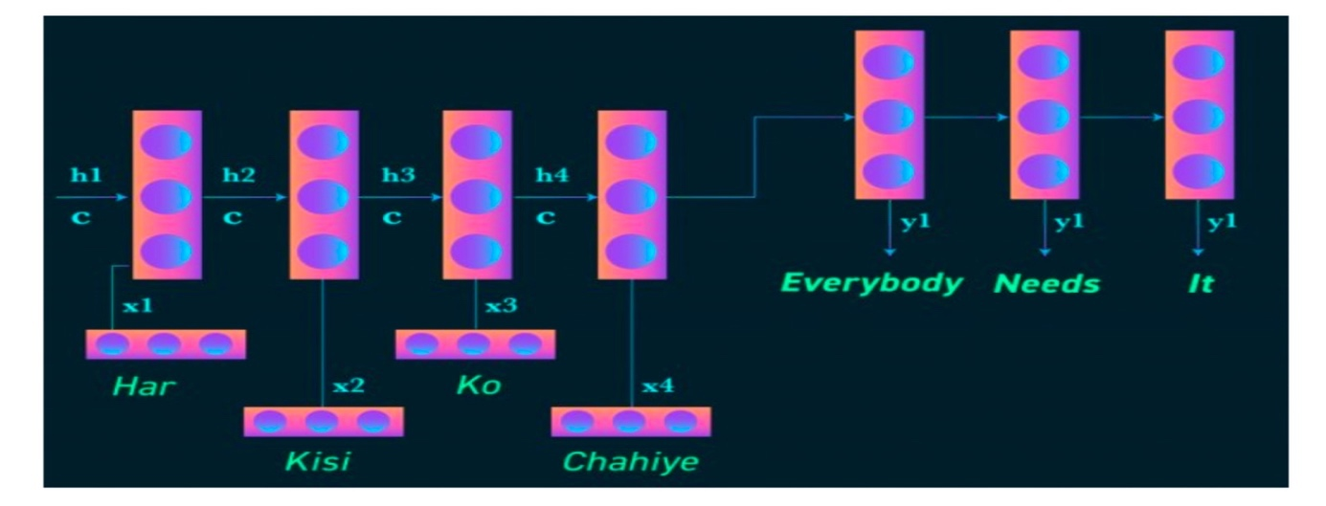

Figure 12 Machine Translation (RNN Application)

# Image recognition and generating description

Convolution neural network (CNN) can be used with RNN to generate image description. Results can be very impressive after constructing the model properly.

# Speech Recognition

Given phoneme (sequence of acoustic signal from sound wave) as input, it predicts the sequence of phonetic segments.

# Training RNN

Like the other neural network RNN needs to be trained. Here backpropagation algorithm is also used with a slight modification as not only the current time step is required to compute the output but also all the previous time steps are also important.

# RNN extension

Researchers have been developing so many things in RNN. Some of the developments are as follows.

|  |  |
| --- | --- |
|  |  |

Figure 13 Bi-directional RNN vs Deep RNN

|  |  |
| --- | --- |
| Bidirectional RNN | Bidirectional RNN requires elements of previous time steps as well as elements of future time steps. Bidirectional RNN comprises two RNNs stacked on the top of each other. |
| Deep (Bidirectional) RNN | It is similar to the bidirectional RNN with multiple layers are stacker per time step. This requires lots of training data but also gives higher learning rates. |

Table 5 Bi-Directional RNN vs Deep RNN

# Different types of RNN

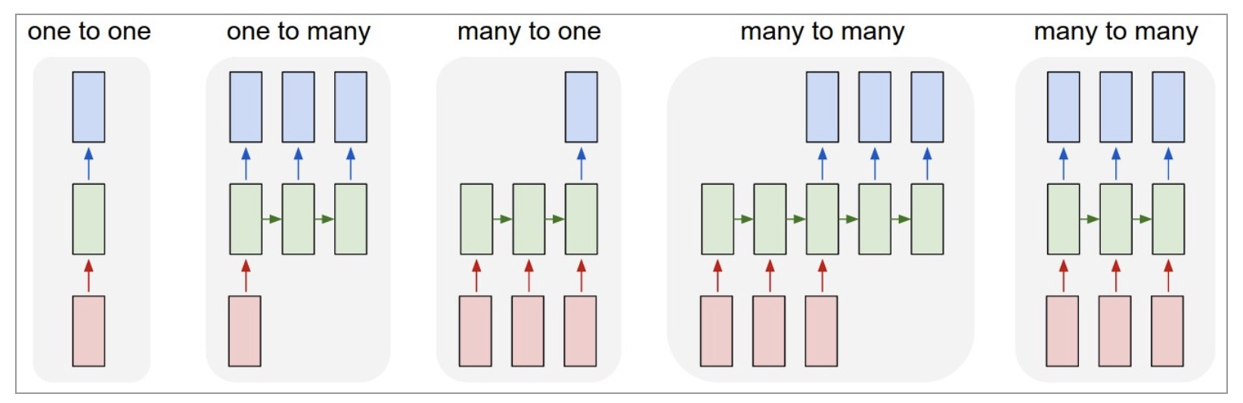

Figure 14 Types of RNN

|  |  |
| --- | --- |
| One to one (vanilla) | it is the basic model of RNN |
| One to many | Here number of inputs is one and number of outputs is more than one. **Example: image captioning**  Here an image is given, and task is to predict some sequence of words as the description of the model. |
| Many to one | Here more than one input layer is used, and only output is available. **Example: Sentiment classification**  Suppose a paragraph i.e. a bulk of words is given, and the sentiment of the para has to be determined. In this type of case many to one model is used. |
| Many to many (where number of inputs is not equal to number of output) | Here number of inputs is more than one and number of outputs is more than one, but the number of input and output may or may not be equal. **Example: Machine Translation** |
| Many to many (where number of inputs is equal to number of output) | Here the number of inputs is equal to number of outputs. **Example: Video classification on frame level** Here first video is divided into frames and then frames are labelled. |

Table 6 Types of RNN

# Mathematical formulas of RNN

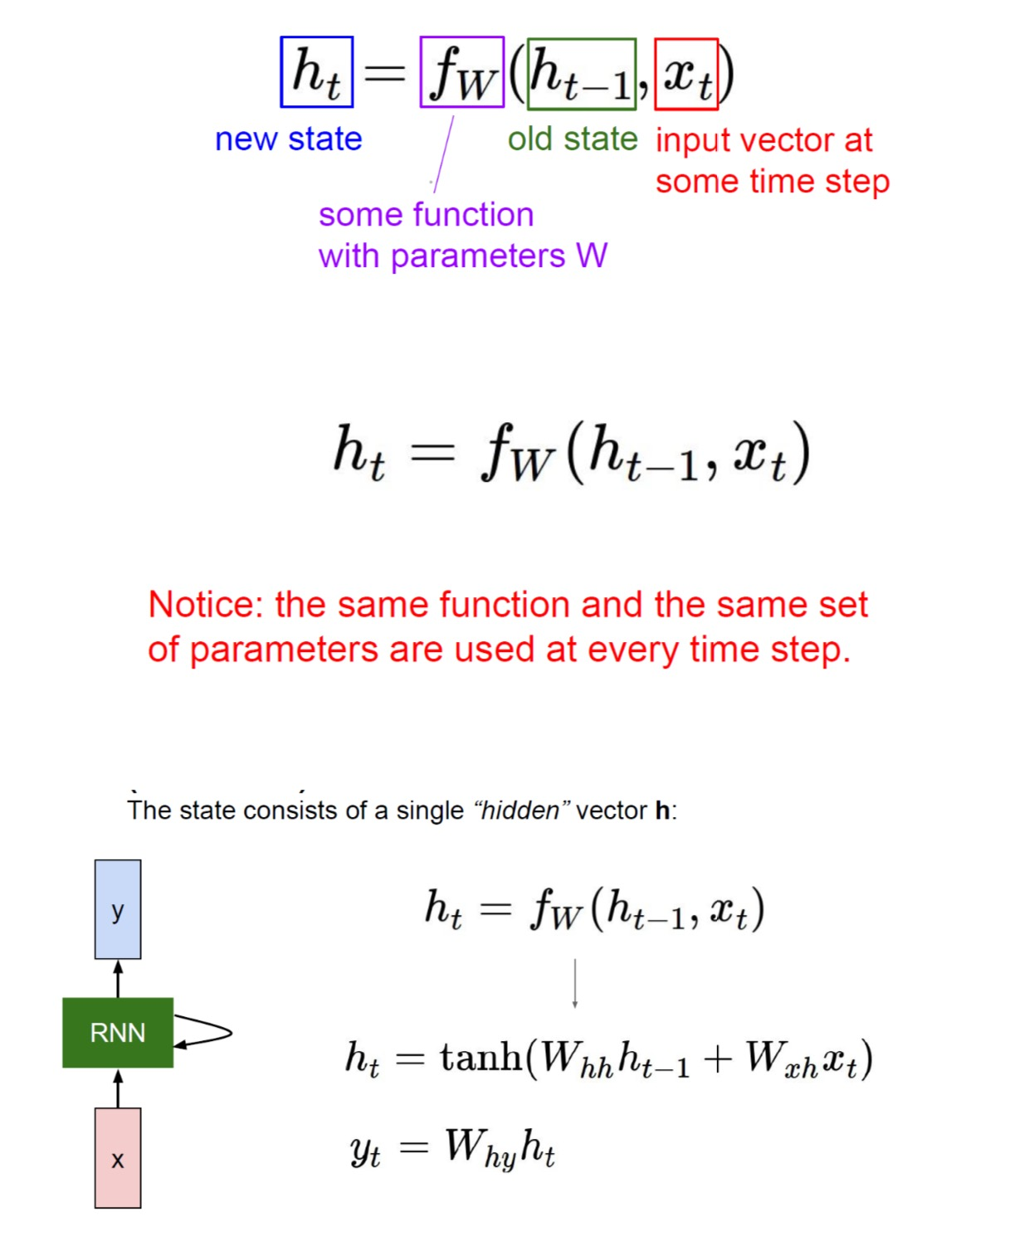

Figure 15 Mathematical Model of RNN

# RNN: Computation Graphs

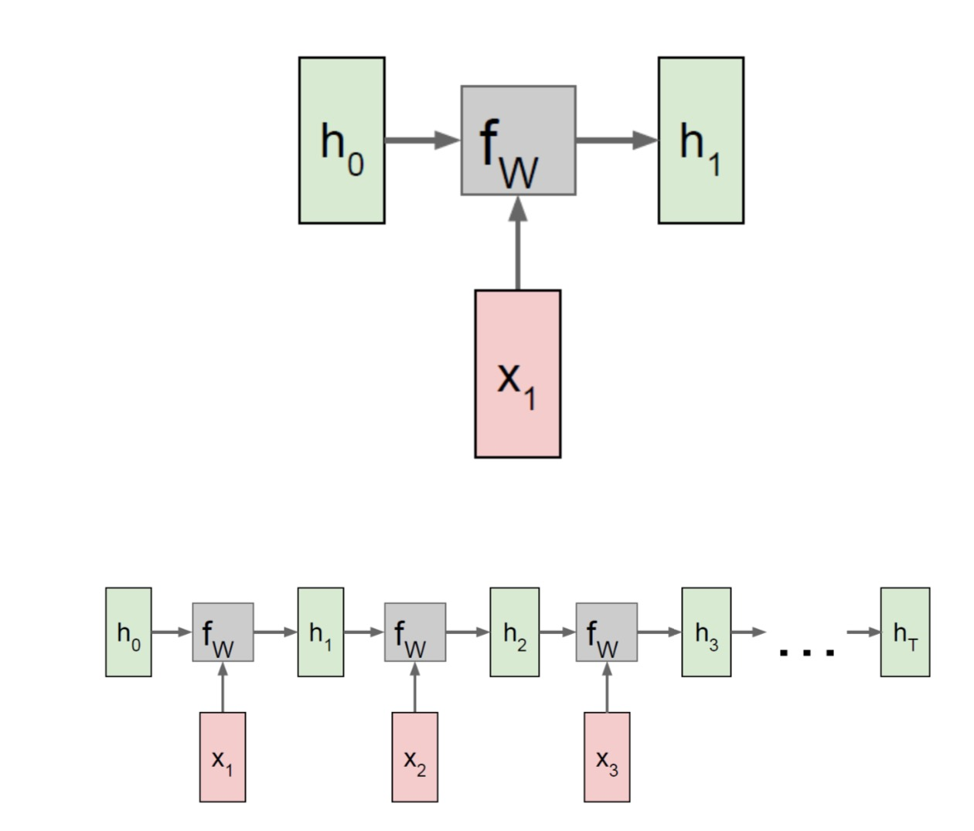

Figure 16 RNN Computation Graphs

# Problems with RNN

# RNN suffers from Gradient flow problem

* In a neural network a very basic but important task is to optimize the network. And by optimization it is meant to minimize the cost of learning and find the values of hyper parameters of the model like learning rate, batch size, no of epochs.
* Parameters are the properties of the training data that are learnt during training. These define the skill of the model. These are not usually set by the developer. Example: weights of a network.
* Hyperparameters are those which cannot be learnt from the model. But these are to be set before training. They help to estimate the parameters. Hyperparameters have to set by developer. Tuning hyperparameters helps the model to work more efficiently. Example: learning rate, decay, number of hidden layers, number of epochs etc.

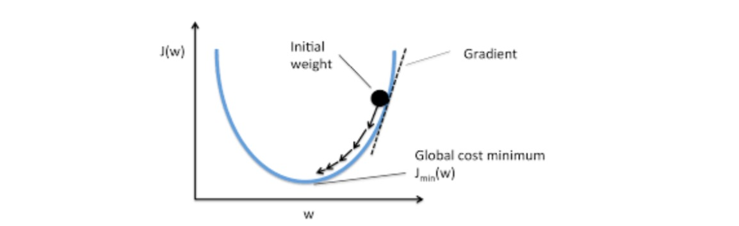

Figure 17 Gradient Descent

# Mathematical procedure

* Suppose the initial values of the coefficient for the function is 0.0. Coefficient = 0.0  
  And suppose cost function is f, i.e. cost = f(coefficient)
* Derivative is used to calculate the optimization point. So here the derivation of the cost is calculated, i.e. basically the slope of a function at a given point (diff = derivative(cost))

A parameter is used to control over the update in each iteration. This parameter is called learning rate. This process is repeated until the cost of the coefficients is nearly zero.

* coefficient = coefficient – (lr∗ diff); here lr stands for learning rate.
* gradient descent algorithm often has problems of exploding gradient and vanishing gradient.
* Though gradient descent works quite similarly for RNN’s, there are some add ones:
* The information propagates through timesteps in RNN.
* At each time step cost function has to calculated.
* After calculating et, it is propagated back into the network to update the weights.
* So, if the gradient is very small and as it is multiplied back in each timesteps it will just result near zero result and if the gradient is very high it will just explode in same way.

|  |  |
| --- | --- |
|  | page20image59556672 |

Figure 18 RNN with multiple Co-Efficient

# Solutions to the vanishing gradient problems

In case of exploding gradient:

* Back propagating is stopped after some point
* Reduce gradient in some way
* Put a limit on gradient.

In case of vanishing gradient:

* Initial weight in a proper manner so that vanishing gradient is minimized.
* Having long short-term memory (LSTM) networks.

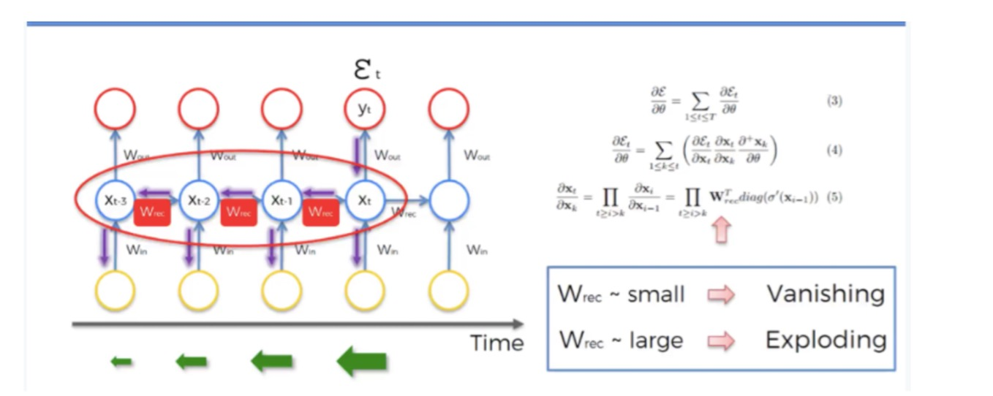

Figure 19 Gradient Descendant and Vanishing Problem

# Gradient flow in RNN

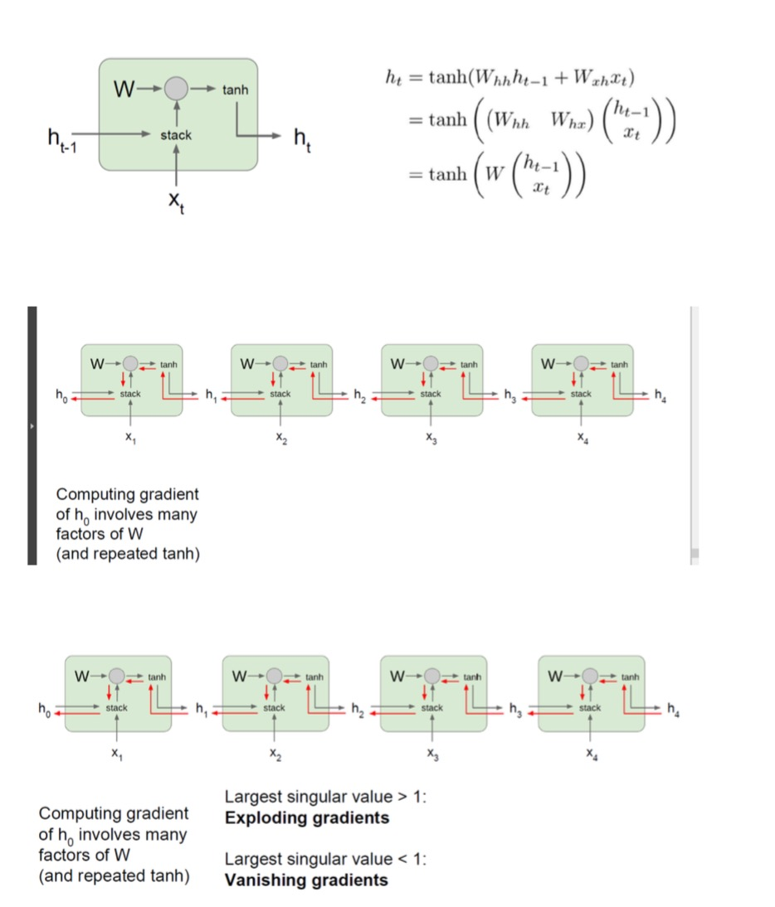

Figure 20 Gradient Flow in RNN

# LSTM (Long Short-Term Memory)

* LSTM is a special kind of RNN, which extends memory. That’s why it is perfect to learn from the patterns or trend that have very long-time difference in them. It also solves the Vanishing Gradient/ Exploding Gradient problem.
* LSTM is well-suited to classify, process and predict time series given time lags of unknown duration. It trains the model by using backpropagation
* It is a special type of RNN, capable of learning long-term dependencies.
* "Long short-term memory (LSTM) units are units of a recurrent neural network (RNN). An RNN composed of LSTM units is often called an LSTM network”[79]
* **There are different application areas that are used:** Language model, Neural machine translation, Music generation, Time series prediction, Financial prediction, Time series prediction, Speech recognition, Rhythm learning, Music composition, Grammar learning, Handwriting recognition, Time series anomaly detection.
* LSTM cell has four gates. Those are forge gate, input gate, gate to write the cell, output gate.

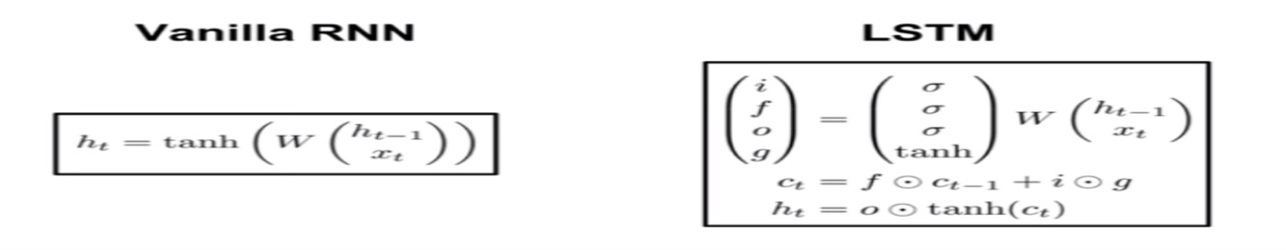

Figure 21 Vanilla RNN vs LSTM

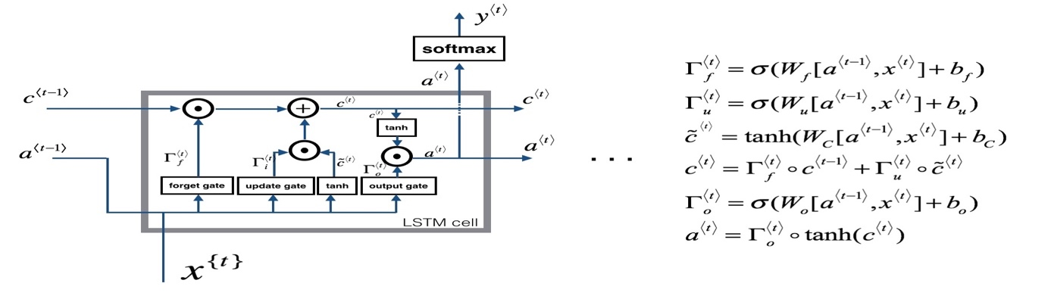

Figure 22 LSTM Cell with Softmax

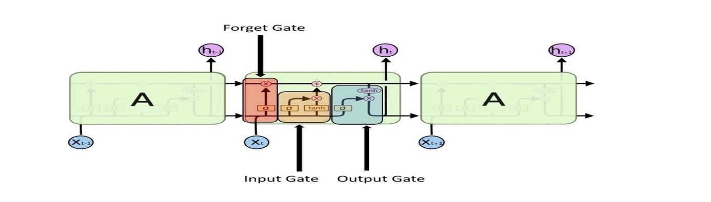

Figure 23 LSTM with four gates

1. **Forget Gate:** After getting h(t-1) i.e. the output of previous step, this gate helps to take decision about how much information is to forget from the previous state. In this way it tries to keep only relevant stuff. It uses sigmoid function to keep the input between 0 and 1 both inclusive. The above diagram represents the Forget Gate.

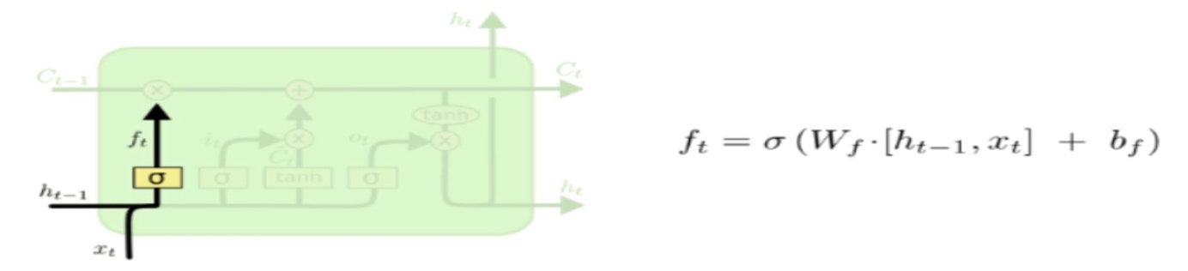

Figure 24 LSTM Forged gates

1. **Input Gate:** This gate decides whether to write the present cell from the present cell or not. tanh layer helps to create a vector to add to present state and sigmoid layer decides the values to be updated. The above picture describes the Input Gate.

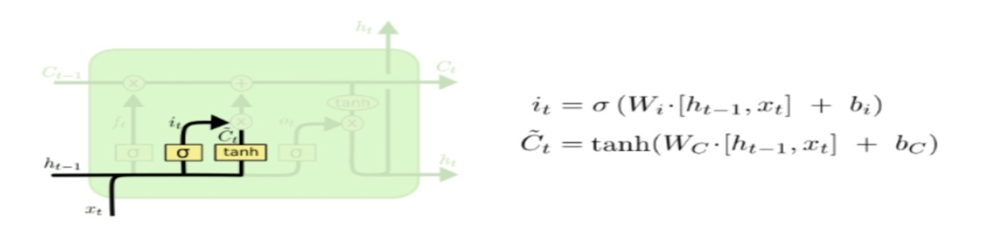

Figure 25 LSTM - Input Gate

1. **Output Gate:** It decides how much to revel as output. The following picture describe this cell.

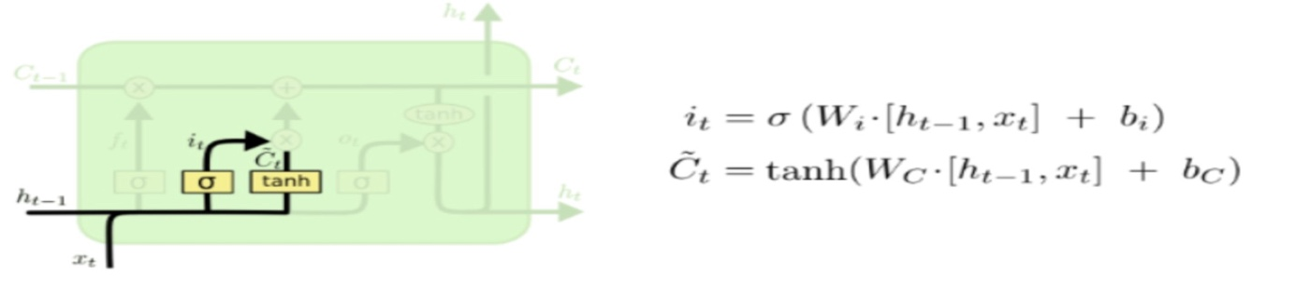

Figure 26 LSTM - Output Gate

# LSTM Model in Sentiment Analysis

LSTM neural network is applied for sentiment analysis. Input is sentence vectors. Then split data into several parts by different companies. Put them into LSTM layer. Then add a dense layer. Output layer will output sentiment analysis result, value range from 0.0~1.0. And then a 4-quantile value is used. If value < value <= 75%quantile as 0(even); value > 75% quantile as 1(positive). Model design is showing below:

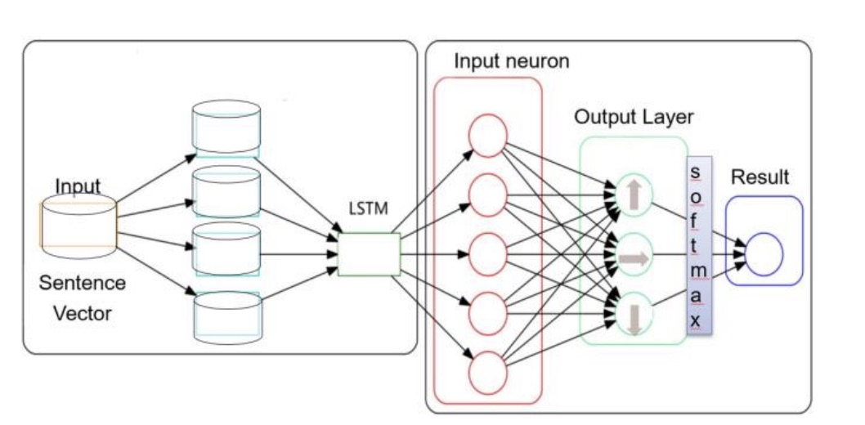

Figure 27 LSTM Sentiment Analysis Model [15]

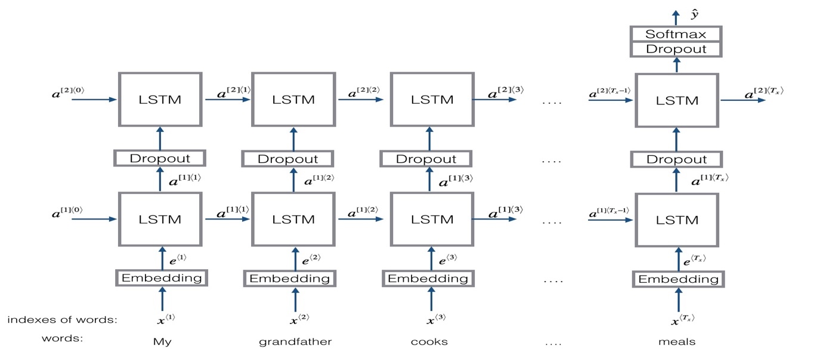

Figure 28 LSTM Sentiment Analyser [14]

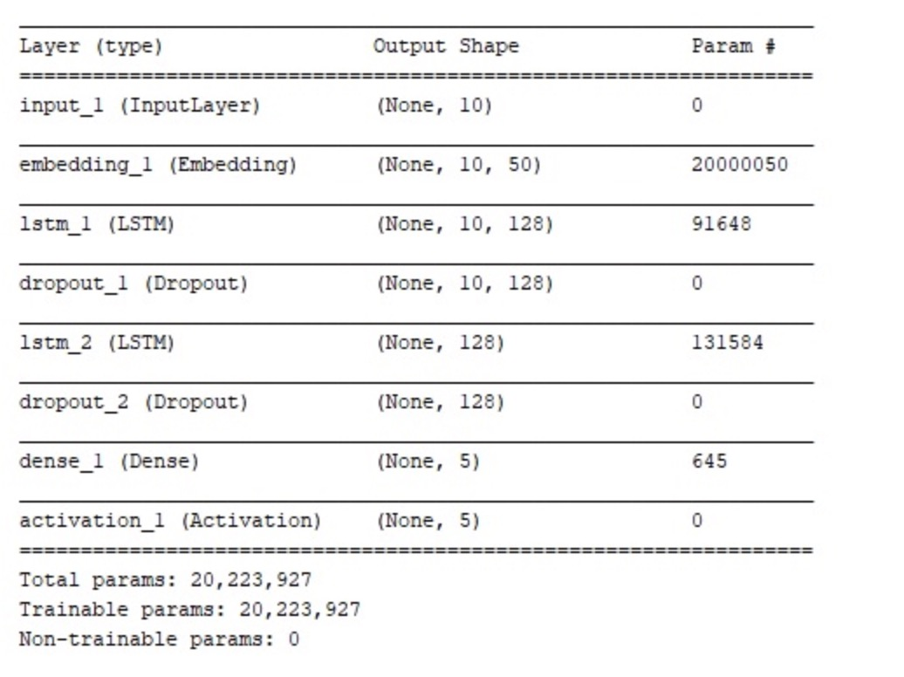

Figure 29 LSTM Sentiment Analysis Output Screenshot

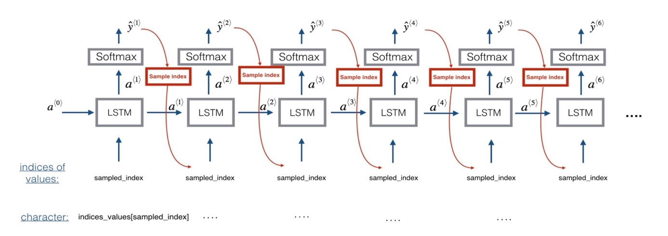

Figure 30 LSTM Softmax and Index Processing

# Trading

A trading strategy states when to buy, sell or hold our financial assets in order to achieve better returns. It tells us to go long or short in markets at the given circumstances. There are two common trading strategies we deal with in this project:

# Momentum Strategy

* Also known as divergence or trend trading, this strategy believes in the movement or lack of it, of a quantity i.e. it expects the movement to continue its trend.
* Stocks with an upward trend tend to move up and those with downward seem to go down.

**Common examples of this strategy include:**

1. **Moving Average Crossover b) Dual Moving Average Crossover c) Turtle Trading (Richard Dennis)**

# Reversion Strategy

* Also known as convergence or cycle trading, this strategy begs to differ from the current trend and believes that the movement of an asset will eventually reverse.
* Mean Reversion strategy insists that stocks return to their mean prices and aims to exploit when stock prices deviate away from the mean. Some Common strategies in this category are**: a)** **Mean Reversion Strategy b) Pairs trading Mean Reversion Strategy**

Moving average crossover strategy of quantitative trading is used which uses two separate Simple Moving Averages (SMA) of a time-series with a short and a long lookback period.

If the short moving average exceeds the long moving average, then we buy a stock, or we go long and if the reverse happens then we exit, or we go short (sell the stock).

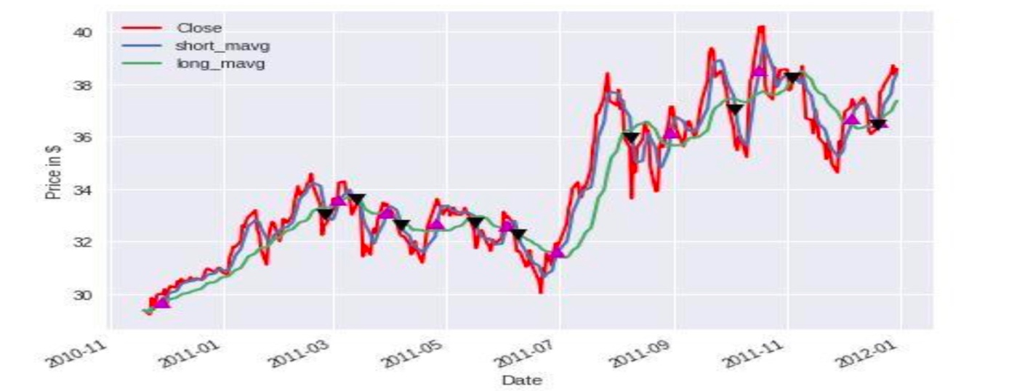

Figure 31 Stock MAVG for Short and Long

# Literature Review

# Introduction

In an effort to understand the advancement in the prediction of financial systems and stock markets using machine learning, this thesis aims to provide a systematic review of current research on various machine learning based prediction methodologies. I undertook an extensive literature review by examining relevant articles from major academic databases (IEEE Xplore, ACM, Springer digital library and Science-Direct). Key search terms include the key words ‘Stock Prediction Methodologies’, ‘Artificial Neural Network’, ‘Machine Learning’ and ‘LSTM’ and a wide range of other technologies.

In addition, I have reviewed the research projects related Stock predictions methodologies based on historical data, news data and also sentiment analysis etc, by searching from various journal databases and existing open source/funding projects. As a result, I have found a large number of journal articles and conference papers related to Stock Market Prediction methodologies studies and Sentiment Analysis based Market predictions respectively, and a number of opportunities for future researchers. A main contribution of this section is that it is the first attempt to categorize classic machine learning prediction methodologies into Neural network-based prediction method systematically; it reviews the current research of stock prediction, Sentiment analysis and also NLP, key enabling technologies, identifies research trends and challenges.

# Problem Statement

The stock market is very volatile and depends on lots of different parameters hence it is very difficult to predict the future stock prices. There are few challenges in this research domain.

**Challenges :**

* It is very difficult to predict the future stock prices because the stock market is very volatile and depends on lots of different parameters hence.
* Complex natural language processing techniques are needed to get the sentiment for a particular company out of whole bunch of data.
* Identifying the exact features which would help in increasing the accuracy of the prediction to improve upon the existing models.
* Since stock data are highly volatile, prediction of share price can be achieved by combining multiple models together (Hybrid Model)
* It is very critical to identify the right machine learning model and discover the best performing parameters to predict the stock prices accurately.

**Stock Returns Key issues :**

There were so much research work had been done by researches in the past 15 years to analyse and identify the key factors related to stock returns, as shown below.

**Predictability and Forecasting :** This has been one of the major research areas in the past several decades, around 25% of the research papers out of 400 are focused on predictability**.**

1. Different models were analysed by researches for better predictability.
2. Avramov (2002)[16] used the Bayesian model which shows the importance of model uncertainty. The paper mentions that, large risks and losses are possible if the investors are not considering this model uncertainty.
3. In order to evaluate the statistical and economic importance of product return predictability, Wei and Zhang (2003)[17] used medium variance analysis. Also, the predictability of returns was calculated not to be linked explicitly to the price of fair properties.
4. Mcmillan (2001)[18] defined different variables that could lead to the estimation of stock prices in the context of financial or microeconomic sources.
5. Duan, Liu and Zeng (2013) [19] mentioned in his paper that, recommendations of behavioral analysis used for new forecasting approach.

**Volatility and Variability :** Over the last 20 years several studies were performed to study about uncertainty or variability. The analysis showed that the uncertainty or variation in stock profits is the most commonly appeared in journals about 31 % of research papers chosen.

* Umutlu, Akdeniz, and Alttay-Salin (2010) [20] were mentioning in their paper about the impact of financial liberalization in volatility of stock returns. It is evident from their paper that, the increase in financial liberalization when the volatility of stock returns decreases.

**Inflation :** Across globe many researchers were doing research in the area of understanding the inflation and its impact on global economies.

* Alagidede and Panogiotidis (2012) [21] were mentioning in their paper that, there is a direct relation between the stock returns and inflation and found out that, there is a positive relationship between these two factors.

**Risk and Liquidity:** Based on the empirical studies, there were not much research work were happening in this domain.

* Chen and Hill (2013) [22] mentioned in their paper that, during the study of stock returns and risk association, they noticed a consistent and coherent relationship between liquidity and stock yield and an essential positive connection between stock returns and liquidity.

# Stock Market Prediction Methodologies

The analysis of market movements relies directly on speculation and stock data trading. The analysis of various stock market prediction technology is mentioned in this Portion. The categorization of various bond sector prediction strategies is shown in the figure.

**Prediction based techniques :** Various techniques are used for prediction and are classified accordingly as per below figure

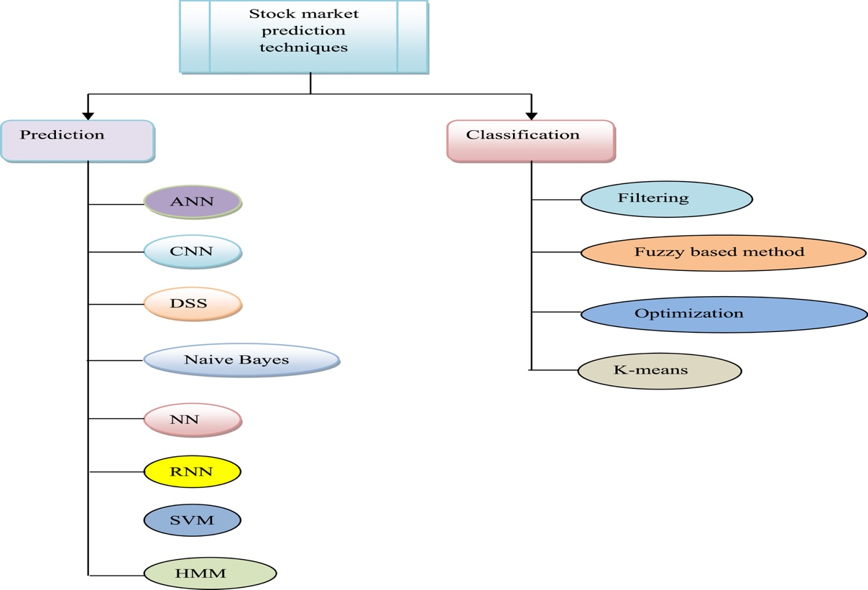

Figure 32 Stock Prediction Methodologies

# Stock market prediction Methodologies Classifications:

As per Ticknor, J.L  [23] has mentioned that, market trends and technical trends were used as indictors combined as input for predicting the cost of the stock and this model is called as “Bayesian regularized ANN” [23] which is used to forecast the financial market details about behaviour.

Rout, A.K [24] have established an innovative model for calculating time series estimates on the basis of Indian stock indices in the financial industry. This model incorporated the Lowest Middle Square (LMS), exercise function and weights of the neural networks. This model is known as the CEFLANN (CEFLANN) Computationally Efficient Functional Connection.

Zhong, X. and Enke, D [25] have developed three techniques model based on which to effectively mining data, namely “Fuzzy Robust Principal Component Analysis (FRPCA)” [25], “Kernel-based Principal Component Analysis (KPCA)”[25], and predicted market index return patterns on the basis of economic featuring. The findings were contrasted. Three approaches are used to forecast, these include: “Fuzzy Robust Main Component Analysis (FRPCA)”[25],“Kernel-Based Principal Component Analysis (KPCA)“[25] and “Principal Component Analysis (PCA)”.[25]

# CNN based prediction techniques :

“CNN are made up of neurons that have learnable weights and biases. Each neuron receives some inputs, performs a dot product and optionally follows it with a non-linearity”[78]. There are more hidden layers in a CNN than in a conventional neural network. Stock market forecasts are using CCN based deep learning methods.

The model developed by Vargas, M.R. et al., [26] to forecast lateral orientation using S&P's 500 index utilizing profound learning methodologies as a scientific predictor. Owing to deep learning policies that accelerate the trade phase, complicated data structures are analysed

# ****HMM-based prediction techniques****

Time series or time depending phenomena are well predicted using HMM. This helps in predicting and forecasting stock market.

The paper published by Dhingra, B, Gupta, A. [27] were explaining about the prediction value dependency on stock ethics and based on previous results which is called as Posteriori HMM.

# ****Neural Network based prediction techniques :****

Chang, P.C. [28] had developed a model that was built to forecast market patterns with feedback as technical indicators that help to refine the EPCNN algorithm for learning and training weightage.

Thomas Fischer and Christopher Krausshave done their research in their paper *“Deep learning with long short-term memory networks for financial market predictions”*. This paper deploys LSTM for predicting S& P 500 stocks and compares the performance of random forest, a deep neural net and a logistic regression classifier.

Pang, X et al. had developed a model to evaluate stocks utilizing the data in real time from the livestock industry. NN based on Deep LSTM and automated encoder were developed to forecast market patterns.

The neuro fuzzy design focused on Elliott Wave Theory has been established by Atsalakis, G.S. et al [30]. That is called the “Wave Analysis Stock Prediction” (WASP) system which is valuable for precise equity price forecasts. This algorithm may be used to forecast the stock market correctly.

Chatzis, S.P.[31] had built the prediction model utilizing a suite of machine learning approaches in which broad collections of data on everyday inventories and a wide variety of economies are chosen.

Shen, W [32] has developed a model based on “Artificial Fish Swarm algorithm (AFSA)” for training the system and forecasting market indexing with the Shanghai Commodity and also the model was designed to use “Radial Basis Neural Network (RBFNN) “.

Asadi, S [33] had developed a cognitive model which is combination of various methodologies such as GAs convergence, data reprocessing processes and the “Levenberg–Marquardt algorithm”[33]. The pre-processing processes of the data involve input variable collection and data transformation in order to boost their accuracy.

# ****RNN based prediction techniques****

Hsieh, T.J had designed a model based on “Artificial Bee Colony (ABC-RNN)” [35] algorithm for forecasting the stock prices. The first step in this process is to decompose the time series values of stock price and then removing the outliner and noise data from this data by using optimized RNN algorithm with fine-tuned weights and biases as hyper parameters.

Xie, X.K [36] and Wang [36], had designed a model which is primary suitable for intra-day trading using RNN based time series analysis method. Primarily RNN based time series data is used to identify the feature related to daily stock data for intra-day trading purposes. Precision and Average Profit were primarily used as metrics to measure the performance of this methodology.

Chen, W [37] had designed a model to predict the volatility of stocks in the Chinese stock market which is on RNN model along with “Gated Recurrent Units (GRUs)”[37]. The drawback with this model is that having less accuracy, because it doesn’t consider the advanced algorithms like “Interdependent Latent Dirichlet Allocation (ILDA)” [37]

# ****SVM based prediction techniques****

Oztekin[38] had designed a method based on hybrid model of adaptive neuro-fuzzy inference systems along with ANN and SVM. The drawback with this method is that, it failed to consider for broader trading systems.

Zhang, X[39] had designed a model that can be used for predicting the stock indexes based on the news sentiment. This is hybrid model which includes sentiments about the stock, news events of the company. This inclusive framework is more effective in identifying the impact of events and news sentiment on the given stock price and associated fluctuations.

# ****Clustering techniques****

# ****Filtering based prediction techniques****

Arévalo, R [40] had developed a model focused on trading laws that identify flag patterns. The flag design reflects existing patterns and EMA which was subsequently applied to screen the trades. The downside of this model is that until some trade laws were made, it was not able to fix data snooping problems.

Ariyo, A [41] had designed predictive model based on the NSE) and NYSE stock market provision model ARIMA was created. The findings of ARIMA models are focused on sophisticated forecasting techniques for a short-term prediction.

Srinivasan, P and Ibrahim had established the volatility of the SENSEX index using the Garch model for a certain time. This process showed superior output indicators when forecasting the return of the SENSEX graph.

# ****K-means based clustering technique****

Ramon Lawrence had utilized neural networks to forecast asset values. This article is an inquiry into the of neural networks in market price forecasting. Neural networks can forecast business direction more effectively than conventional approaches as they can uncover correlations in nonlinear and unstable structures. Different market assessments are addressed and contrasted with neural network results, such as technological analysis, fundamental analysis and regression. In comparison to the chaos theory and networks, the Efficient Market Hypothesis (EMH) is often discussed. Initial recommendations for the usage of neural networks on capital markets[44].

Vivek Rajput, Sarika Bobde [45] had mentioned in their paper “Predictive equity market utilizing hybrid strategy” about a model to predict movement of stocks using data mining and the NSE prediction process. The technique suggested would yield two outputs, one from emotion analysis. A successful prediction is made by analysing both the data. For the analytical study, this paper takes account of stocks with highest capitalization in all primary sectors[45].

Li Xiong, Yue Lu Hybrid Method [46] had proposed a model **Hybrid ARIMA-BPNN Time Series Chinese Stock Market Analysis**. The estimation of asset values is a problem owing to the complexities of time series trends. The Back Propagation Near-Neural (BPNN) and Autoregressive Integrated Moving Average (ARIMA) models are common time-series predictions models. The convergence of both the models (can be linear or non-linear time-series) successfully catches the variations embedded in a time sequence.

There are two variants of this paper: one for CNN financial reporting, and one for SI-RCNN for LSTM, and another for IRNN for LSTM technical indicators. Every model's output is used as the input of a trading agent who buys stocks the day after the model forecasts the rate to increase, then he sells stocks the day before and buys the next day. The proposed procedure indicates that financial news is critical in stabilizing the results and is almost unimproved in comparison with numerous technological indicator sets[46].

Marios Mourelatos, Thomas Amorgianiotis, Christos Alexacos, Spiridon Likothanassis had identified that, dependencies between various financial indices is also to challenge modern approaches. The difficulty and the vast volume of past financial knowledge brought up the need for innovative approaches to the issue. This article proposes a model based on deep learning along with “long-term memory networks”(LSTM) [71] for the purpose of modelling and trading the financial indices [47]

Mohammad Asiful Hossain, Rezaul Karim, Ruppa Thulasiram, Neil D B. Bruce, Yang Wang had developed Dynamic Deep Learning Modes. Most investors and academics have also been conscious of financial market forecasts. Popular ideas say that capital markets are largely a spontaneous move, and that attempting to forecast it is a foolish task. The estimation of product values is an extremely challenging task because of the number of factors involved. Both these issues are discussed in this paper[48].

J.J.Z. Xie, Z. G had published their research paper “Prospective equity index focused on a composite formula”. This paper explores the forecast performance of the New York Stock Exchange model of ARIMA and artificial neural networks, using stock details. The empirical findings demonstrate the prevalence of the ARIMA paradigm in neural networks. The results shows conflicting viewpoints on the downside of neural networks and ARIMA model. [49].

A hybrid ARIMA-ANN moving average filter model can be developed to apply on time series-based data projection as per the literature mentioned by C. Babu and B. Narendra. Eswara Reddy.

A brief examination is carried out in general on supervised study and encompasses classical, non-sequential pattern classification framework which comprises of supervised sequence labelling and classes of sequence labelling tasks which come from different label sequence assumption.

P.J Werbos[52] had mentioned in his article, that aims at the general principle of back propagation, a straightforward approach employed widely in fields such as pattern detection and fault diagnostics.

Rudra Kalyan Nayaka, Debahouti Mishraa and Amiya Kumar Rath have been working on stock market pattern reversal study of Indian benchmarking indices using Naïve SVM-KNN-based model. This article suggests a hybridized support system for the Indian stock market indexes (SVM) method with K-Nearest Neighbor method. The aim of this paper is to understand how Indian stock-market using the two indexes BSE Sensex and CNX Nifty predicting closing price.

However, since several factors influence the financial markets, and financial data is time series data it is challenging to find the right moment to purchase or sell stock. Many time series models were therefore introduced for market price predictions, and in comparison, the previous time series approaches do have several problems using “integrated nonlinear feature selection (INFS)”[54] method for stocks [54] for the “Adaptive Neuro Fuzzy Inference System (ANFIS)”[54].

Liang-Ying Wei Deng-Yang Huang Shun-Chuan Ho Jyh-Shyan Lin Hao-En Chueh Chin-Sung Liu Tien-Hwa Ho[56] had proposed a feedback type of the “functional link artificial neural network (FFLANN)”[55] with “recursive least square (RLS) “[55].

Bahdanau and Y. van Merrienboer had mentioned in their paper that addresses the projected success of the New York Stock Exchange model and the artificial neural network models with reported market info. The empirical findings demonstrate the supremacy of the ARIMA paradigm in neural networks. These findings further solve and clarify conflicting views on the accuracy of the neural networks and the ARIMA model in literature[57].

G. Fr Zhang[58] have proposed the paper noticed that an artificial grammatical structure of a sentence is automatically created by the proposed recursive convolution network. [58]. The ARIMA is one of the most common linear models in time series foresees in the past thirty years. Recent research into artificial neural network (ANN) forecasting shows that ANNs may be a successful option to conventional linear approaches. ARIMA and ANN models are sometimes linked to the higher prediction dominance findings

A hybrid model based on both ARIMA and ANN models is suggested which can benefit the intensity of the ARIMA and ANN models. Specific data sets demonstrate that the integrated model can be an efficient way to improve the predictability of each of the separately used models [59]. Predicting stock market values through neural networks utilizing “Gated Recurrent Units (GRUs)”[61].

Predicting stock values is a crucial function in predicting time series, and is of significant importance to creditors, commodity traders and professionals. In recent times various prediction methodologies have been used to forecast the inventory price, including regression algorithms, that can be useful tools to provide good financial time forecasting accuracy. A new hybrid method has been recommended for optimizing the stock price prediction[62]which combines “Support Vector Regression”[62] and Hodrick Prescott filter[62].

Zabir Haider Khan, Tasnim Sharmin Alin, Md. Akter Hussain [63] have used ANN for stock market prediction and have used 5 fundamental input variable which are general index(GI), Net Asset Value(NAV), profit per earning(P/E) ratio, Earnings per share(EPS) and share volume. They have applied these parameters to NN and compared their outcome.

# ****Research gaps and issues****

Given the various methodologies used to estimate markets, some constraints need to be overcome in order to achieve an accurate equity market prediction. This segment deals with analysis discrepancies and difficulties with the numerous forecast techniques for the stock market.

Based on stock market forecasts, various challenges associated with NN are identified and documented below. ANN has not been considered an efficient scheme for stock market forecasts because neural models cannot handle high overhead computational costs due to the large neurons due to the correct adaptation of weight[64]. In [65], the NN administered both the assessments and the preparation at a diminished rate, impacting the efficiency of the forecast. In addition, the bypass that can be done using NN, which is stuck in the central minima and blackbox technique

The findings obtained by the stock predictive method established by NN[51]]were not optimized with accuracy due to the effect of the pattern misclassification and the usage of network parameters. The problem with the CNN stock forecasting approach is that, it was not ideal for incredibly comprehensive implementations. The degree of effective identification obtained by CNN was lower than the other state-of-the-art market forecast system[66]

In order to build an effective stock expert system on acquisition, the established decision-making support system [67]did not use the realistic information and methods gathered. In order to develop an effective model, ANN needed long-term preparation and had little reason to decide a solution[61].

A method of selecting features was built in SVM to forecast stock market patterns. The feature selection process did not specify the number of ideal features needed, thereby significantly influencing the accuracy of the program. The prediction method developed for SVM and NN relies on the correlation value of the feature chosen[63].

The study has determined that more academic publications were released in 2011. ANN was used to predict market trends in most papers, while fuzzy systems are used to aggregate inventory data. For forecasting market patterns in stock prediction systems, MATLAB is the most popular software method. Various index data are the most commonly used data sets for stock market prediction. Other data sets are also used for stock market analysis, such as Nasdaq, Istanbul stock bond, Teheran stock index.

**The various drawback observed in the above literature review are primarily related to high volatility and the impact of news or sentiment data on stock price index. This has significant impact on the stock price movement , hence addressing this concern/drawback is the major motivation behind this thesis. This thesis describes the hybrid approach by consuming stock data along with news/sentiment data while forecasting stock price. This helps in improving the accuracy of the stock prediction model.**

# Research Methodology

* 1. **Introduction:** Data acquisition and pre-processing is probably the hardest part of most machine learning projects.
  2. **The Learning Environment:**

The Weka and YALE Data Mining Environments were used for carrying out the experiments. The general setup used is as follows:

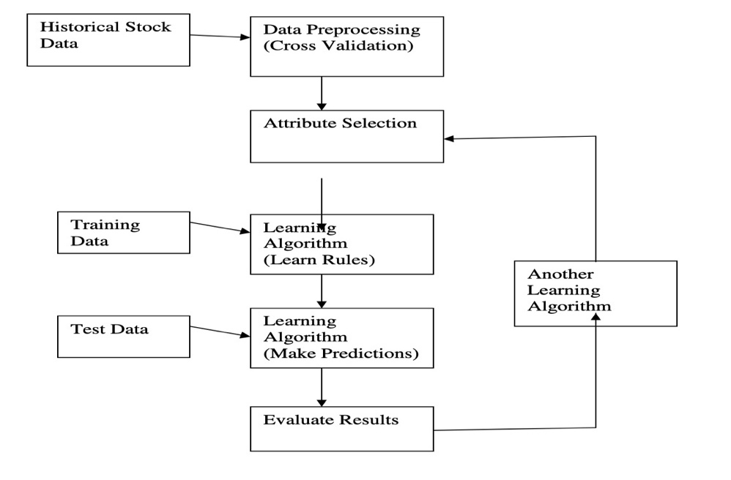

Figure 33 Historical Data & Training Data Set Learning Algorithm[69]

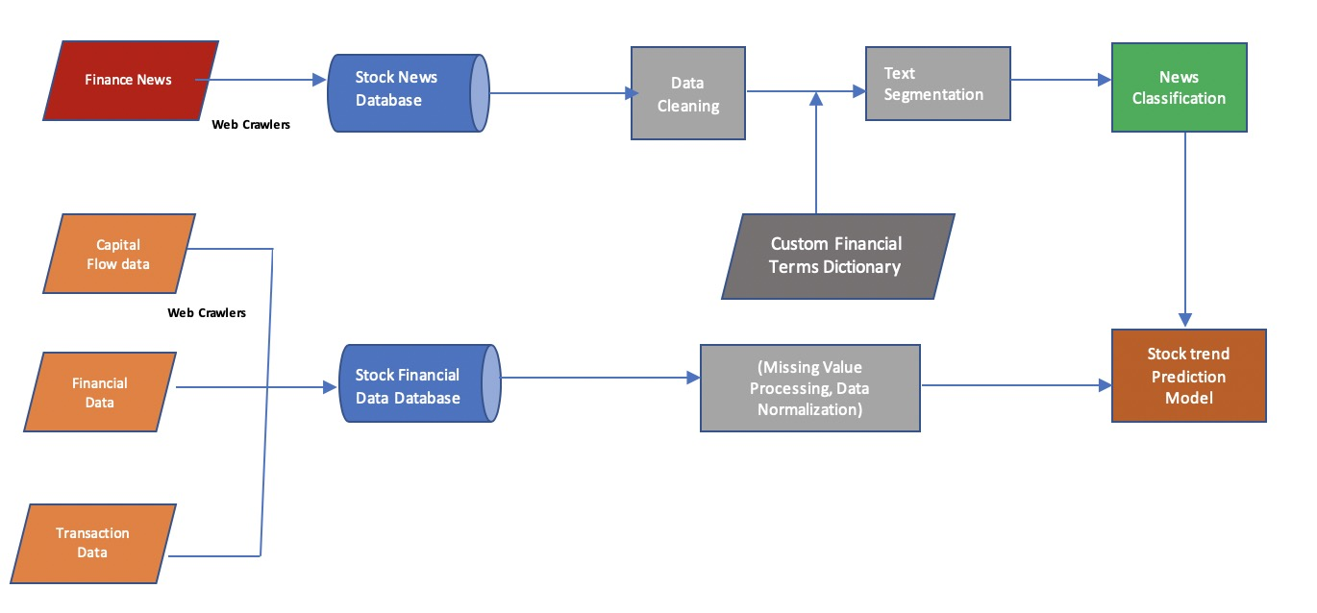

Figure 34 Stock Data Processing Pipeline

* 1. **Data Gathering:**
* **Stock indices:** As expected, several analysts forecast aggregate index market prices rather than estimate stock prices of specific firms. It represents the average shift of bond rates of benchmark indices.
* **Historical data**

1. **Historical stock fundamentals:** Historical fundamental data is actually very difficult to find (for free, at least). Although sites like [Quandl](https://www.quandl.com/) do have datasets available as paid service. Pre-process the historical price data
2. **Creating the training dataset:** Ultimate goal for the training data is to have a 'snapshot' of a particular stock's fundamentals at a particular time, and the corresponding subsequent annual performance of the stock. Thus, algorithm can learn how the fundamentals impact the annual change in the stock price.

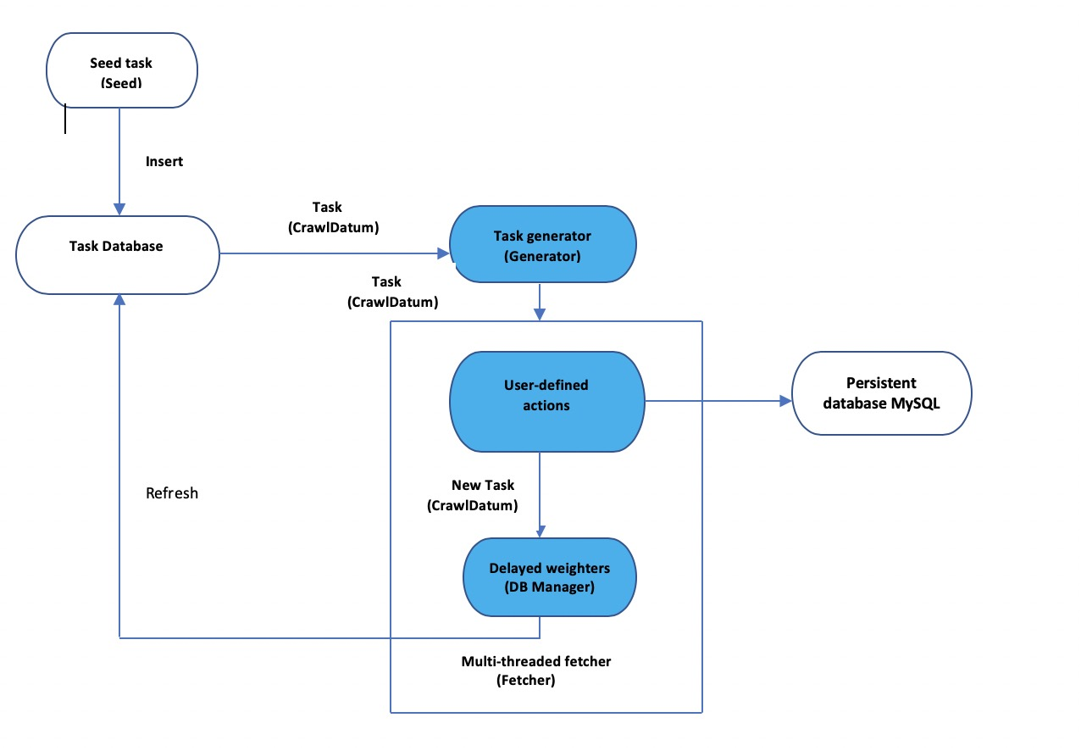

Figure 35 Web Crawler Diagram

* 1. **Data Processing:**
     1. **Article Filtering:**

Reports retrieved from the API news collection include data in the section-represented categories. Any pages include other types of papers unrelated to stocks, such as genetics, notes of origin, schedule etc. Consequently, these posts have been deleted from such websites.

* + 1. **Merge stock indices with articles:**
* The overall workflow to use machine learning to make stocks prediction is as follows:
* Acquire historical fundamental data – these are the features or predictors
* Acquire historical stock price data – this is will make up the dependent variable, or label
* Pre-process data
* Use a machine learning model to learn from the data
* Backtest the performance of the machine learning model
* Acquire current fundamental data
* Generate predictions from current fundamental data
  1. **Data Processing and Wrangling:** 
     1. **Data Collection:**

Tweets was derived from the twitter Database on Apple, Google, and AAPL. The public's view on the stock of the company and the views on the company's goods and services. Keywords are specifically crafted for filtering and tweets collected such that over a span of time they reflect the exact feeling of the public towards Microsoft. News of Microsoft and messages on Twitter will also be found in new updates.

* + 1. **Data Pre-Processing:**

The statistics obtained on equity markets was nonsensical as the economy does not operate during holidays. A basic method is implemented to estimate the missing details. Typically stock data follows a concave structure. If then, the inventory value is x on a day and the corresponding value is y, which is absent. The first missed value is approx. (y+x)/2 and all holes are filled by the same formula.

* + 1. **Data Clean-up:**

Tweets contain multiple acronyms, emoticons and redundant details such as images and URLs. Tweets are then prepared to reflect the best public emotions.

* **Tokenization:** Tweets are broken up and symbols are omitted such as emoticons, space and meaningful individual words will be used in future
* **Stop word Removal:** Terms such as a, is, and with etc. are then removed from the word list after breaking a message.
* **Regex Matching for special character Removal**
  1. **Sentiment Analysis:**

The role of sentiment analysis is quite unique to the field. Tweets focused on the present mood are graded as optimistic, negative and neutral. For Optimistic, 0 for Neutral and 2 for Harmful Feelings, tweets are annotated as 1. A machine learning algorithm is equipped for the interpretation of the annotated non-human messages, which is derived from human messages.

* + 1. **Feature Extraction:** Textual representations can be done using n-grams.

**N-gram Representation:**

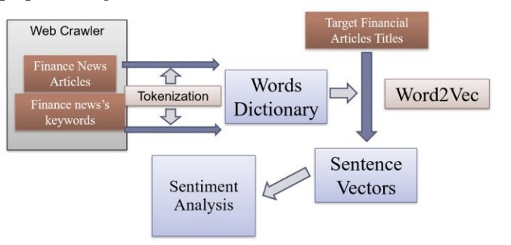

Figure 36 Sentiment Analysis Overview Diagram

* + 1. **Stock Trend Prediction**

LSTM is also used to build trend prediction model. Sentiment analysis results + stock data are input of LSTM Model [70]. After feature selection and sentiment analysis, we got stock data at day t and sentiment label at day t. Combine them as the input. Output is trend prediction result -1/0/1 representing negative/even/positive.

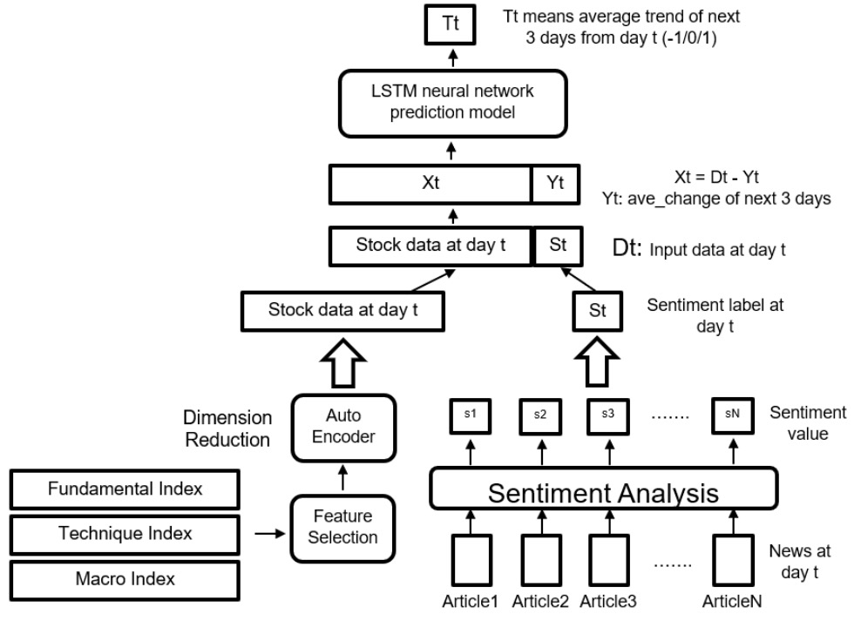

Figure 37 LSTM Model for Stock Index Processing with Sentiment Analysis[15]

* + 1. **Model Training:**

Features extracted by using the above methods for tweets are fed into the classification and trained to estimate the movement of market price change versus volume and feeling of news and tweets. Apply linear regression to find a correlation between market price shift vs volume as well as news and tweets feelings.

Tweets Collected Data (through API)

Data Pre-processing & Cleaning of Data

Classification of Tweets (positive, neutral, negative)

Feature Extraction

Model Training

Figure 38 Twitter Sentiment Analysis

* + 1. **Experimental Design Dataset:**

Tweets data and News articles from Bloomberg or any channel and Stock Information

* + 1. **Evaluation Measures**

1. Measure correlation between stock price movement and tweets
2. Mean Squared Error for Linear Regression Model
3. Loss function and accuracy percentage for Classification model
   1. **Data Processing System Design:**

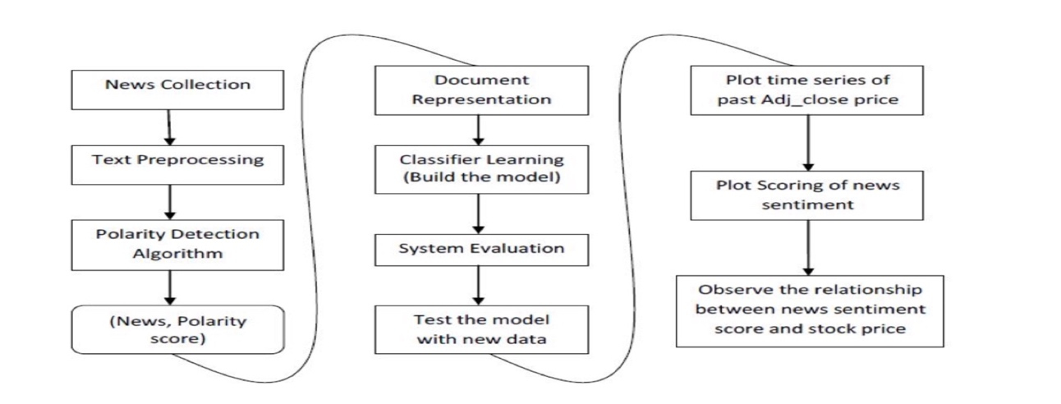

Figure 39 News Processing and Plot sentiment Scoring [13]

* + 1. **Data Sources** 
       1. **Historical Stock Prices Data**

The dataset contains following fields: Date, Open, High, Low, Close and Volume.

Historical data sets of stock prices can only obtain per day at the minimum from Yahoo Finance otherwise it would have to be streamed from directly from the NASDAQ website, which I did not have the access to. Ideally hourly stock prices would have worked by matching the time series with the Twitter feeds. Data sets of stock prices were collected from the Yahoo Finance website for all three companies. Each set had seven columns consisting of Date, Open, High, Low, Close, Volume and Adjusted Close.

* Date is the day of trading.
* Open is the opening price of the stock at the start of the day’s trading.
* High is the highest price of the stock form that day.
* Low is the lowest price of the stock from that day.
* Close is the closing price of the stock at the end of the day’s trading.
* Volume the number of shares traded that day.
* Adjusted Close is the after-trading hours price. The difference between the open and close price.

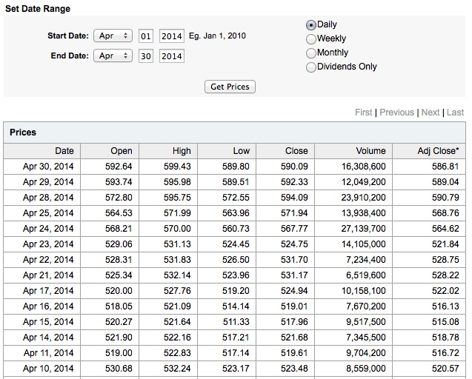

Figure 40 Sample Historical Data

* + - 1. **Twitter Data**
* Twitter data from Internet Archive collection of twitter stream.
* It contains the tweets in a nested structure as: Year → Month → Date → Hour → Minute.
* The dataset contains the fields as shown below: contributors, coordinates, created_at, delete, display_text_range, entities, extended_entities, extended_tweet, favorite_count, favorited, filter_level, geo, id, id_str, reply_count, retweet_count, retweeted, retweeted_status, source, text, timestamp_ms, truncated, user etc.,

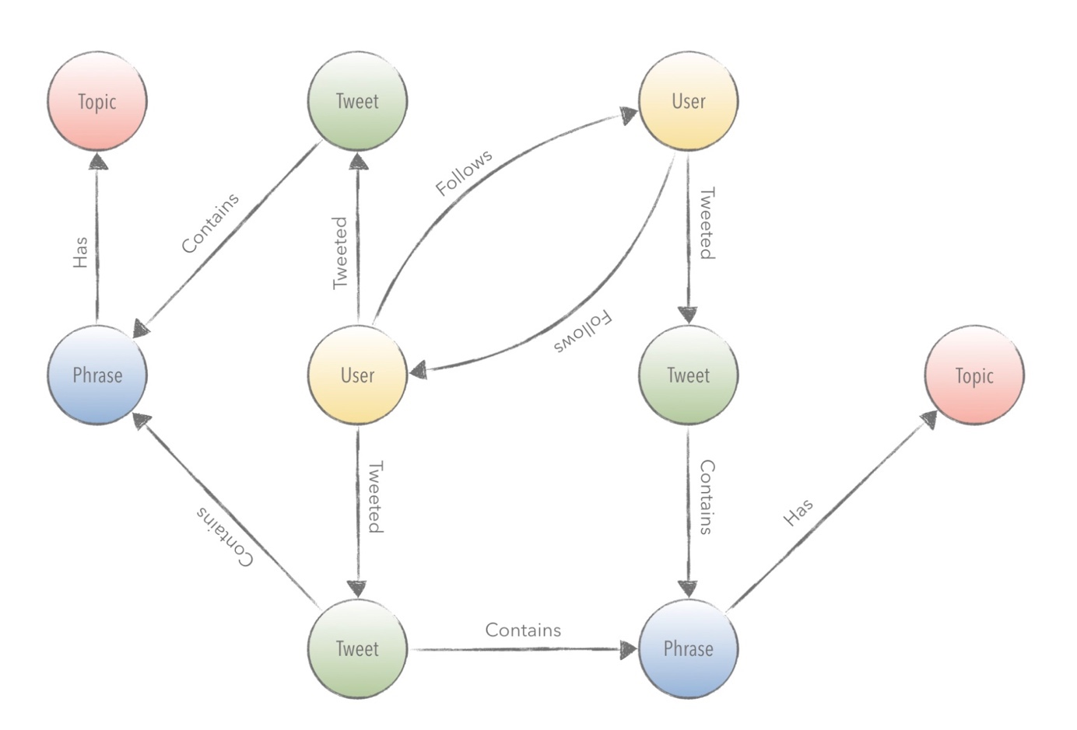

Figure 41 Sample Tweet Graph Model

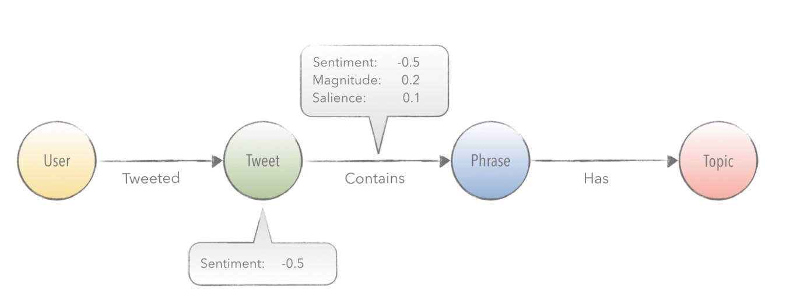

Figure 42 Twitter Use Case Overview

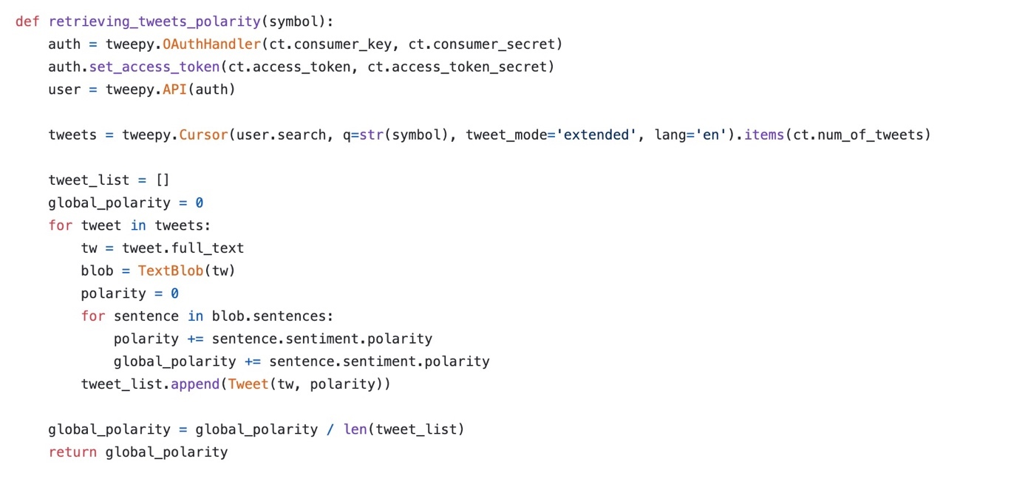

Figure 43 Sample Code to read tweet data

* + - 1. **News Data:**
* News Dataset from Kaggle News Category Dataset and Kaggle US Financial News Articles.
* Kaggle News Category Dataset contains approximately 200k news articles of various categories
* The fields in this dataset include date, authors, category, headline, short description and link.
* The news articles are from the following news publishers: Bloomberg.com, CNBC.com, reuters.com, wsj.com, fortune.com.
  + - 1. **Stock Data**

Generally, adjusted prices for stock market prediction are used because normal prices might have other influences such as stock splitting which may lead to a poorly performing model.

Historical data can be extracted by using investpy, which is mainly intended for historical data extraction.

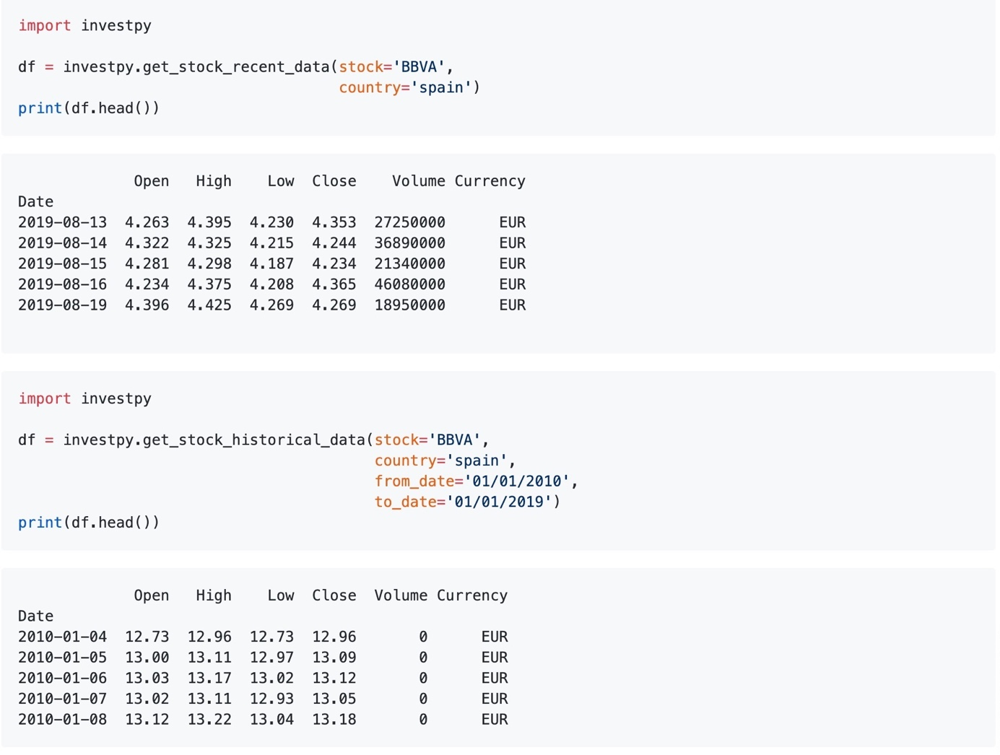

Figure 44 Investpy Historical Data

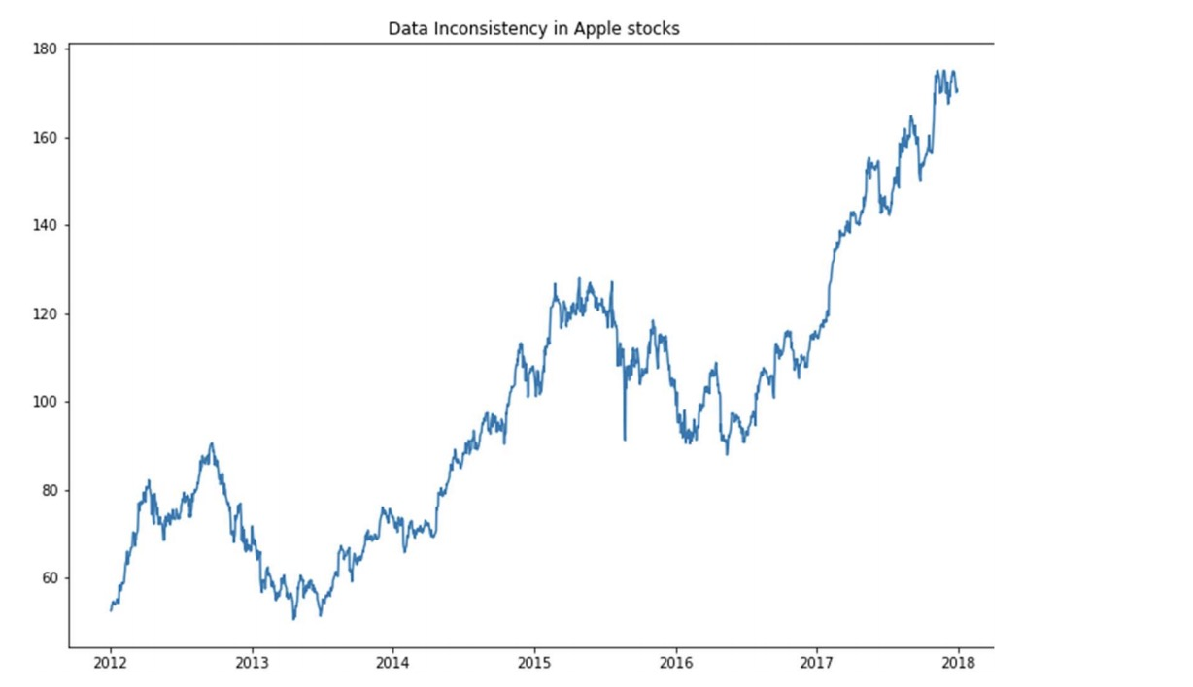

Figure 45 Apple Stock Yearly chart

* + - 1. **News Data (**Count of articles based on News Categories)

The Bar Chart below shows the count of articles by each category for the Kaggle News Category Dataset.

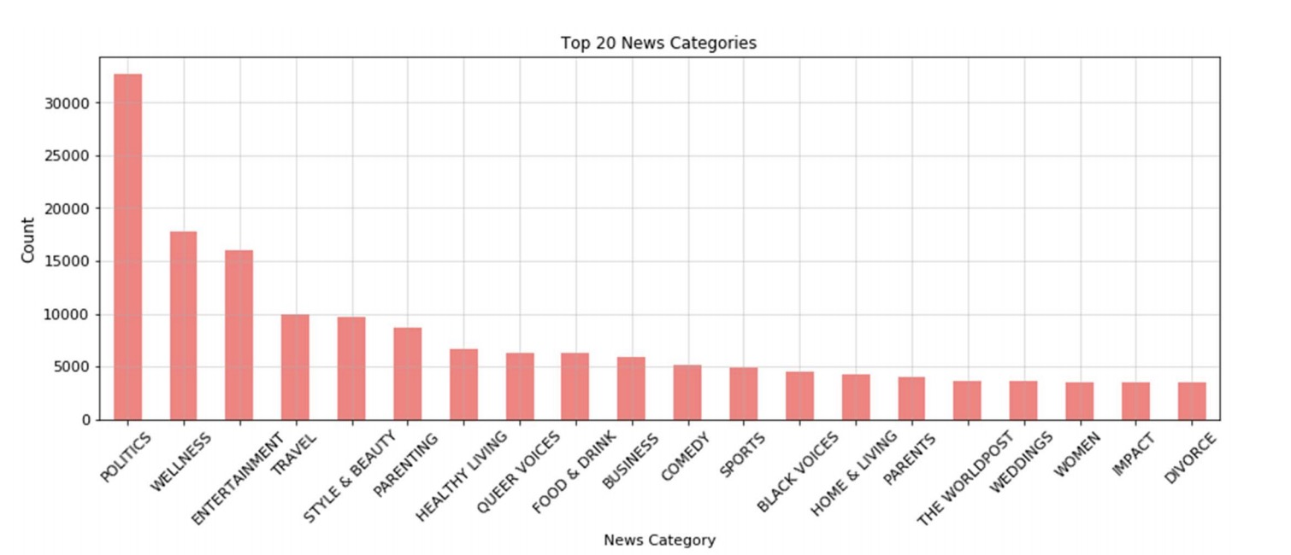

Figure 46 Top 20 News Catergories

* + 1. **Exploratory Data Analysis (EDA)**
       1. **Data Pre-Processing:**
* Text data is unstructured data.
* Tokenize the document into words to operate on word level, followed by removal of noisy words and numbers stop words and punctuation.
* Using polarity words dictionaries calculate the score of that document using general words with positive and negative polarity.
  + - 1. **Algorithm:**
* Tokenize the document into word vector.
* Prepare the dictionary which contains words with its polarity (positive or negative)
* Check against each word weather it matches with one of the words from positive word dictionary or negative words dictionary.
* Count number of words belongs to positive and negative polarity.
* Calculate Score of document = count (pos.matches) – count (neg.matches)
* If the Score is 0 or more, we consider the document is positive or else, negative.
  + - 1. **Twitter Data – Pre-Processing**
* Processed the twitter data to extract sentiments for stocks (for ex Apple and Facebook).
* **The data cleaning process is as follows:**
  + Remove unwanted fields, **Fields Used :** 'Date', 'screen_name', 'followers_count', 'text'.
  + Convert the timestamp (ms) in to Date and Time.
  + Replace the null values with 0 or empty string values so that the data can be processed further.
  + Clean tweets to remove unwanted texts, characters, symbols and emojis using regular expressions.
  + Filter tweets to retain only those tweets containing only words from APPLE_Word_List and joint_words and tweets not containing words in the APPLE_unwanted_list. This step ensures that we only get tweets that are related to Apple technologies and not apple the fruit.

APPLE_Word_List = ['apple','aapl', 'airpod', 'app store', 'earpods', 'homepod', 'imac', 'itablet', 'magic trackpad', 'magic mouse', 'iphone', 'ipad', 'ipod', 'macbook', 'ios','itunes', 'iwatch'] joint_words = ['steve jobs', 'tim cook']

APPLE_unwanted_list = ['fruit', 'cherries', 'berries', 'berry', 'food', 'pie', 'nutrition', 'pear', 'citrus', 'mango', grape', 'peach', 'apricot', 'mango', 'plum', 'avocado', 'ripe', 'melon', 'cherimoya', 'tropical', 'pineapple']

1. The tweets’ text was then passed to a function to extract the sentiments polarity (-1 to 1)
2. We then performed multiple aggregations by Date to generate the following features:
   1. Median_sentiment
   2. Count_tweet
   3. Avg_sentiment
   4. Sum_followers_count
   5. Max_followers_count
   6. Sum_favourite_count
   7. Sum_retweet_count
   8. Avg_weighted_sentiment
      1. Rather than using a plain average sentiment we put more weights on tweets with a higher follower count to put more importance on tweets that had a higher audience exposure.
      2. Sum_weighted_sentiment.
         1. **News Data – Pre-Processing:**

* Data clean-up process (as similar as above), identify the text and check for words in the word list and assign ‘AAPL’ for Apple related and ‘FB’ for Facebook related articles.
* Pass the body text into a function to extract sentiments.
* Retain only the relevant news articles i.e. ‘AAPL’ for Apple and ‘FB’ for Facebook
* Carry out aggregations by Date to generate useful features:

1. Median_sentiment b. Count_news c. Avg_sentiment d. Sum_company_frequency e. Max_company frequency f. Sum_weighted_sentiment g. Avg_weighted_sentiment The output data was then saved as csv files.
   * + 1. **Stock Data – Pre-Processing**

Since the data was already pre-filtered with important features, there was no need for any pre-processing. Both Apple and Facebook’s stock data was stored in separate .csv files.

**Sentiment Analysis :**

* sentiment analysis on our news data sets (Huffington Post, Wall Street Journal, Bloomberg, Reuters, CNBC) as well as the twitter dataset.
* sentiment polarity function is used to obtain a sentiment score by passing the whole body of a news article or the whole text of a tweet through TextBlob’s API. The resulting score lies within a range from –1 to +1 and has the following meaning:

|  |  |  |
| --- | --- | --- |
| **Score Range** | **Sentiment** | **Comment** |
| - 1 to 0 | negative | a lower score means a more negative sentiment |
| 0 | neutral | neither negative nor positive sentiment |
| 0 to 1 | positive | a higher score means a more positive sentiment |

Table 7 Sentiment Scores based on comment

* + 1. **Feature Engineering:** Three datasets with the following features as shown in the table:

Identify the feature which can be added to the list , by correlated with the closing prices, keep the feature list in the final vector if that correlates.

|  |  |  |
| --- | --- | --- |
| **Dataset** | **Number of Features** | **Features List** |
| News | 6 | date, authors, category, headline, short description and link. |
| Twitter | 37 | contributors, coordinates, created_at, delete, display_text_range, entities, extended_entities, extended_tweet, favorite_count, favorited, filter_level, geo, id, id_str, in_reply_to_screen_name, in_reply_to_status_id, in_reply_to_status_id_str, in_reply_to_user_id, in_reply_to_user_id_str, is_quote_status, lang, place, possibly_sensitive, quote_count, quoted_status, quoted_status_id, quoted_status_id_str, quoted_status_permalink, etc |
| Stock | 5 | Open, High, Low, Close, Volume |

Table 8 Feature Engineering with Number of features

* + 1. **Correlation Analysis**
       1. **Historic Stock Data**

1. **VWAP (Volume Weighted Average Price):** Calculated by adding up the dollars traded for every transaction (price multiplied by the number of shares traded) and dividing by the total shares traded.

VWAP = Σ Price x Volume / Σ Volume

1. **DOW (Day of Week):** The last trading day of week may have certain behavior that is specific to that particular day.
2. **US/CAD Exchange Rate :** Since NASDAQ listed company stocks showed positive correlation between US dollar price and closing price.
3. **Running Difference** : Running difference is simply high price of a stock on a date minus the lowest price of that stock on that day. This feature captures the variation of price per day.

|  |  |  |
| --- | --- | --- |
| **Spearson’s correlation with Close Price** | **Correlation score** | **Correlation meaning / direction** |
| DOW (Day of Week) | -0.001226 | very weak - negative |
| High | 0.999722 | very strong - positive |
| Low | 0.999744 | very strong - positive |
| Open | 0.999425 | very strong - positive |
| Volume | 0.204484 | weak - positive |
| Running Difference | 0.343693 | weak - positive |
| US/CAD exchange rate | 0.720408 | strong - positive |
| VWAP(Volume Weighted Average Price) | 0.856878 | very strong - positive |

Table 9 Spearson’s correlation for Historic Stock Data

* + - 1. **News Data**

1. **Count News** : count of the number of news for a company (AAPL) grouped by date.
2. **Avg_Sentiment:** Average of the body sentiments for 1 company (AAPL) grouped by day.

|  |  |  |
| --- | --- | --- |
| **Spearson’s correlation (Close Price)** | **Correlation score** | **Correlation meaning** |
| news_avg_sentiment | -0.003421 | very weak - negative |
| count_news | -0.199476 | very weak - negative |

Table 10 Spearson’s correlation for News Data

* + - 1. **Twitter Data**

1. **Tweet_Count :** Count of the number of tweets for 1 company grouped by date.
2. **Tweet_Avg_Sentiment :** Average sentiment of tweets for AAPL grouped by date.

|  |  |  |
| --- | --- | --- |
| **Spearson’s correlation (Close Price)** | **Correlation score** | **Correlation meaning** |
| tweet_count | -0.424871 | moderate - negative |
| twitter_avg_sentiment | -0.086189 | very weak - negative |

Table 11 Spearson’s correlation for Twitter Data

Finally, the following fields as features are used for the model: Using the above features, we predict the Closing Stock Price.

|  |  |  |
| --- | --- | --- |
| **Dataset** | **Number of Features** | **Features** |
| News | 2 | news_avg_sentiment', 'count_news'. |
| Twitter | 3 | 'tweet_count', 'twitter_sum_followers_count', 'twitter_avg_sentiment'. |
| Stock | 9 | 'DOW', 'Date', 'High', 'Low', 'Open', 'Running Difference', 'US/CAD', 'VWAP', 'Volume'. |

Table 12 Dataset with Features Details

* + - 1. **Classifier Learning:**

Hybrid models which comprises of various text classification and text summarization methodologies using NB Classifier, Random Forrest which helps in improving accuracy in text classification and text summarization. The factors like accuracy, precision, recall and other model evaluation methods are used to analyse to identify the best possible text classification and text summarization.

* + - 1. **Graph Analysis**

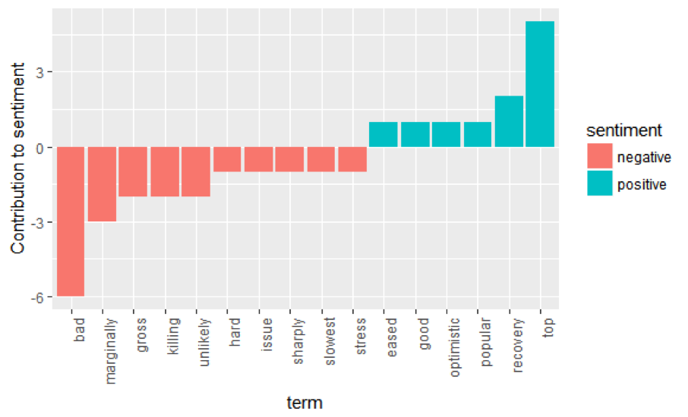

Figure 47 Graph Analysis of sentiments

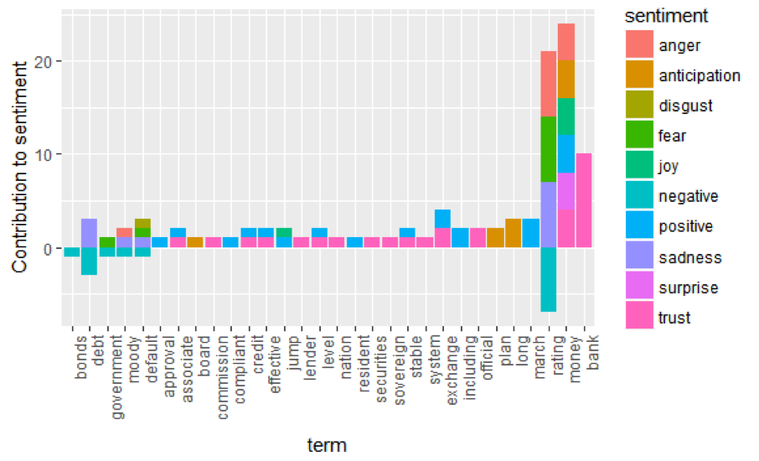

Figure 48 Sentiment Classification and subjective measure

|  |  |
| --- | --- |
| 2 | 1 |

Figure 49 Polarity Analysis

# Models and Strategies

For each of the subsequent sections there are two subsections each for the two projects we aim to document, namely

* Kaggle-NYS-Estock-prediction
* Research Paper Implementation: Baek and Ha Young Kim.

# Data

* The financial data is an indicator of business performance and the efficiency of strategies/tactics applied in the business.
* It consists of sets of information related to the financial status of a business such as the price of shares of the company.
* “New York Stock Exchange” kaggle dataset which consists of historical prices and fundamental data about the S& P 500 companies.

**Contents:**

**prices.csv:** original, unaltered daily prices.

**prices-split-adjusted.csv:** same as prices with added adjustment for stock splits.

**securities.csv:** general information about each company with division on its sectors

**fundamentals.csv:** metrics extracted from annual SEC 10K filings (2012- 2016).

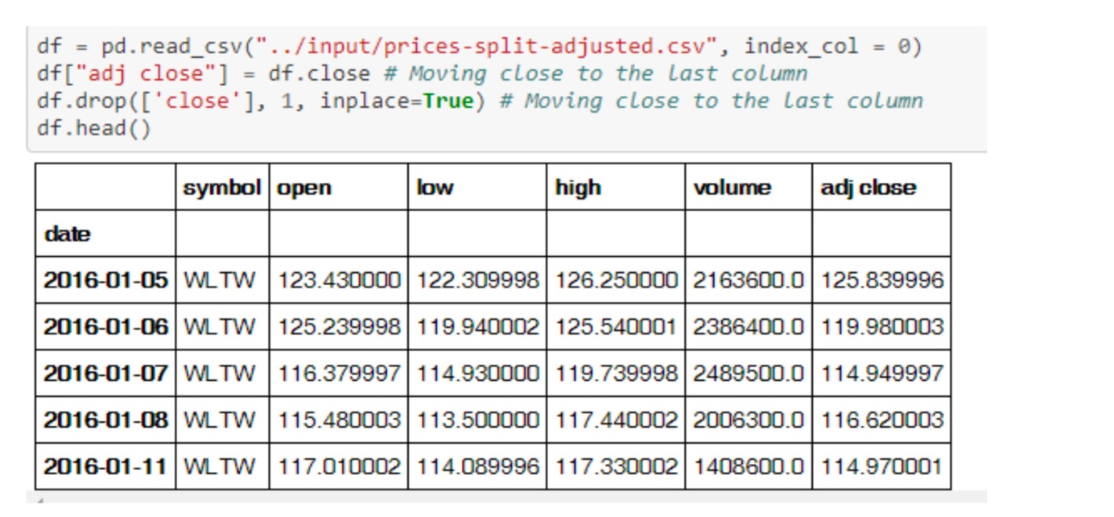

Figure 50 Price Adjusted Dataframe

# The SingleNet model:

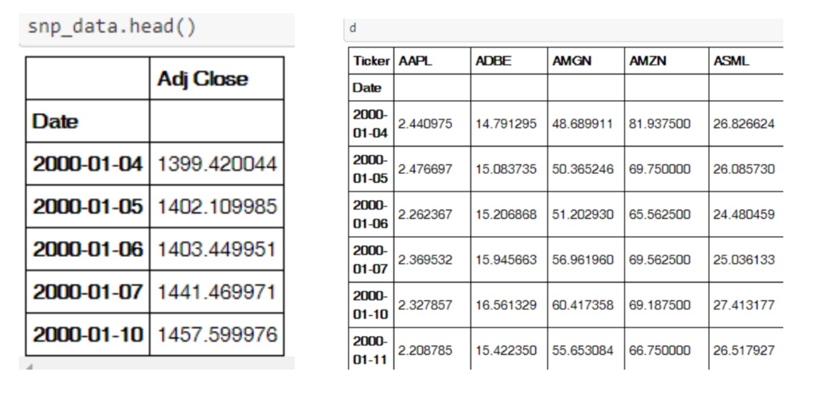

Figure 51SingleNet Data Model Smple Output

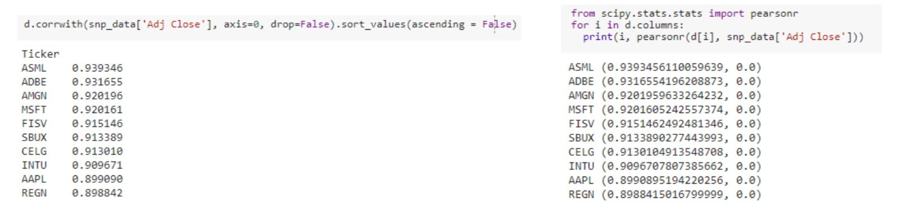

Figure 52 Correlation Index Output

Uses only the historical closing prices of S& P index. The closing prices of these companies are all highly correlated with the S& P500 stock market index. greater than 0.8 were selected (under 5 percent significance level and all p-values less than 0.05).

# Model Architecture

* After normalization the data is divided into consecutive windows of 22 days and the total data is then split between train and test sets by allocating 90% to the train and 10% to test data.
* The training data is further split 10:90 to give 10% validation data and the remaining 90 for training.
* The model consists of two LSTM layers with 256 units each with the first layer returning outputs at each time step (return_sequence = True) and the second returning only the final output (return_sequence = False). Other parameters used with the model include Batch size, Epochs, Dropout rate, Validation split, Optimizer, Loss (Mean Square Error Metrics). Here X is the original value at data point, Xmax is minimum value of the feature (closing price) that X belongs to and Xmin is the minimum of that feature correspondingly. Consequently, every feature (closing price) can be translated in the range [0,1]. The normalized data is then fed into a model. The paper specifies three models with following configurations:



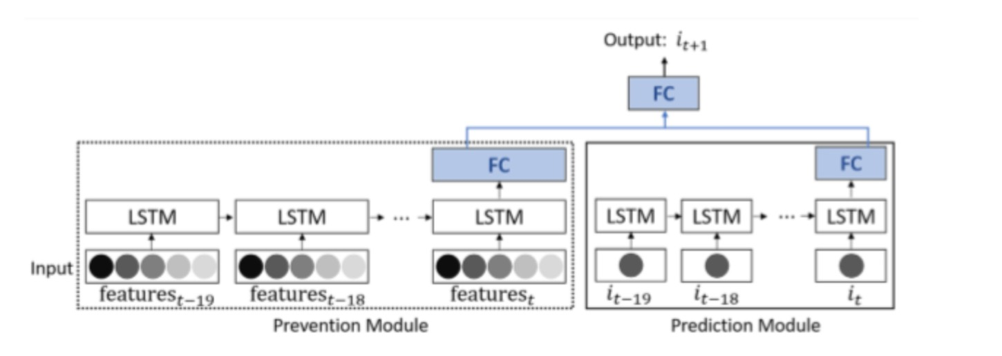

Figure 53 LSTM Prevention. And Prediction Module Diagram

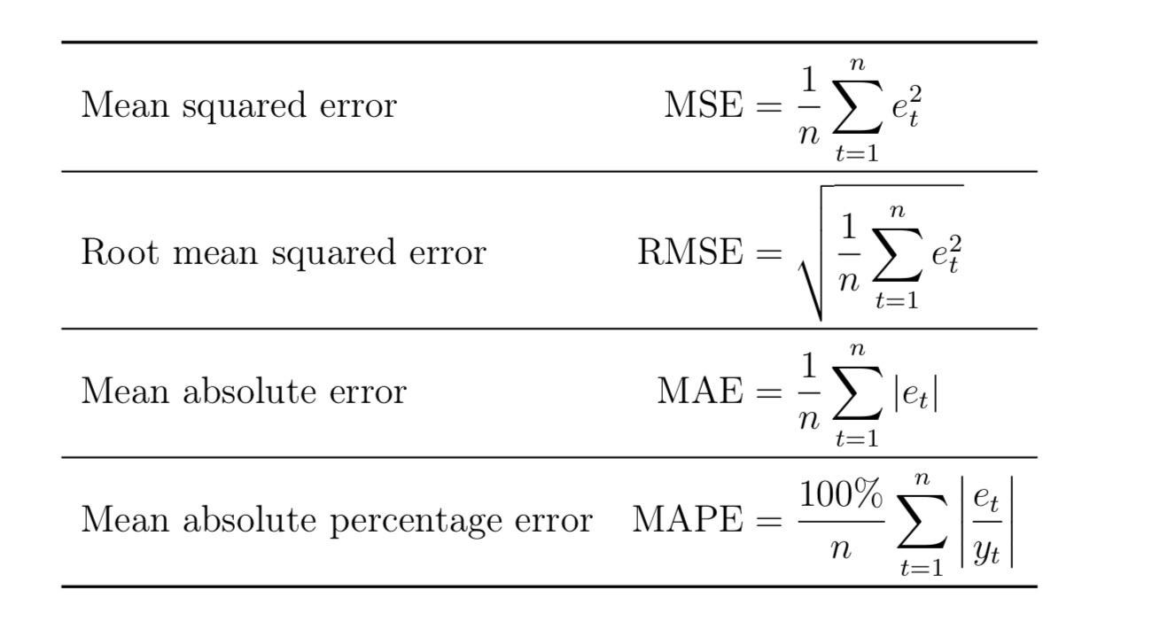

Figure 54 MSE, RMSE, MAE, MAPE Formulas

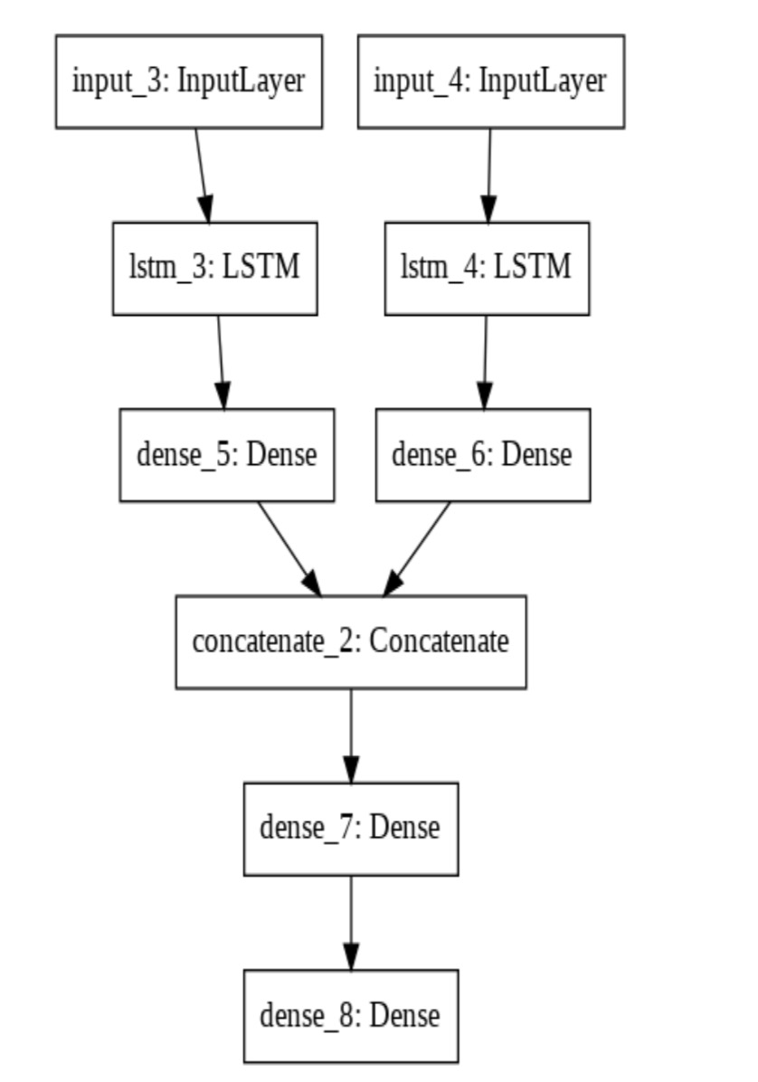

Figure 55 LSTM Model for Dense Processing

# Software Tools

Below list of software libraries are tools used as part of this thesis are.

|  |  |  |
| --- | --- | --- |
| S.No | Library | Description |
| 1 | Keras | Open Source Neural Network library on top of Theano or Tensorflow.  Keras is high-level API wrapper for the low-level API, capable of running on top of TensorFlow, CNTK, or Theano.  Keras High-Level API handles the way we make models, defining layers, or set up multiple input-output models. |
| 2 | TensorFlow | It’s a deep learning library. Tensorflow library incorporates different API to built at scale deep learning architecture like CNN or RNN. TensorFlow is based on graph computation |
| 3 | Python |  |
| 4 | Twitter API |  |
| 5 | Investpy API | To extract historical stock data |
| 6 | Quandl API | For downloading historical stock prices |
| 7 | NLTK | NLTK is a leading platform for building Python programs to work with human language data. It provides easy-to-use interfaces along with lexical resources such as WordNet, along with a suite of text processing libraries for classification, tokenization, stemming, tagging, parsing, and semantic reasoning, wrappers for industrial-strength NLP libraries. |

# Implementation Details:

# LSTM Network for Sentiment Analysis:

1. LSTM networks are proven to be effective for NLP applications for text data processing (Sundermeyer et Al., 2012)[71] and machine translation (Cho et Al., 2014)[72].
2. News data are always text based rather than numerical
3. Convolution layer has to be applied in order to make the decision whether the processed data will impact stock price positively or negatively based on Polarity and Subjectivity of the particular texts
4. Neural network that outputs a fully connected layer with a sigmoid or SoftMax activation function.
5. Usually the data is in textual form, hence splitting the text into split words is the first step to be done.
6. Comparing against pre-defined dictionary of lexicon to identify the words as positive, negative or neutral
7. Since here it’s all about text, hence LSTM input will be sentence vectors.
   1. Split data into several parts per company.
   2. Put them into LSTM layer.
   3. Add a dense layer.
   4. Output layer will output sentiment analysis result, value range from 0.0~1.0.
   5. Then a 4-quantile value is used. If value < value <= 75%quantile as 0(even); value > 75%quantile as 1(positive).
8. Polarity score (from sentiment analysis) will be added as new column in the data frame for further reference during processing.
9. Polarity score will be considered as part of feature while making LSTM processing.

|  |  |  |  |  |  |
| --- | --- | --- | --- | --- | --- |
| **Date** | **High** | **Low** | **Close** | **Volume** | **Polarity** |
| 14-0 | 226.4 | 222.8 | 223.09 | 32226700 | 0 |
| 15 | 220.7 | 217.09 | 218.75 | 39763300 | 0.0166 |
| 16 | 220.1 | 217.56 | 217.78 | 21154324 | 0 |
| 17 | 220.82 | 219.43 | 220.7 | 18443215 | -0.1665 |

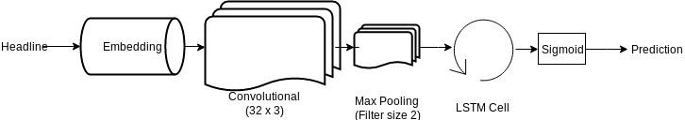

Figure 56 LSTM Network model for prediction [73]

# LSTM Network Input Processing :

1. First step is to pre-process the news data, thus removing all non-alphabetical characters
2. Construct the split vector.
3. This input data will be used for further text processing to find polarity and subjectivity of text.
4. Training

* 80% of the dataset would be used for training
* 20% of the dataset would be used for testing.

# LSTM Sentiment Analysis Implementation Algorithm:

* Training and Testing data segregation (80%-20% respectively)
* Data Normalization by applicating scalar co-efficients.
* Identifying the hidden layers of LSTM (along with loss function and hyper-parameters)
* Construct LSTM network by combining all LSTM functions and hidden layers together
* Apply prediction methodology against LSTM out to obtain the final output.

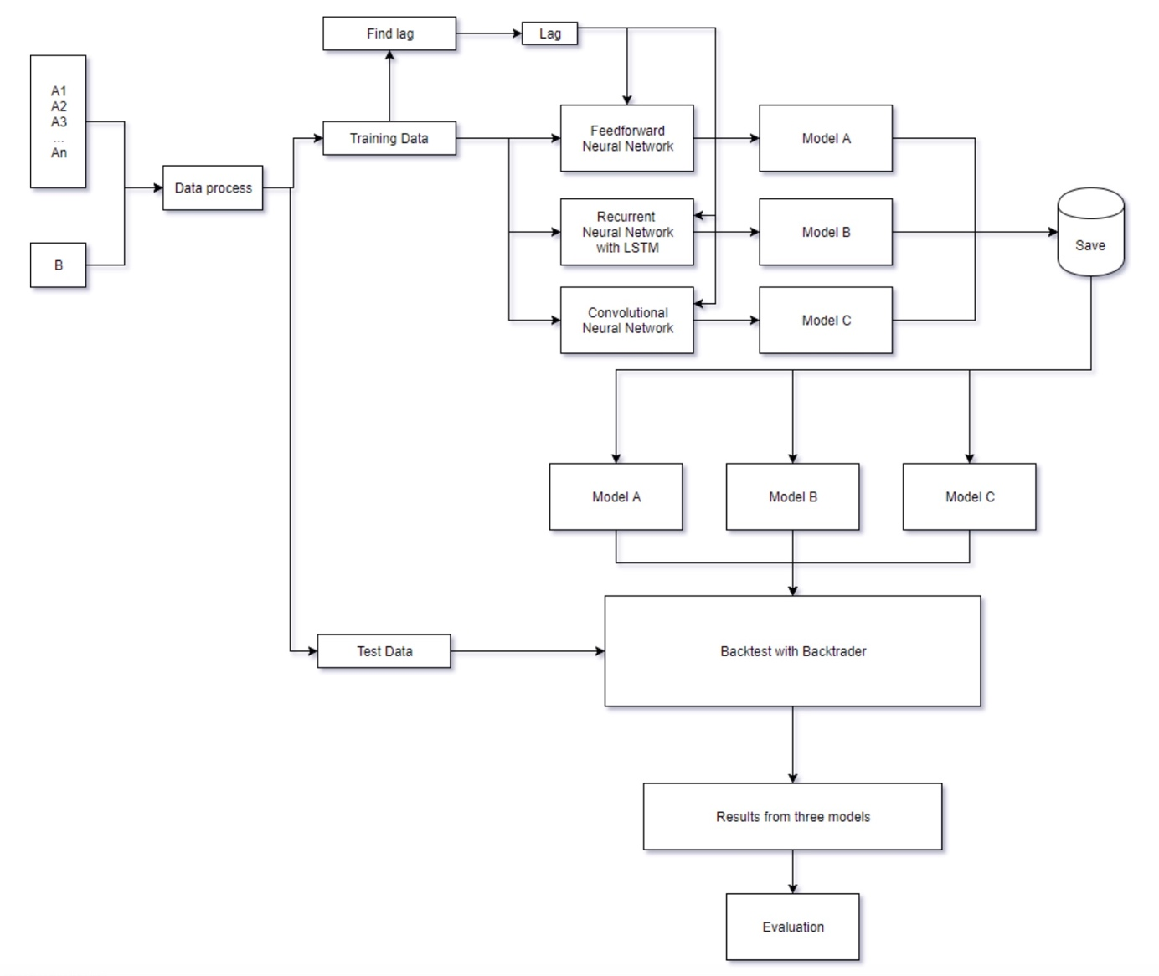

Figure 57 LSTM Network Data Processing with Backtest

# End to End Use Case Diagram:

A typical workflow for this project is represented with following use case diagram.

The user now has ability to visualize stock predictions using pre-trained neural network models. The visualization for predicted prices could help a buyer to perform Buy or Sell on a stock under consideration.

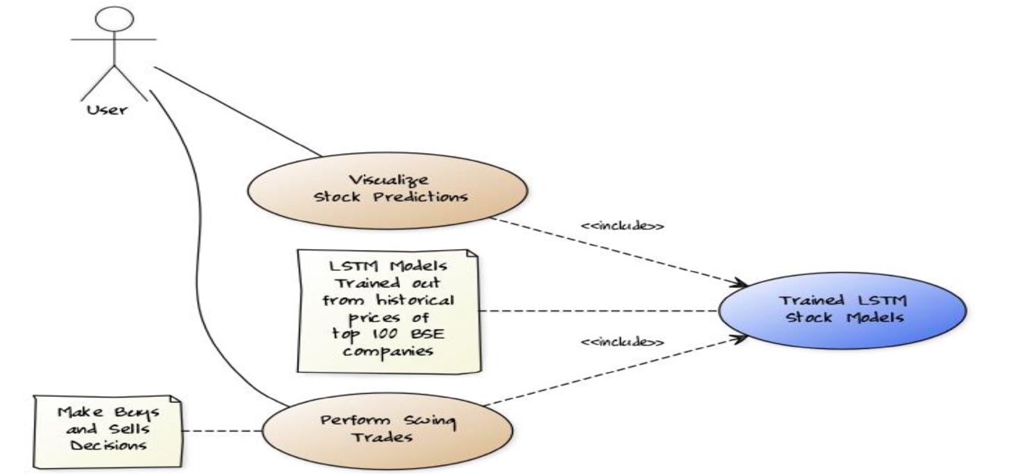

Figure 58 Use Case Diagram

# Dataset Preparation:

The dataset that will be used to train the neural network would be the historical stock values of a company’s share. The historical values would be ranging from 5 years to 10 years of data. The data would be available freely from website like: <https://in.investing.com>; <https://www.quandl.com>.

The dataset in figure 5 has lot many columns in it, however for the training purpose, only ’Date’ and ‘Close’ Price columns will be taken into considerations.

The dataset will be split into two parts – training data (80%) testing data (20%). Since we will pass on this data to the LSTM neural network, we would have to preprocess the data set in such a way such that LSTM can tell for given say past N days stock price the next day’s value was XX.

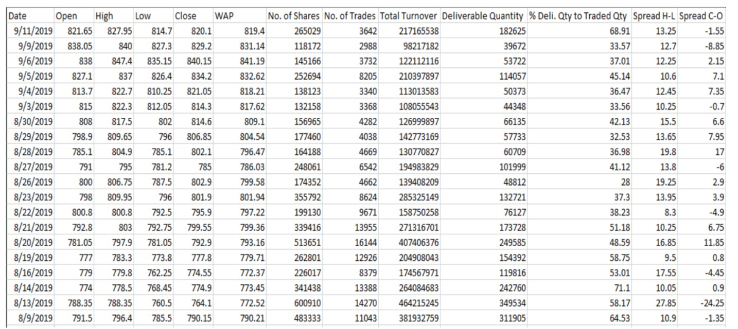

Figure 59 Sample Historical Stock Data

# Downloading the stock data from quandl.com:

Python’s qunadl API are used to fetch the data for given stock. Data fetched once, is then saved in a csv format that will be utilized for training and testing dataset preparations. Only the ‘Date’ and ‘Close’ column is taken into consideration while parsing the data.

# Pre-processing the data:

The data once downloaded from quandl API, will be preprocessed to select the desired columns and discard the unused data.

# LSTM Data Preparation

Before making LSTM fit, data has to be pre-processed in below mentioned steps

* The approach is to apply supervised learning problem for the given dataset, in-order to do that, first step is to transform the time series data.
* Since time series data is always stationary and has trends, transformation of time series data is very much critical pre-processing step.
* Second step is to transform the observations from previous steps to specific scale.

# Transformation Process:

* Use the observation from the last time step (t-1) as the input.
* Use the observation at the current time step (t) as the output.
* Using library functions from Pandas (like Shift () ) to push the values from one position to another position.
* Using the approach of differencing the data, trend in the time series can be removed. Using Pandas library function (like Diff()), the difference from the previous observation and current observation will be found, which results in difference series (without trend data).
* Using LSTM activation function (like hyperbolic tangent (tanh)), scaling on the output value will be applied, which makes outputs values between -1 and 1.
* Applying scaling coefficients ( like min and max) on the training dataset and applied to scale the test dataset and any forecasts.

# Normalizing the Stock Data:

For getting better accuracy and allowing the neural network to converge easily, the stock prices will be first normalized before it can be prepared for training (Normalize the close price between [0, 1])

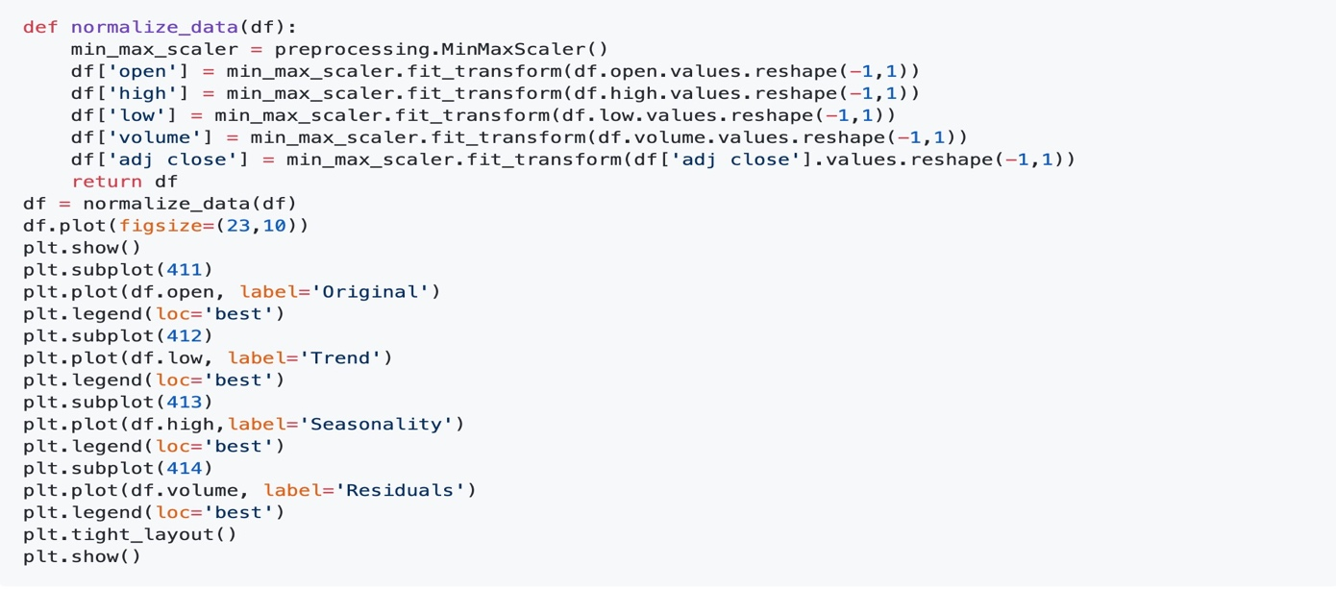

Figure 60 Data Normalization Code

# Training Set and Testing Set

* For feeding the data to the neural network, the stock data needs to be reshaped.
* For each 5 previous stock prices we would train for the 6th Stock Price

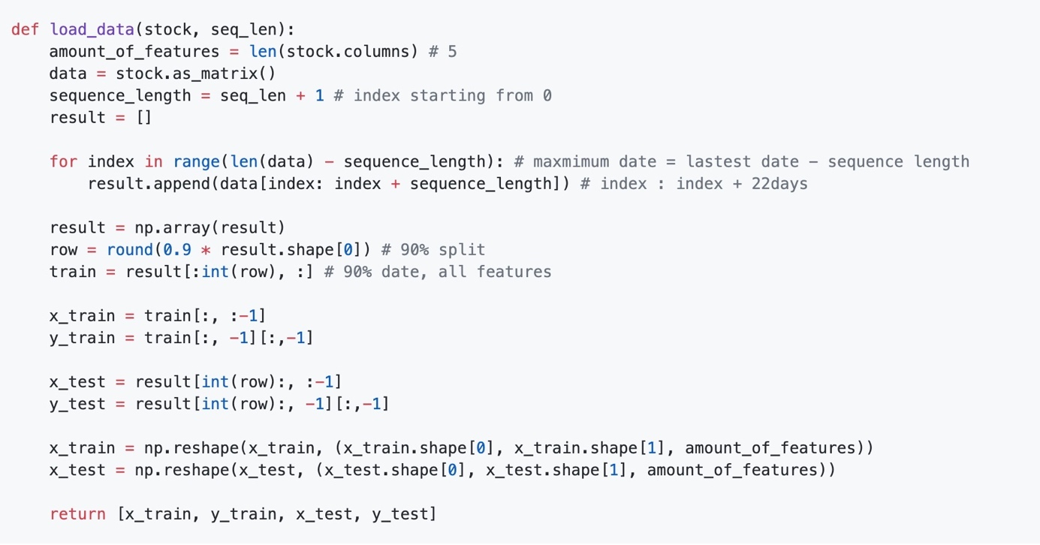

Figure 61 Training and Testing Dataset

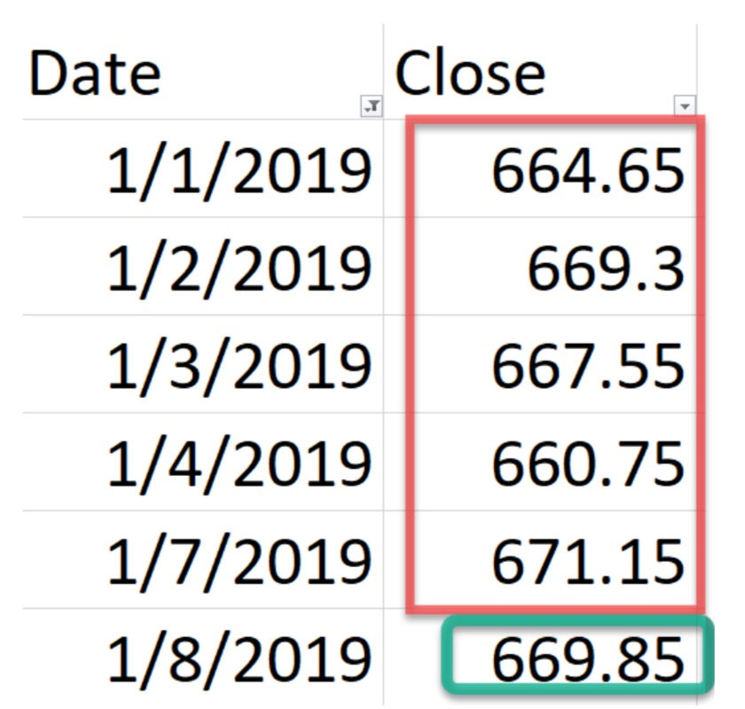

Figure 62 Stock Closing price for week data

# UML Diagram

Following UML represent the entire design of the application.

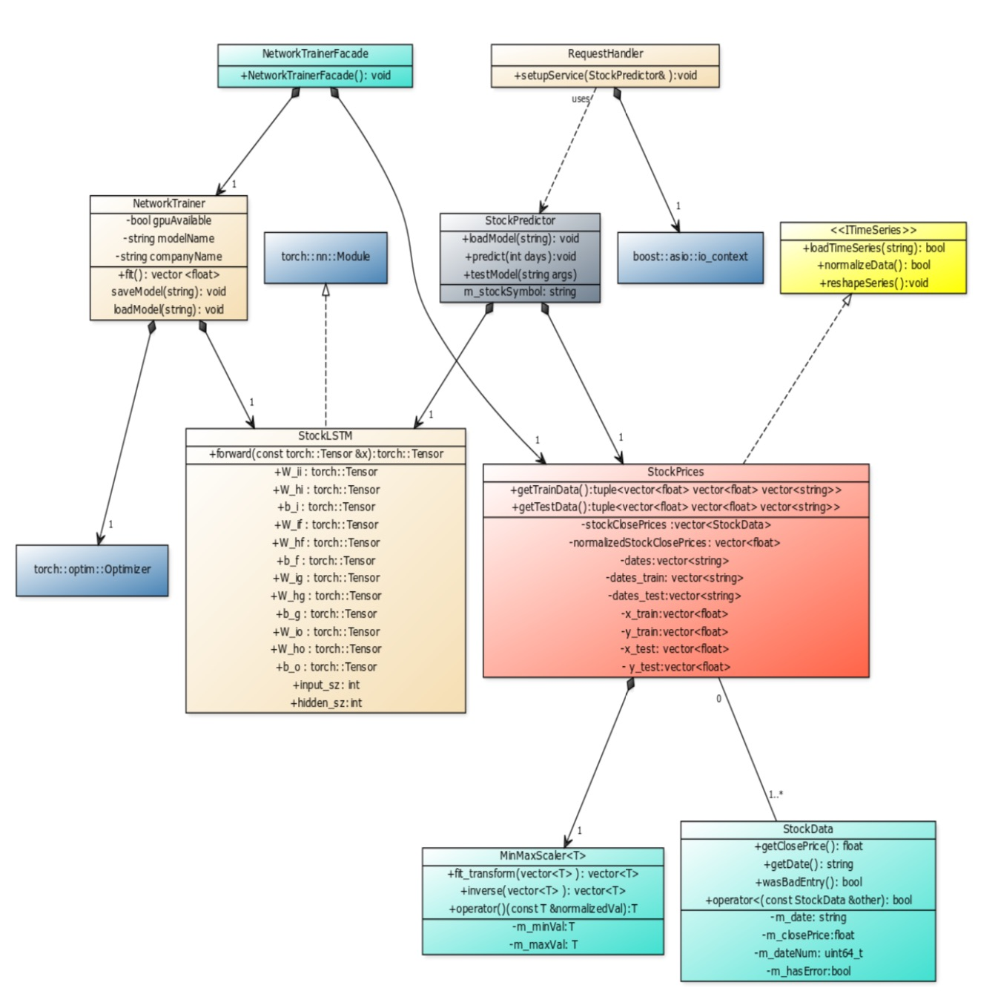

Figure 63 UML Diagram

# Neural Network Creation

There are several neural network libraries which provide built in support for LSTM neural network, using one of the widely used open source library. is a nice open source library widely used in research areas.

**LSTM Design Network Architecture visualizing using MATLAB**

layers = [

sequenceInputLayer(1,"Name","Input Sequence")

lstmLayer(32,"Name","StockLSTM")

dropoutLayer(0.1,"Name","dropout_1")

lstmLayer(32,"Name","lstm")

dropoutLayer(0.2,"Name","dropout_2")];

Number of layers: 5

Number of connections: 4

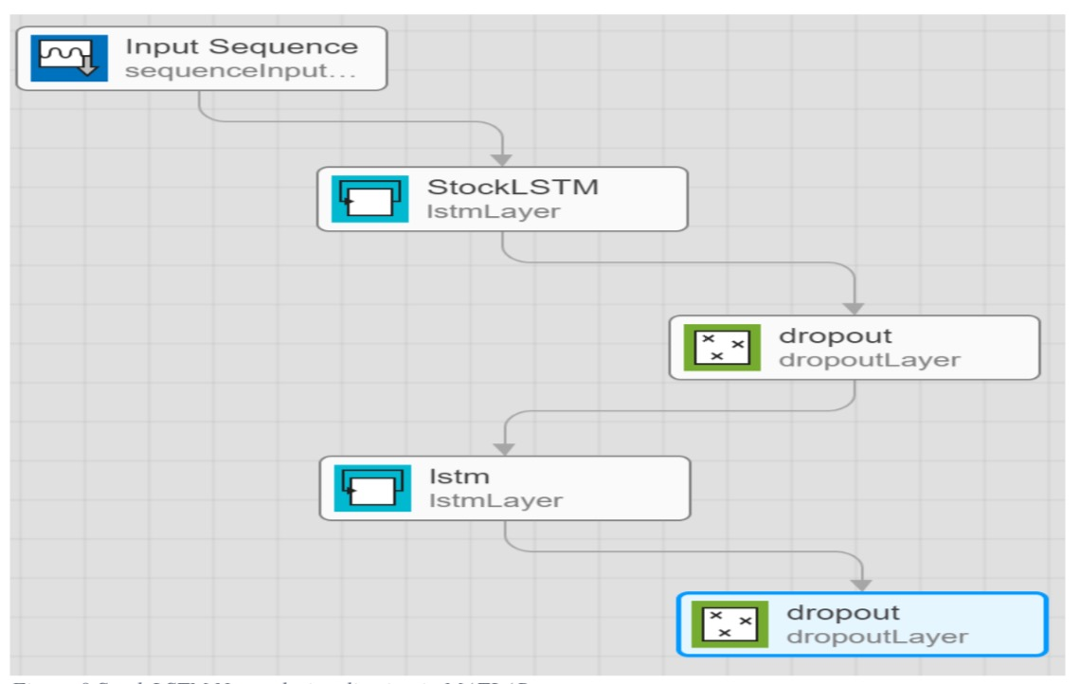

Figure 64 LSTM Model creation

# The Stock Price Neural Network Design:

Incorporating the LSTM Neural Network created above, another neural network wrapper is created which would be finally used for training on stock prices. The LSTM stacking is represented as follows, which includes a Dropout layer followed by a Linear Layer.

A feed forward pass to this neural network would proceed as follows:

1. Input tensor is of size (previousSamples, totalBatch, 1) and is feedforward to LSTM Layer -1 (All states here are initialized to 0).
2. Output of Layer-1 is feedforward to LSTM Layer -2 with the states captures.
3. Adjust the output tensor which is (totalBatch, 1) and make it to (totalBatch) and feedforward to the Drop Out Layer with probability of 20 %
4. The final output of dropout layer is feedforward on Linear Layer.
5. Linear Layer’s output the final output for one epoch, the size is the (totalBatch)

# LSTM Network Model (with Hidden Layers)

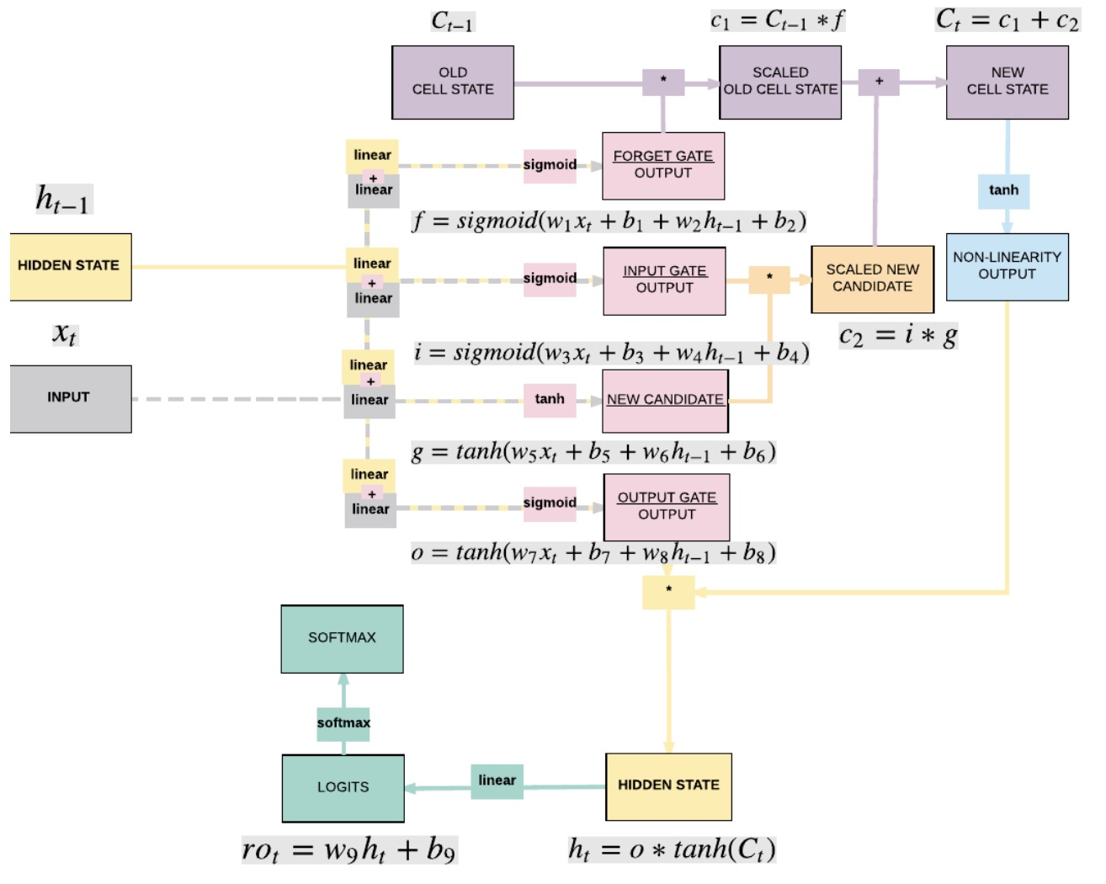

Figure 65 LSTM with Hidden Layer Diagram [74]

# LSTM Network Model Implementation Considerations:

After successful Data-Preprocossing , LSTM model has to be created along with Loss and Optimizer class as shown in below figures.

1. Create Model Class
2. **Instantiate Model Class**
3. Instantiate Loss Class
4. Long Short-Term Memory Neural Network: **Cross Entropy Loss**

* *Recurrent Neural Network*: **Cross Entropy Loss**
* *Convolutional Neural Network*: **Cross Entropy Loss**
* *Feedforward Neural Network*: **Cross Entropy Loss**
* *Logistic Regression*: **Cross Entropy Loss**
* *Linear Regression*: **MSE**

1. Instantiate Optimizer Class

* Simplified equation
  + θ=θ−η⋅∇θθ=θ−η⋅∇θ
    - θθ: parameters (our variables)
    - ηη: learning rate (how fast we want to learn)
    - ∇θ∇θ: parameters' gradients
* Even simplier equation
  + parameters = parameters - learning_rate * parameters_gradients

# LSTM Network Model Training Process:

Training the neural network would be done with some constraints. The training pass will be stopped when either of the following criteria is met.

* A maximum number of epochs is exhausted.
* A minimum required loss is achieved, and network did not converge.
* A maximum threshold time is elapsed, and network did not converge.

1. **Convert inputs/labels to variables :** LSTM Network which is of input size [1, 28]
2. Identify if there is any gradient buffets, if so clear them.
3. Process input and generate output for the same input.
4. Calculate the loss using Loss Model
5. Identify the gradient using hyper-parameters which are configured while creating model.
6. Gradient will be getting updated (repeatedly) using the given hyper parameters.
   * “parameters = parameters - learning_rate * parameters_gradients”[77]
7. Re-iterate the process again and again.

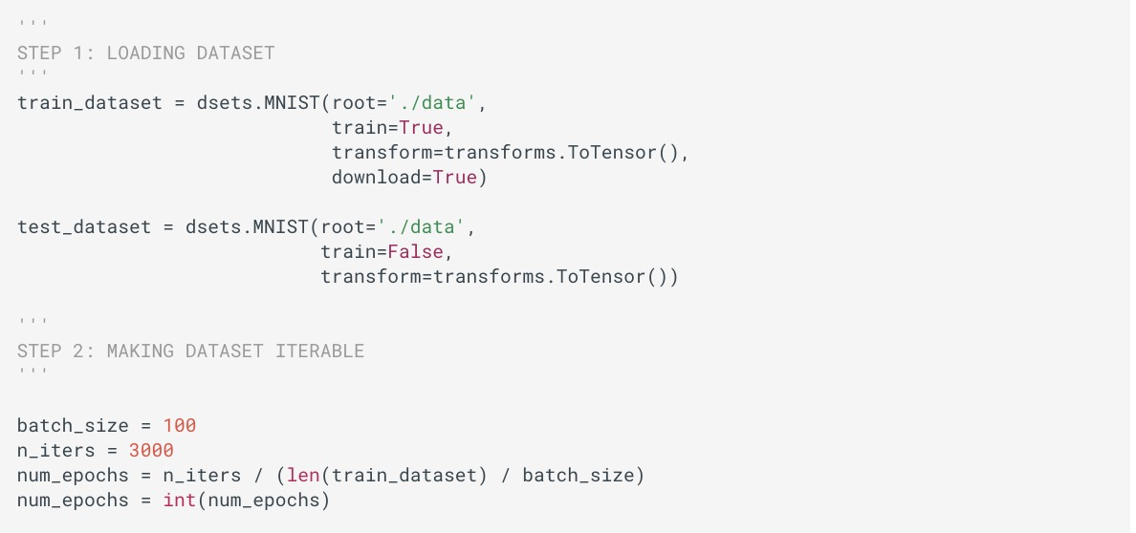

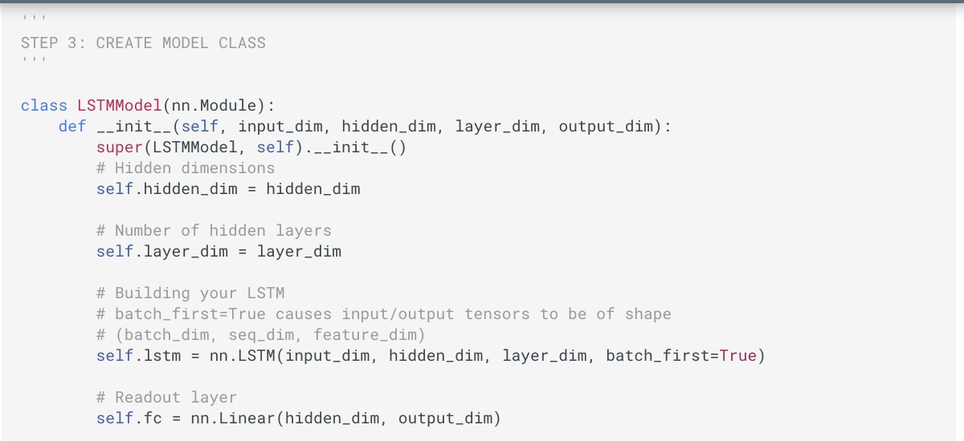

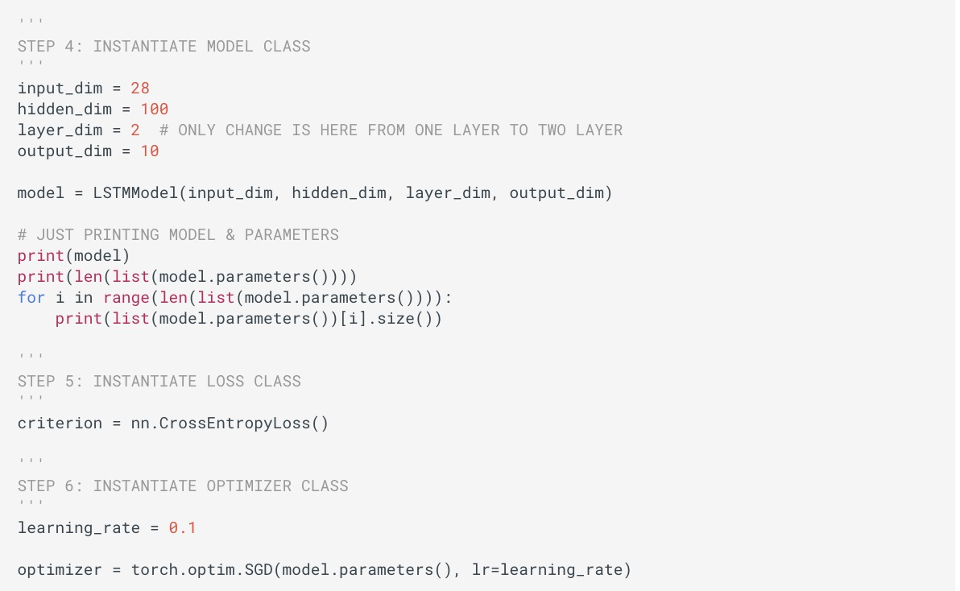

Figure 66 LSTM Model Creation Code

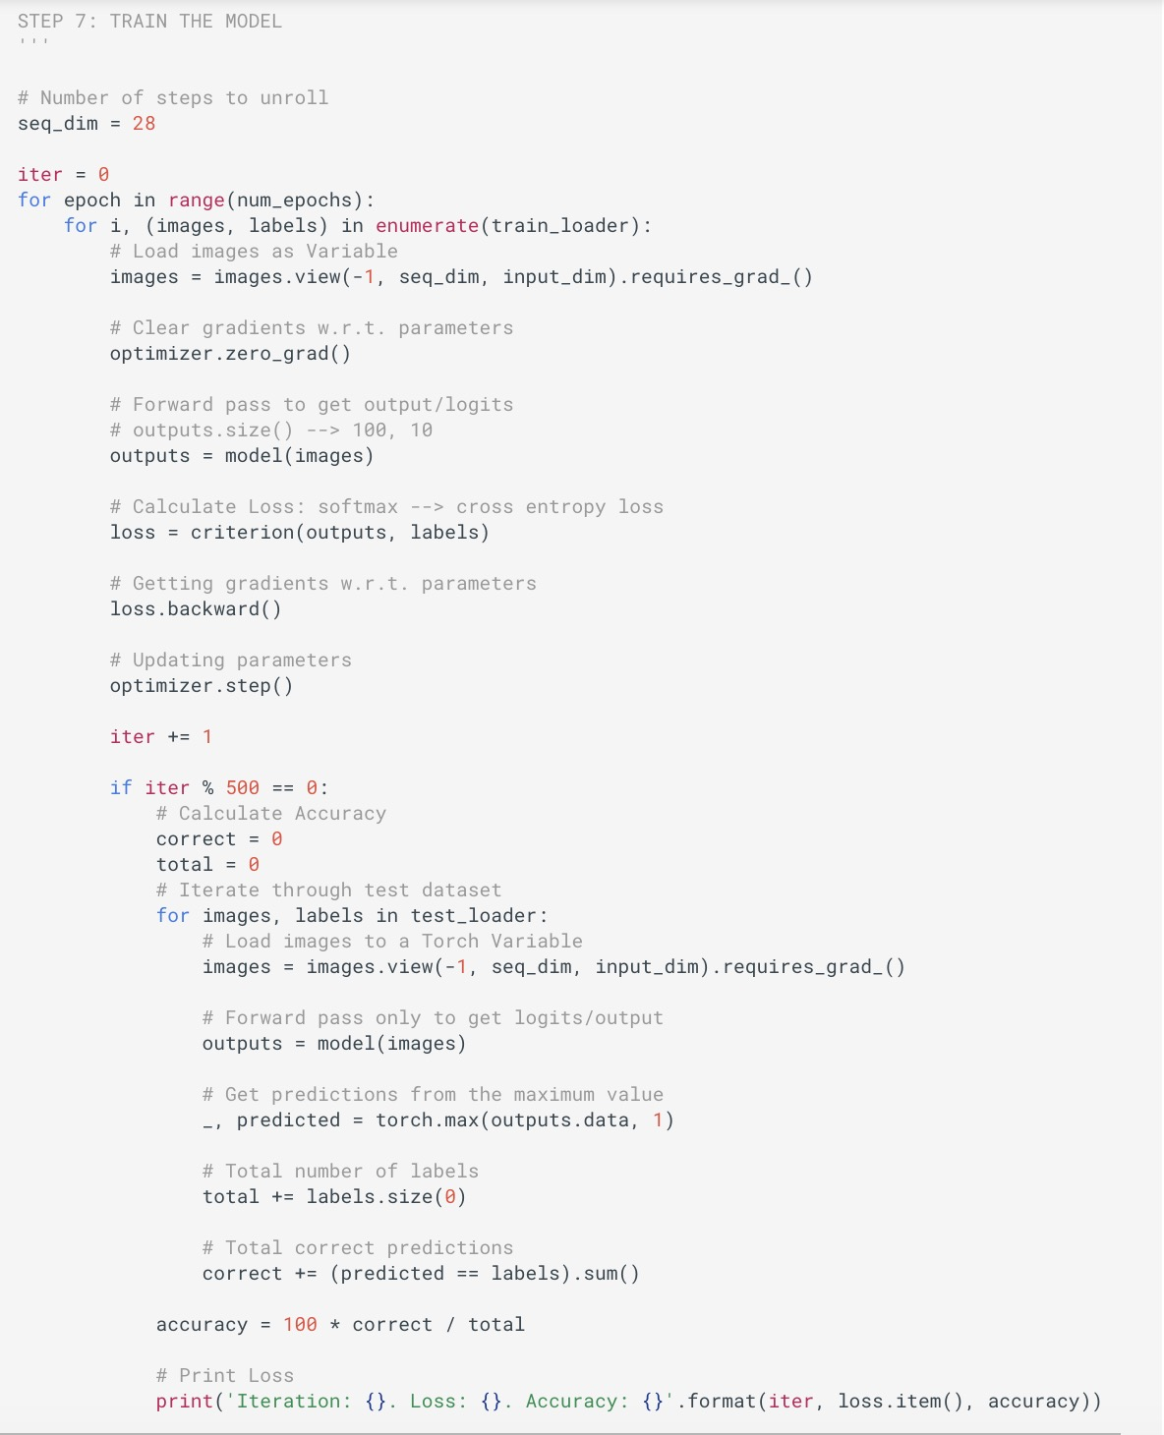

Figure 67 LSTM Model Training

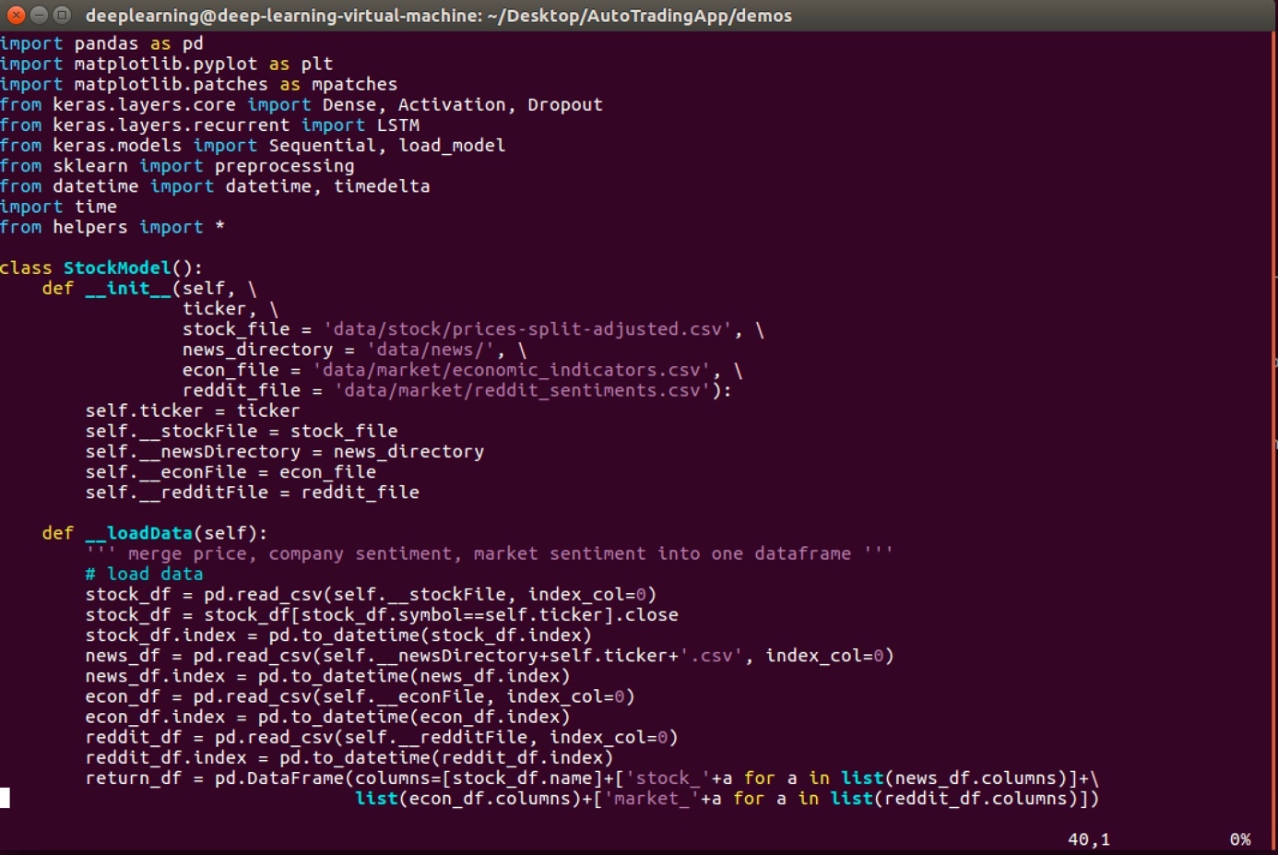

Figure 68 Demo Code Screenshots 1

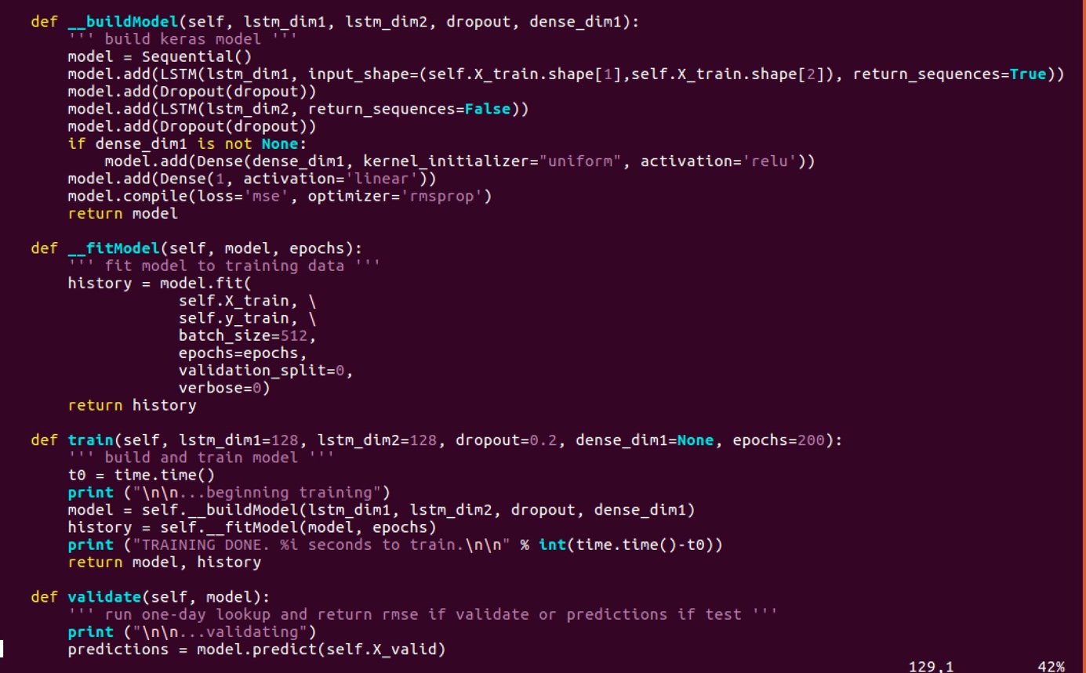

Figure 69 Demo Code Screenshots 2

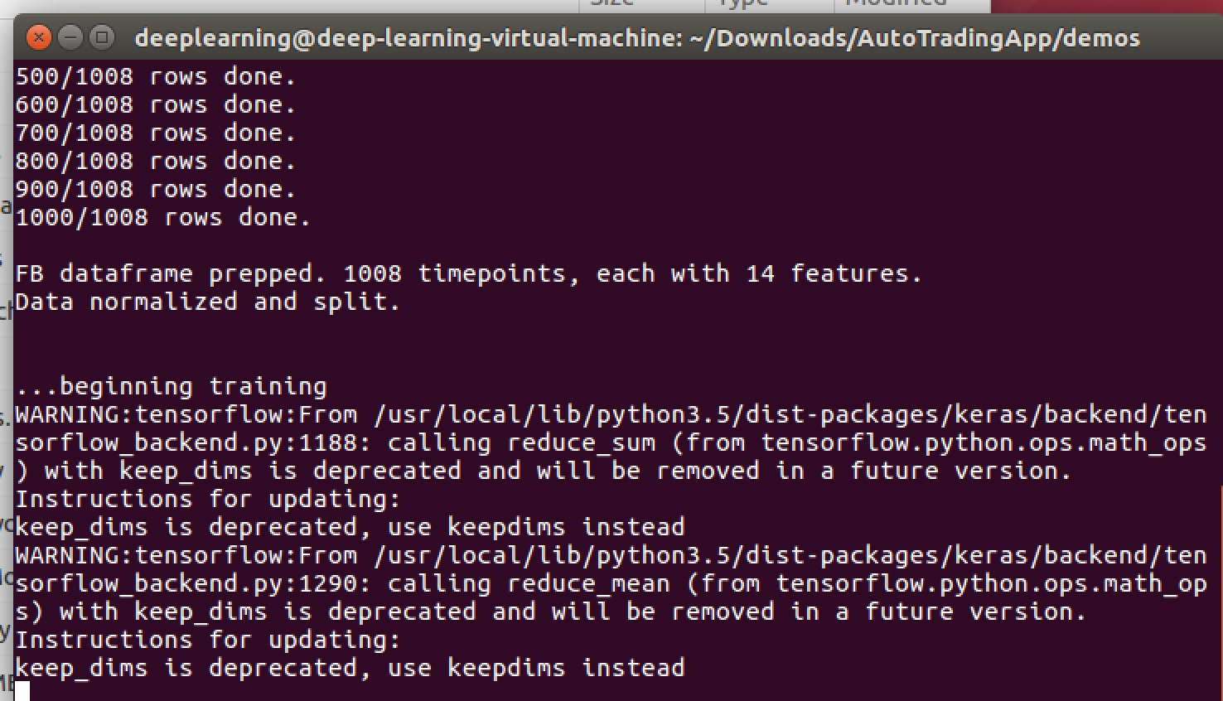

Figure 70 Demo Code Screenshots 3

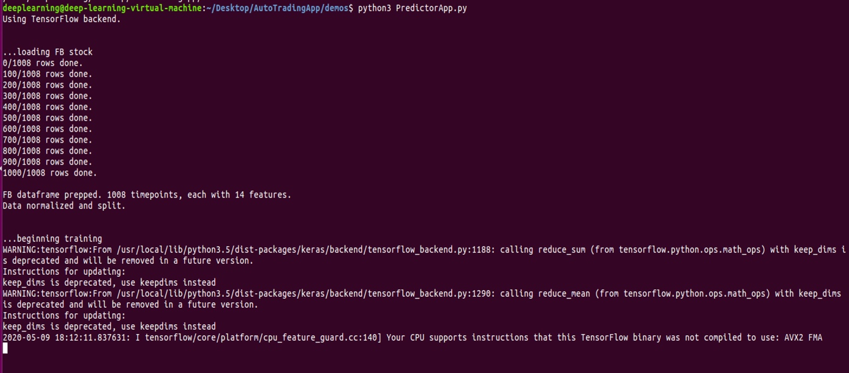

Figure 71 Demo Code Screenshots 4

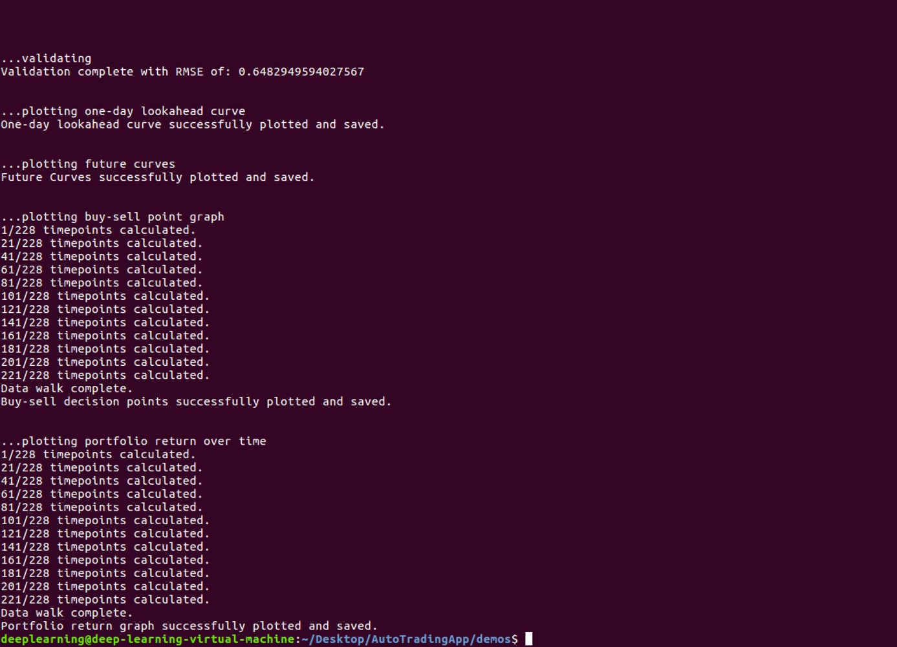

Figure 72 Demo Code Screenshots 5

# One Epoch

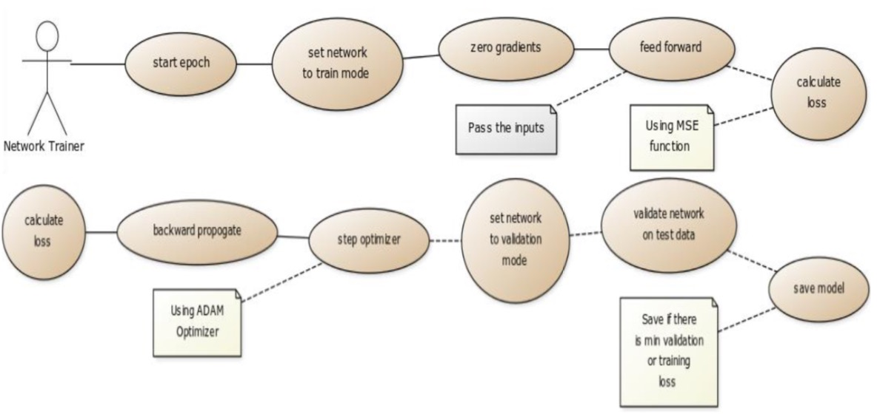

Figure 73 One Epoch Diagram

One epoch of training would do following:

1. Set network to training mode.
2. Zero out the gradients
3. Predict the output using the neural network
4. Calculate loss using mean square error function
5. Backward propagation
6. Step the optimizer
7. Calculate the training loss
8. Validate and save model

* Set network to evaluation mode
* Feed forward the test data
* Calculate the validation loss

# Testing the Neural Network

For testing the neural network, the save network is reloaded into RAM:

* Reload a previous trained neural network (For required future N days, for predicting 1 sample we would need last N but 5 samples)
* Get the test data for the most recent prices
* Erase all but 5 samples
* Normalize samples are predicted and added to the test vector
  + Predict the 6th closing price from 5 previous testSamples
  + Use the last price Prepare for next training set

# Training Workflow

The application provides command line option to either train network for a specific stock or perform training for a list of stock provided through a csv file. For this project for sake of simplicity a list of top 100 company stocks, based on market capitalization, is taken out of companies listed on Bombay Stock Exchange and stored in a filename BSE100.csv. The file simple has stock symbols and companies name listed. For training on BSE100.csv file once stock is trained (when either of the training criteria is met), the trained neural network is stored in another csv file named full_trained.csv

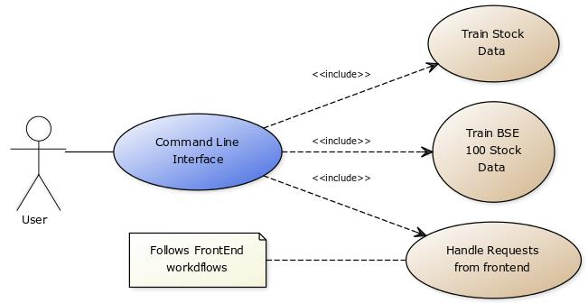

Figure 74 Data Training Workflow

# UI Workflow:

The following use case diagram shows the workflow for usage of front-end application. The following figures shows the different sections created to visualize the trained neural network models for different stock.

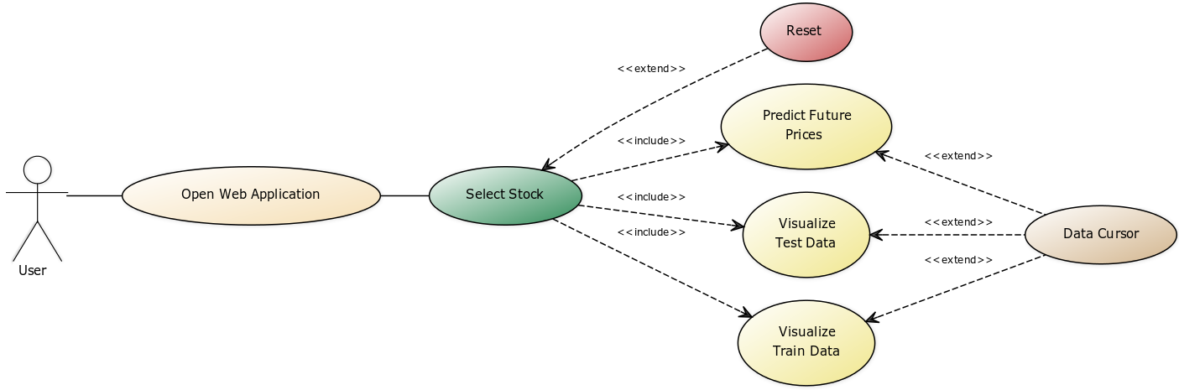

Figure 75 UI Workflow

# Evaluation and Test Results

* The trend of the predicted stock prices is close to the trend of actual stock prices.
* Average weighted sentiment adds more importance to the data that has a wider audience exposure than just the sentiment. Combined three datasets (historic stock data, news data, twitter data) with an inner join. Using this joint table, four different test cases are created as seen in the table below.
* Using Feature Selection, elected only the features which sources have the greatest impact on a closing stock price.
* Below table indicates that, a combination of historic stock data with news data has the lowest RMSE, which means that a closing price can most accurately be predicted using these two sources. Having found out that using historic stock data with news data has the lowest RMSE, we proceeded with training our model with as much data as we have for each test case / combination of data sources. The results are shown in the tables below.
* **Case 1: Stock Data (LSTM)**

|  |  |  |  |  |  |  |  |
| --- | --- | --- | --- | --- | --- | --- | --- |
| **Case** | **Stock Data** | **Twitter Data** | **News Data** | **Look Back** | **Learning Rate** | **EPOCHs** | **Min RMSE** |
| 1 | Checkmark |  |  | 12 | 0.002 | 100 | 5.64 |
| 2 | Checkmark | Checkmark |  | 15 | 0.002 | 100 | 5.78 |
| 3 | Checkmark |  | Checkmark | 15 | 0.002 | 100 | 4.72 |
| 4 | Checkmark | Checkmark | Checkmark | 12 | 0.002 | 100 | 6.25 |

Table 13 Case 1 LSTM for Stock Data

**Case 2: Stock Data and News Data**

|  |  |  |  |  |  |  |  |  |  |
| --- | --- | --- | --- | --- | --- | --- | --- | --- | --- |
| **SNo** | **Epochs** | **Batch Size** | **Hidden Layers** | **Neurons** | **Loop Back** | **Dropout** | **Learning Rate** | **Train RMSE** | **Test RSME** |
| 1 | 100 | 2 | 1 | 8× 32 × 1 | 15 | 0 | 0.001 | 2.51 | 13.17 |
| 2 | 100 | 1 | 1 | 8× 32 × 1 | 30 | 0.5 | 0.002 | 3.94 | 33.78 |
| 3 | 100 | 2 | 2 | 8 × 32 × 32 × 1 | 30 | 0 | 0.001 | 2.14 | 22.48 |

Table 14 Case 2 LSTM for Stock Data News Data

|  |  |  |  |  |  |  |  |  |  |
| --- | --- | --- | --- | --- | --- | --- | --- | --- | --- |
| **SNo** | **Epochs** | **Batch Size** | **Hidden Layers** | **Neurons** | **Loop Back** | **Dropout** | **Learning Rate** | **Train RMSE** | **Test RSME** |
| **1** | 100 | 2 | 1 | 8× 32 × 1 | 15 | 0 | 0.001 | 3.26 | 14.39 |
| **2** | 100 | 1 | 1 | 8× 32 × 1 | 30 | 0.5 | 0.002 | 4.38 | 27.80 |
| **3** | 100 | 2 | 2 | 8 × 32 × 32 × 1 | 30 | 0 | 0.001 | 2.34 | 16.31 |

**Case 3: Stock Data, Twitter Data**

|  |  |  |  |  |  |  |  |  |  |
| --- | --- | --- | --- | --- | --- | --- | --- | --- | --- |
| **SNo** | **Epochs** | **Batch Size** | **Hidden Layers** | **Neurons** | **Loop Back** | **Dropout** | **Learning Rate** | **Train RMSE** | **Test RSME** |
| 1 | 100 | 2 | 1 | 8× 32 × 1 | 15 | 0 | 0.001 | 3.22 | 7.68 |
| 2 | 100 | 1 | 1 | 8× 32 × 1 | 30 | 0.5 | 0.002 | 4.25 | 12.41 |
| 3 | 100 | 2 | 2 | 8 × 32 × 32 × 1 | 30 | 0 | 0.001 | 3.52 | 10.52 |

Table 15 Case 3 Stock Data, Twitter Data, News Data

**Case 4: Stock Data, Twitter Data and News Data**

|  |  |  |  |  |  |  |  |  |  |
| --- | --- | --- | --- | --- | --- | --- | --- | --- | --- |
| **SNo** | **Epochs** | **Batch Size** | **Hidden Layers** | **Neurons** | **Loop Back** | **Dropout** | **Learning Rate** | **Train RMSE** | **Test RSME** |
| 1 | 100 | 2 | 1 | 8× 32 × 1 | 15 | 0 | 0.001 | 4.11 | 12.48 |
| 2 | 100 | 1 | 1 | 8× 32 × 1 | 30 | 0.5 | 0.002 | 4.47 | 16.49 |
| 3 | 100 | 2 | 2 | 8 × 32 × 32 × 1 | 30 | 0 | 0.001 | 4.20 | 13.75 |

Table 16 Case 4 Stock Data, Twitter Data, News Data

LSTM model which takes as an input the generated features from the Stock, Twitter and News dataset and predicts the stock prices for the next day by using the past n days information. As the model is trained for the past years, the model can predict the future stock prices.

|  |  |
| --- | --- |
|  |  |

Figure 76 Comparison of Tweets and Corpus Stocks

|  |  |  |  |
| --- | --- | --- | --- |
| **SNo** | **Feature Combination** | **Dimension** | **Accuracy** |
| 1 | Stock Data | 9 | 64.86 |
| 2 | Stock Data + Technical Index Data | 20 | 66.75 |
| **3** | **Stock Data + Tweet Data + News Data** | **22** | **75.78** |
| 4 | Stock Data + Tweet Data | 19 | 65.38 |

Table 17 Prediction Accuracy vs Feature Combination

Finally, closing price predictions using combination of different features can be seen in the below figures.

**Case 1: Historical Stock Data**

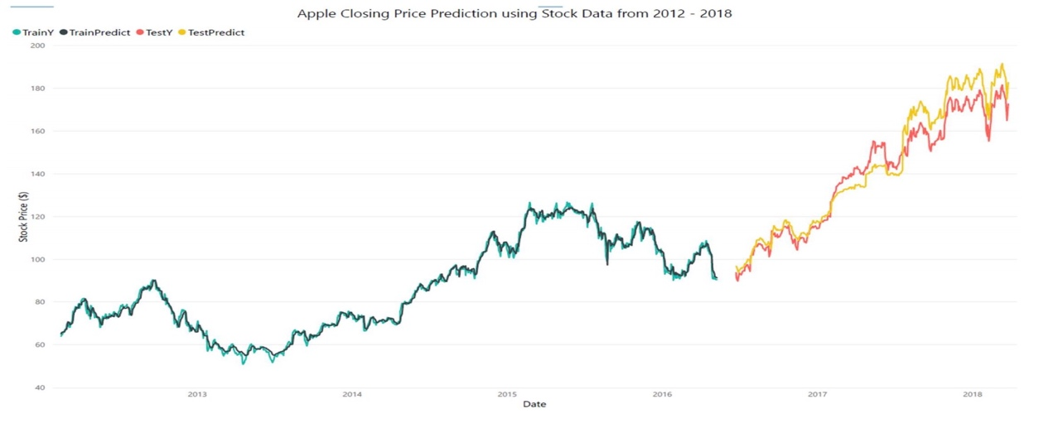

Figure 77 Apple Historical Data

**Case 2: Historical Stock Data & Twitter Data**

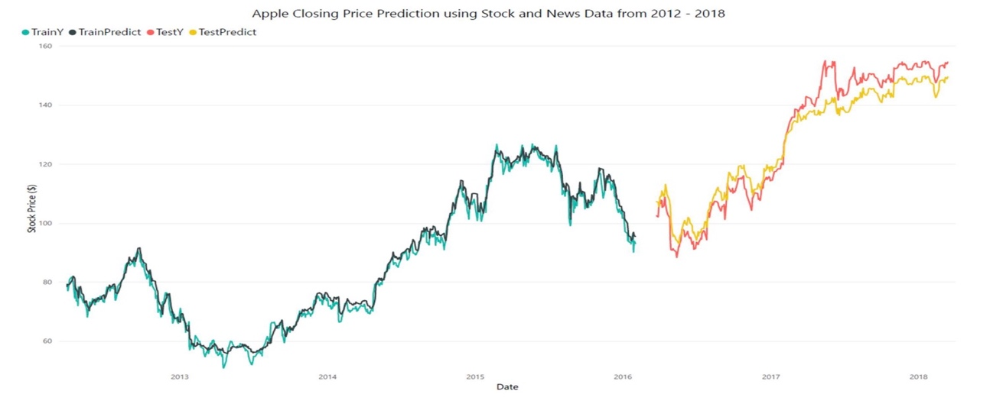

Figure 78 Apple Historical Data and Twitter Data

**Case 3: Historical Stock Data & News Data**

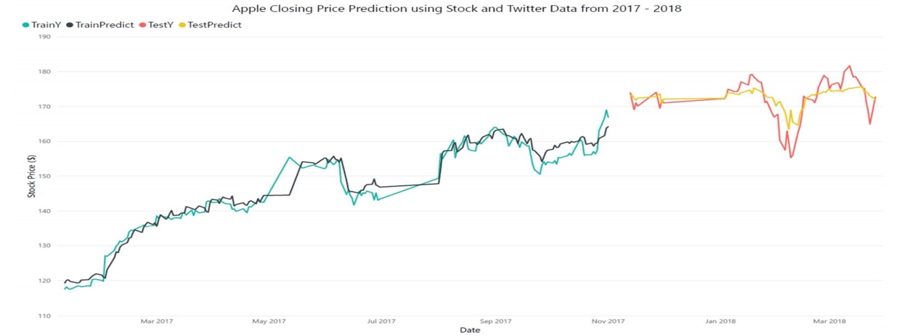

Figure 79 Apple Historical Data and News Data

**Case 4: Historical Stock Data, Twitter Data & News Data**

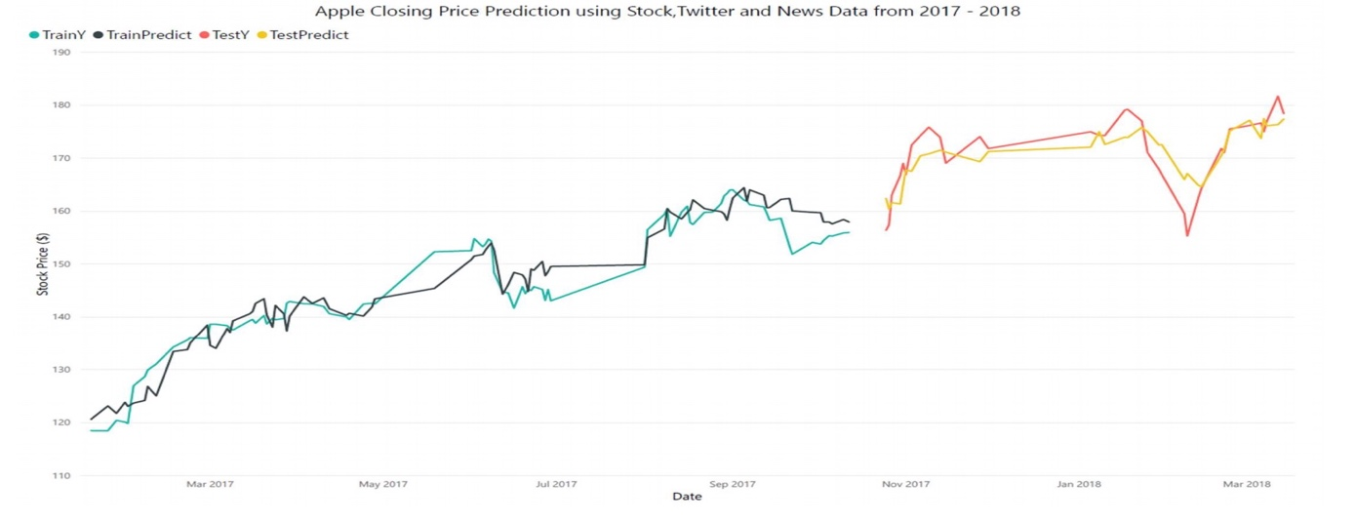

Figure 80 Apple Historical Data, News Data and Twitter Data

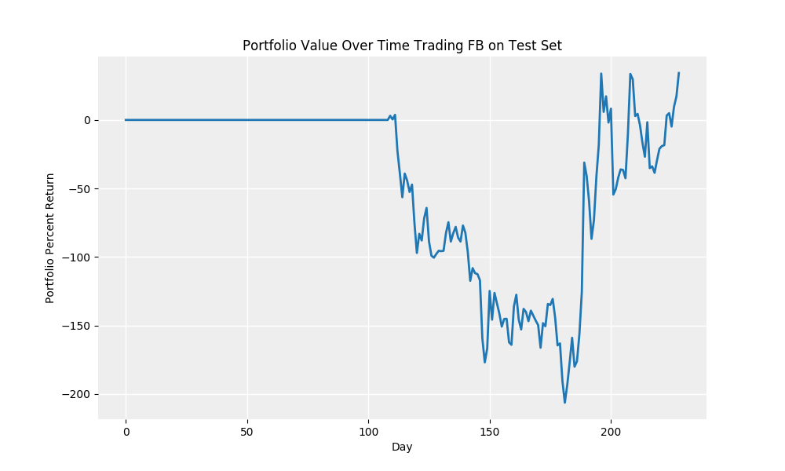

Figure 81 Portfolio Value Over Time Trading FB on Test Set

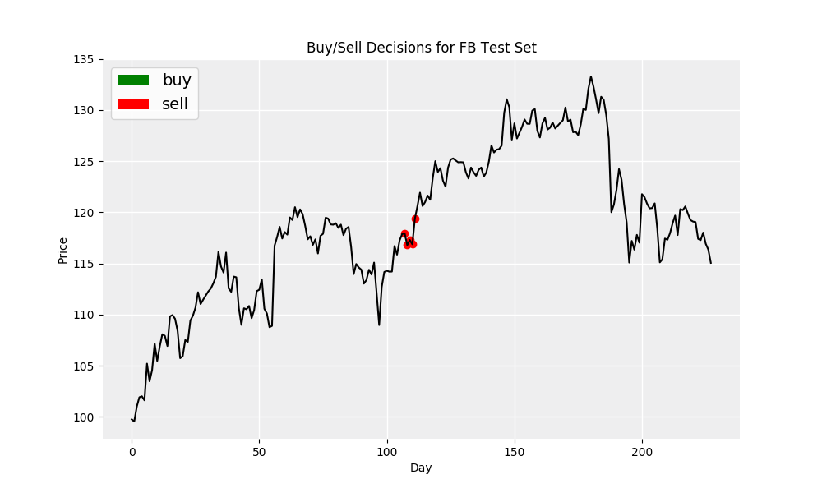

Figure 82 Buy/Sell Decisions for FB Test Set

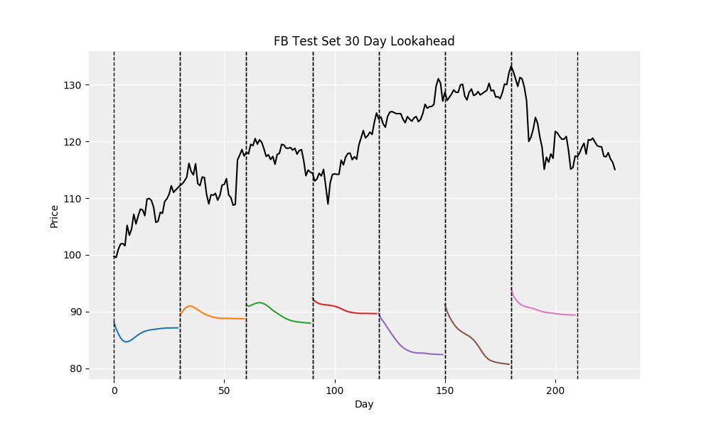

Figure 83 FB Test Set 30 Day Lookahead

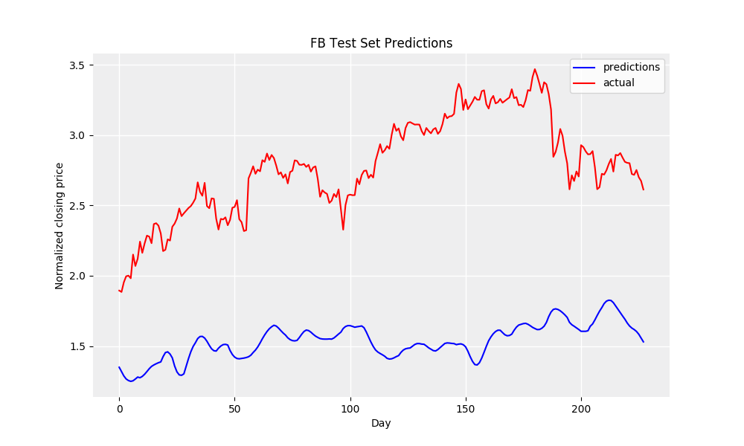

Figure 84 FB Test Set Predictions

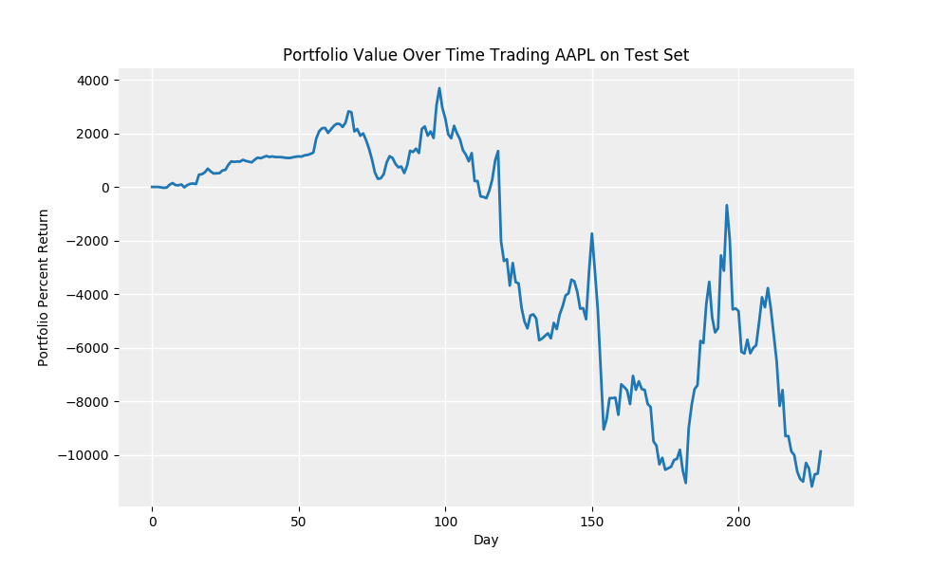

Figure 85 Portfolio Value Over Time trading for AAPL

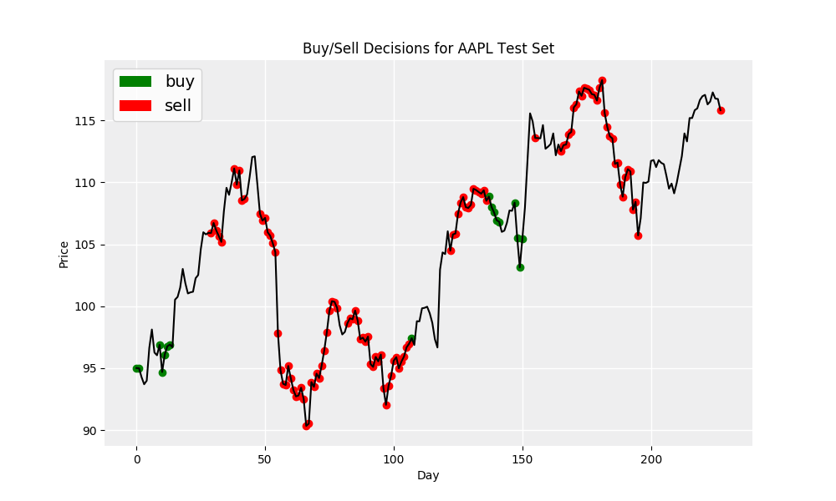

Figure 86 Buy/Sell Decisions for APPL Test Set

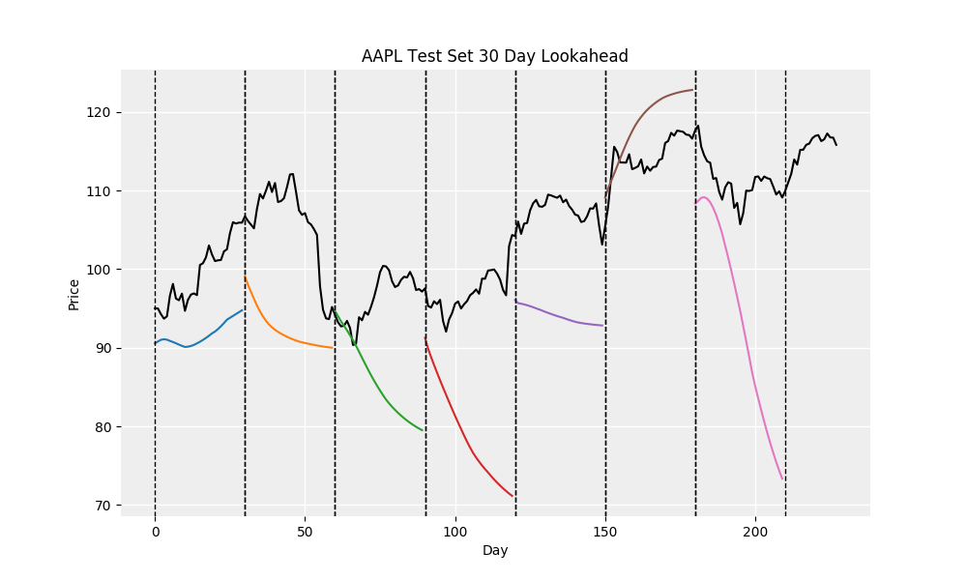

Figure 87 AAPL Test Set 30 Day Lookahead

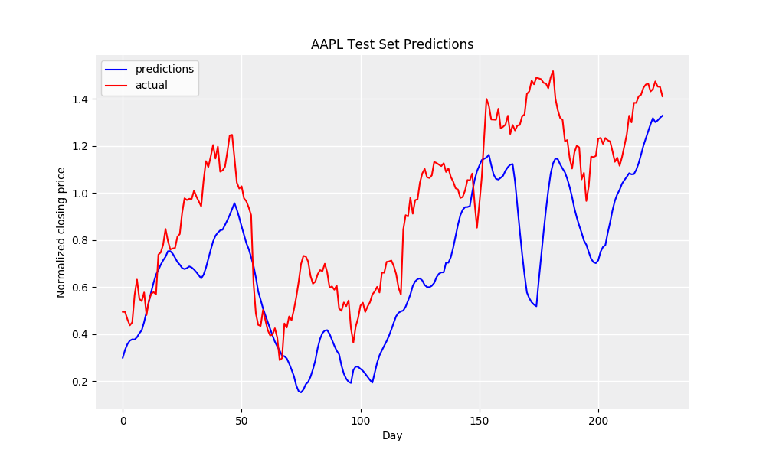

Figure 88 AAPL Test Set Predictions

# Conclusions and Learnings

Forecasting the price of a financial asset is of great importance as it reduces the risk of decision making for investors. The prices of financial assets are dynamic and respond are dependent on a lot of factors which decide its movement. Being able to account every single one of these in hope of making precise predictions is a challenging act. A large number of investment experts and firms have taken advantage of this scenario and gained large profits from inexperienced investors. These studies have indicated that LSTMs have been the best player in this field and deep learning is the way ahead.

This project was able to demonstrate the trends in financial data prediction and explore further application of these techniques. Hyper-tuning of parameters, applying different normalization techniques, adding Regularization and dropout to eliminate Over-fitting and other optimization techniques along with these improved networks helped in achieving lower errors and better predictions.

**Key Learnings:**

* Extracting features and aggregating large datasets which is of in some GBs using various data wrangling techniques.
* Understanding various feature engineering mechanisms to create features that are important for predictions for a model in the stock market domain. Performing feature engineering to increase the value of a feature by combining multiple features. SDA (Stacked Denoising Auto Encoder) is applied to reduce the dimension of features which is not sensitive to the noise. The aim of an auto encoder is to learn higher-level representation for a set of data, typically for dimension reduction.
* NLP techniques to extract features like sentiments from text data.
* Creating LSTM model over time series data for future price prediction.
* How to decide which feature has the most impact on the prediction.
* Understanding finance domain and stock market field and how the data of this domain is dependent on various features such as VWAP and sentiments.
* LSTM models were then plugged in to Algorithmic Trading strategies leveraged portfolios for back-testing. This gave great insights about financial analysis along with financial predictions.
* Also, other financial factors like trading signals, investor sentiment, news abstracts etc. should be added to the model input variables in order to further the generalization and reduce overfitting in model in the future.
* This lead to have better understanding of Machine Learning and Data Science to increase by leaps and strides. Also got acquainted with the financial domain of knowledge and expanded the knowledge to new fields.

# Expected Outcomes

Expected outcome for a given stock is to find the target selling/buying price to maximize the profit. Time series forecasting is a very intriguing field to work with. Particularly when it comes to stock predictions eagerness to learn and put more thoughts which eventually could be used for making better financial investments. The model was evaluated to predict few stocks using this model. Predications made here is riskier for performing direct trading in share market based on the values predicted, however this would be surely helping to do some swing trading with least risk. The project work explores the LSTM Neural Network, which itself is a very vast topic for research work.

Few assumptions based on which this portfolio strategy methodology is applied.

* Since the impact of news (good/bad) on stock data is always short lived, first assumption is that trade (buy and sell or sell and buy) will be completed with-in 30 minutes to make maximum profit.
* Returns were always calculated based on based on the price at which trade has happened minus the closing price for that day.
* Sentiment Score based model suggested trade is considered right prediction if that stocks gains 0.5 or more percentage.

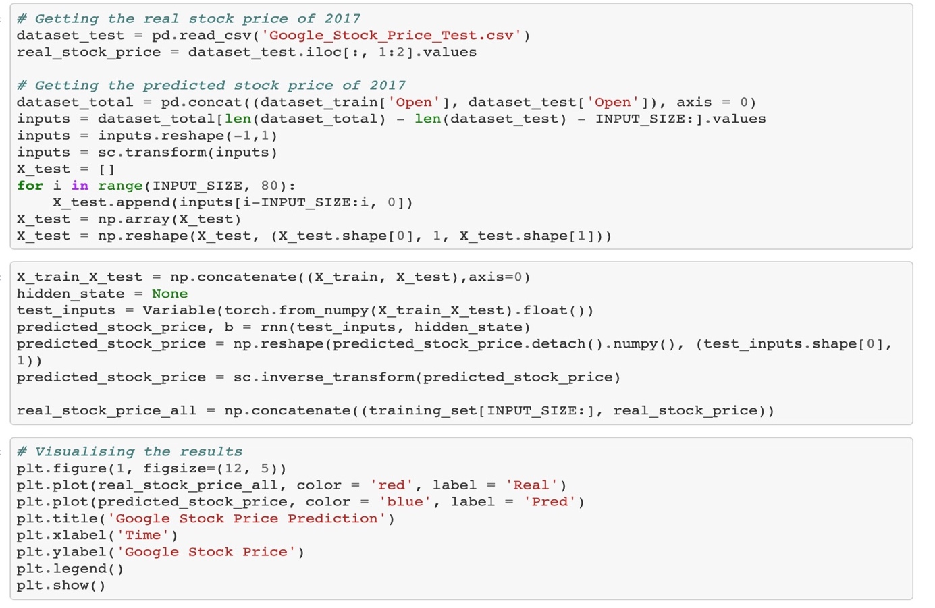

Figure 89 Code Snippet for Visualizing the results

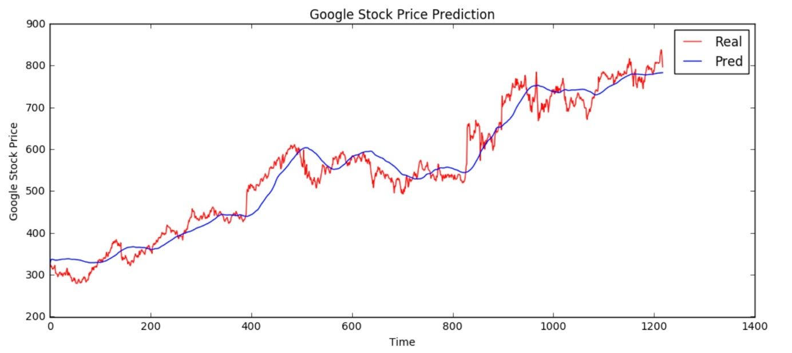

Figure 90 Google Price Prediction. Vs. Actual

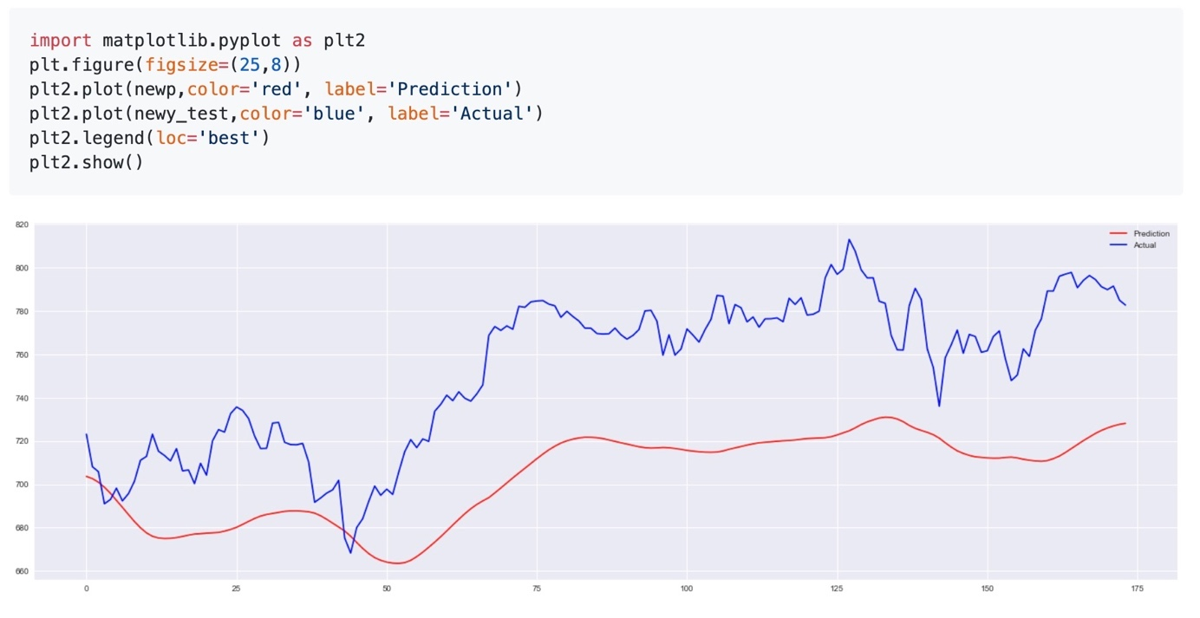

Figure 91 Sample Plot with Precition

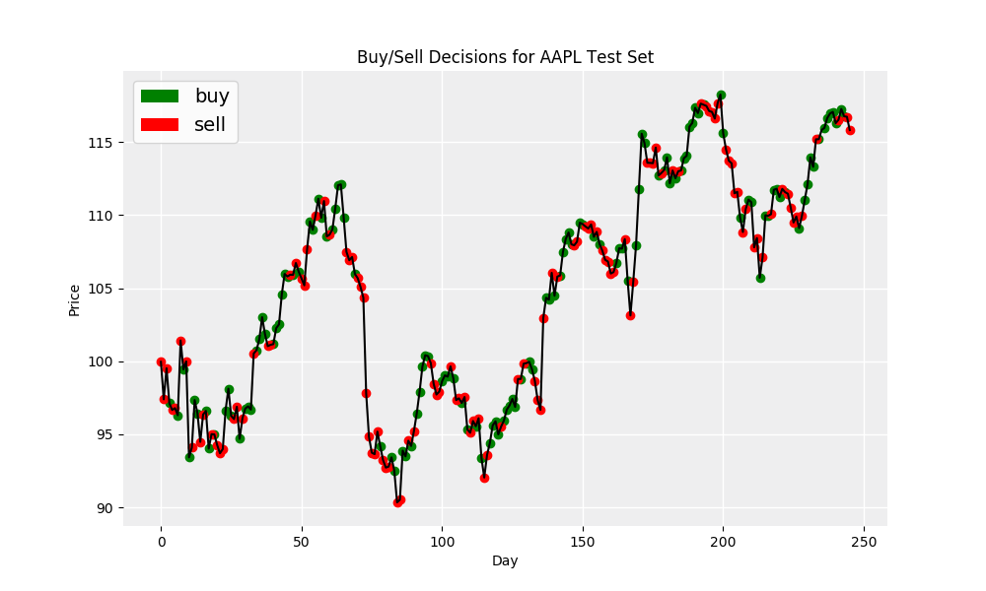

Figure 92 Buy/Sell Decisions for AAPL Test Set

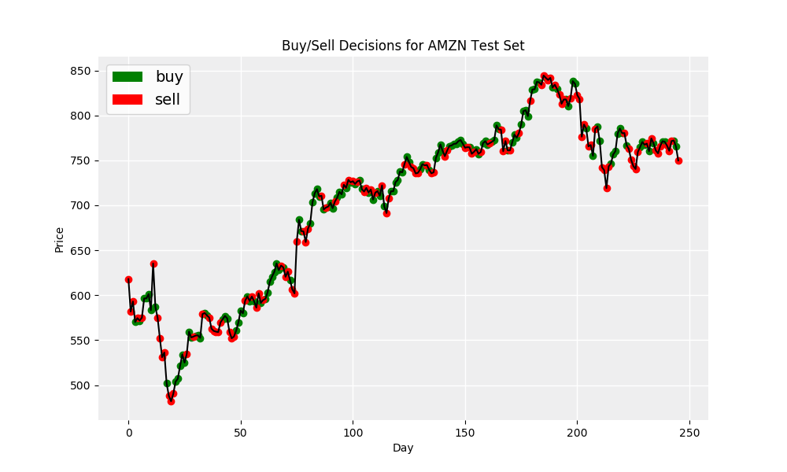

Figure 93 Buy/Sell Decisions for AMZN Test Set

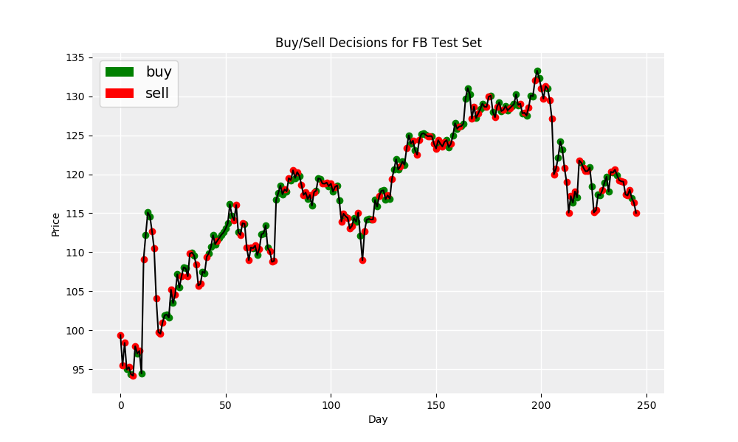

Figure 94 Buy/Sell Decisions for FFB Test Set

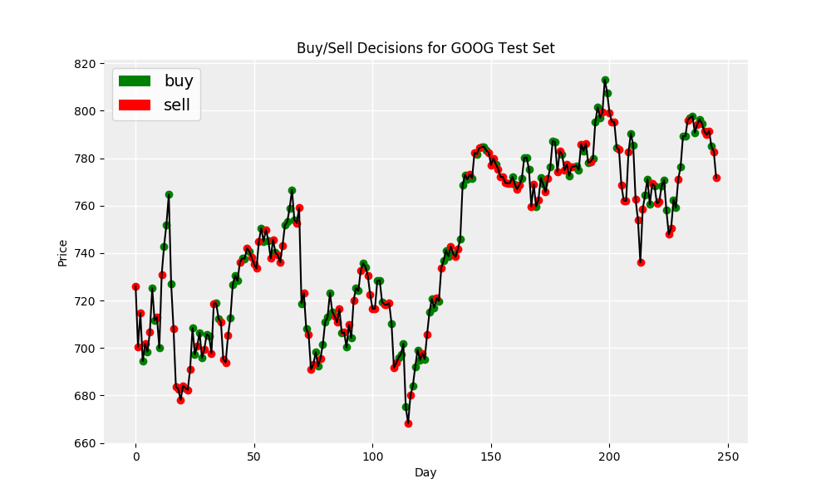

Figure 95 Buy/Sell Decisions for Google Test Set

# Summary

Time series forecasting is a very intriguing field to work with, particularly when it comes to stock predictions eagerness to learn and put more thoughts which eventually could be used for making better financial investments. Predications made here is riskier for performing direct trading in share market based on the values predicted, however this would be surely helping to do some swing trading with least risk.

The project work explores the LSTM Neural Network which itself is a very vast topic for research work. In this project predicted the future closing stock price using historical stock data in combination with the sentiments of news articles and twitter data. Started with data collection of the historical stock price, twitter and news data by web scraping and through various data sources. Data Pre-processing helped in removing unwanted records and carry out aggregations to extract useful features.

Sentiment analysis has been performed on the news and twitter data to generate weighted average sentiments. The usefulness of the features is validated by performing correlation analysis. Based on feature engineering, identified critical are used as an input to our LSTM model and predict the future closing stock prices. The best results were obtained by using the stock data along with the new data. On the other hand, when including twitter sentiments, the error was higher which indicates that the vast number of tweets were not directly related to Apple’s success which can interfere with predictions.

**To summarize our results:**

* Best result is obtained when combination of Stock, Twitter and News Data are used.
* Twitter Data alone did not provide better stock predictions.
* Including Twitter data with Stock and News data combined had a negative effect on RMSE.
* A Learning Rate of 0.002 was found to be most effective.
* A lookback of 15 was found to be the best given our data sources.
* Advanced NLP techniques can be used to improve the model predictions using twitter data.

# Future Work

While some of the stock prices when used for training the model, resulted in very close graph with respect to the original stock prices, some of the company’s stock prices didn’t result in very good trained model.

To overcome this, the network parameters needs to be tuned properly. A better benchmark would be required to precisely choose number of units, optimizer learning rate, number of previous stock prices, dropout probability, etc.

The tuning parameters needs to be provided through a configuration file, enabling us to avoid compilation of code, when any of the network parameters changes.

The front-end UI needs to be updated for better look and feel and enhance user experience. The response received from back-end needs to be done using existing popular framework models.

# Bibliography

1. Makeshwar, M.S., Rajgure, N.K. & Pund, M. (2010). Object Identification using Neural Network. International Journal of Computer Science and Application , pp.29–32.
2. Hertz, J., Krogh, A. and Palmer, R.G. (1991), Introduction to the Theory of Neural Computation, Redwood City, CA: AddisonWesley.
3. Kohavi, R. (1995). A Study of Cross-Validation and Bootstrap for Accuracy Estimation and Model Selection. In International Joint Conference on Artificial Intelligence. San Francisco, CA: Morgan Kaufmann Publishers.
4. Herrera, J.L. (1999). Time Series Prediction Using Inductive Reasoning Techniques. Instituto de Organizacion y Control de Sistemas Industriales.
5. Bachelier (1900), Cootner (1964) and Fama(1965), Theory of Speculation
6. [www.finace.yahoo.com](http://www.finace.yahoo.com)
7. J.-H. Wang and J.-Y. Leu, “Stock Market Trend Prediction Using ARIMA-Based Neural Networks,” The 1996 IEEE International Conference on Neural Networks, Washington DC, 3-6 June 1996, pp. 2160-2165.
8. “Predicting stock market index using fusion of machine learning techniques” by Jigar Patel, Sahil Shah, Priyank Thakkar , K Kotecha Computer Science & Engineering Department, Institute of Technology, Nirma University, Ahmedabad, Gujarat, India, Article history: Available online 25 October 2014, http://dx.doi.org/10.1016/j.eswa.2014.10.031 0957-4174/ 2014 .
9. Jiahong Li, Hui Bu and Junjie Wu, "Sentiment-aware stock market prediction: A deep learning method," *2017 International Conference on Service Systems and Service Management*, Dalian, 2017, pp. 1-6.
10. Novel Approaches to Sentiment Analysis for Stock Prediction by Chris Wang, Yilun Xu, Qingyang Wang Stanford University chrwang, ylxu, iriswang @ stanford.edu
11. Sun, Haonan, et al. "Stacked Denoising Autoencoder Based Stock Market Trend Prediction via K-Nearest Neighbour Data Selection." International Conference on Neural Information Processing. Springer, Cham, 2017.
12. Predicting Stock Prices using Social Media Team: Stock Brokers | CMPT 733 - Programming for Big Data 2 | April 08, 2018 | By Mihir Gajjar, Gaurav Prachchhak, Tommy, Betz, Veekesh Dhununjoy
13. International Journal of Computer Science & Information Technology (IJCSIT) Vol 8, No 3, June 2016 , STOCK TREND PREDICTION USING NEWS SENTIMENT ANALYSIS Kalyani Joshi1, Prof. Bharathi H. N.2, Prof. Jyothi Rao3 .
14. <https://github.com/omerbsezer/LSTM_RNN_Tutorials_with_Demo>
15. Proceedings of the International MultiConference of Engineers and Computer Scientists 2019, IMECS 2019, March 13-15, 2019, Hong Kong, Stock Market Trend Prediction with Sentiment Analysis based on LSTM Neural Network, Xu Jiawei, Tomohiro Murata.
16. Avramov, Doron. (2001). Stock Return Predictability and Model Uncertainty. Journal of Financial Economics. 64. 423-458. 10.1016/S0304-405X(02)00131-9.
17. Journal of Multinational Financial Management,Volume 13, Issues 4–5, December 2003, Pages 443-463,Statistical and economic significance of stock return predictability: a mean–variance analysis, Steven X.Wei1ChuZhang
18. International Review of Economics & Finance,Volume 10, Issue 4, December 2001, Pages 353-368,Nonlinear predictability of stock market returns: Evidence from nonparametric and threshold models, David GMcMillan
19. Knowledge-Based Systems,Volume 50, September 2013, Pages 151-158 ,Posterior probability model for stock return prediction based on analyst’s recommendation behavior, Jiang jia Duana Hong Zhong, Liua Jian ping, Zengb.
20. Journal of Banking & Finance, Volume 34, Issue 3, March 2010, Pages 509-521, The degree of financial liberalization and aggregated stock-return volatility in emerging markets,MehmetUmutluaLeventAkdenizbAslihanAltay-Salihb
21. International Review of Financial Analysis ,Volume 18, Issues 1–2, March 2009, Pages 1-11.
22. The Externalities of High Frequency Trading, Chen Yao, The Chinese University of Hong Kong (CUHK) - CUHK Business School, JH Hill, University of Illinois at Urbana-Champaign, Date Written: August 7, 2013.
23. Ticknor J.L.,A Bayesian regularized artificial neural network for stock market forecasting, Expert Syst. Appl., 40 (14) (2013), pp. 5501-5506.
24. Rout A.K., Biswal B., Dash P.K,,A hybrid FLANN and adaptive differential evolution model for forecasting of stock market indices Int. J. Knowl.-Based Intell. Eng. Syst., 18 (1) (2014), pp. 23-41
25. Zhong X., Enke D, Forecasting daily stock market return using dimensionality reduction, Expert Syst. Appl., 67 (2017), pp. 126-139.
26. Vargas M.R., de Lima B.S., Evsukoff A.G.,Deep learning for stock market prediction from financial news articles,Proceedings of IEEE International Conference on Computational Intelligence and Virtual Environments for Measurement Systems and Applications (2017), pp. 60-65.
27. Gupta A., Dhingra B.,Stock market prediction using hidden markov models,Proceedings of Students Conference on Engineering and Systems (2012), pp. 1-4.
28. Chang P.C.,A novel model by evolving partially connected neural network for stock price trend forecasting,Expert Syst. Appl., 39 (1) (2012), pp. 611-620.
29. Pang X., Zhou Y., Wang P., Lin W., Chang V.,An innovative neural network approach for stock market prediction,J. Supercomput. (2018), pp. 1-21.
30. Atsalakis G.S., Dimitrakakis E.M., Zopounidis C.D, Elliott Wave Theory and neuro-fuzzy systems, in stock market prediction: The WASP system Expert Syst. Appl., 38 (8) (2011), pp. 9196-9206.
31. Chatzis S.P., Siakoulis V., Petropoulos A., Stavroulakis E., Vlachogiannakis N. Forecasting stock market crisis events using deep and statistical machine learning techniques, Expert Syst. Appl., 112 (2018), pp. 353-371
32. Shen W., Guo X., Wu C., Wu D.Forecasting stock indices using radial basis function neural networks optimized by artificial fish swarm algorithm, Knowledge Based Syst., 24 (3) (2011), pp. 378-385.
33. Asadi S., Hadavandi E., Mehmanpazir F., Nakhostin M.M.Hybridization of evolutionary Levenberg–Marquardt neural networks and data pre-processing for stock market prediction, Knowledge Based Syst., 35 (2012), pp. 245-258.
34. Adebiyi A.A., Ayo C.K., Otokiti S.O.Fuzzy-neural model with hybrid market indicators for stock forecasting, Int. J. Electron. Finance, 5 (3) (2011), pp. 286-297
35. Hsieh T.J., Hsiao H.F., Yeh W.C.Forecasting stock markets using wavelet transforms and recurrent neural networks: An integrated system based on artificial bee colony algorithm,Appl. Soft Comput., 11 (2) (2011), pp. 2510-2525
36. Xie X.K., Wang H.Recurrent neural network for forecasting stock market trend, Proceedings of International Conference on Computer Science, Technology and Application (2017), pp. 397-402
37. Chen W., Zhang Y., Yeo C.K., Lau C.T., Lee B.S, Stock market prediction using neural network through news on online social networks Proceedings of International Conference on Smart Cities (2017), pp. 1-6
38. Oztekin A., Kizilaslan R., Freund S., Iseri A. A data analytic approach to forecasting daily stock returns in an emerging market, European J. Oper. Res., 253 (3) (2016), pp. 697-710
39. Zhang X., Qu S., Huang J., Fang B., Yu P. Stock market prediction via multi-source multiple instance learning IEEE Access (2018)
40. Arévalo R., García J., Guijarro F., Peris A. A dynamic trading rule based on filtered flag pattern recognition for stock market price forecasting Expert Syst. Appl., 81 (2017), pp. 177-192
41. Ariyo A.A., Adewumi A.O., Ayo F.Stock price prediction using the ARIMA model, Procedings of Computer Modelling and Simulation (2014), pp. 106-112
42. Srinivasan P., Ibrahim P. Forecasting stock market volatility of BSE-30 index using GARCH models Asia Pac. Bus. Rev., 6 (3) (2010), pp. 47-60
43. Nanda S.R., Mahanty B., Tiwari M.K.Clustering Indian stock market data for portfolio management, Expert Syst. Appl., 37 (12) (2010), pp. 8793-8798
44. Systematic analysis and review of stock market prediction techniques, Author links open overlay panelDattatray P.GandhmalK.Kumar, Computer Science Review, Volume 34, November 2019, 10019, <https://doi.org/10.1016/j.cosrev.2019.08.001>
45. Ramon Lawrence. “Using Neural Networks to Forecast Stock MarketPrices”. Neural Networks in the Capital Markets, chapter 10, pages 149–162. John Wiley and Sons, 1995.
46. Vivek Rajput, Sarika Bobade . “Stock Market Prediction Using Hybrid Approach”. International Conference on Computing, Communication and Automation (ICCCA2016).
47. Li Xiong, Yeu Lu (2017). “Hybrid ARIMA-BPNN Model for Time Series Prediction of the Chinese Stock Market”. 2017 3rd International Conference on Information Management.
48. Manuel R. Vargas,Carlos E.M. dos Anjos,Gustavo L.G. Bichara,Alexandre G. Evsukoff (2018). “Deep Learning for Stock Market Prediction Using Technical Indicators and Financial News Articles”. 2018 International Joint Conference on Neural Networks (IJCNN).
49. Marios Mourelatos, Thomas Amorgianiotis, Christos Alexakos, Spiridon Likothanassis (2018). “Financial Indices Modelling and Trading Utilizing Deep Learning Techniques”. 2018 Innovations in Intelligent Systems and Applications (INISTA)
50. Mohammed Asiful, Hossain, Rezaul Karim, Ruppa THulasiram, Neil D.B Bruce, Yang Wang (2018). “Hybrid Deep Learning Model for Stock Price Prediction”. 2018 IEEE Symposium Series on Computational Intelligence (SSCI).
51. J.J. Wang, J. Z. Wang, Z. G. Zhang, and S. P Guo (2012)."Stock index forecasting based on a hybrid model". Omega, vol. 40, pp. 758-766.
52. C. Narendra Babu and B. Eswara Reddy (2014). "A moving-average filter based hybrid ARIMA-ANN model for forecasting time series data". Applied Soft Computing, vol. 23, pp. 27-38.
53. Graves (2012). “Supervised Sequence Labelling with Recurrent”. Studies in Computational Intelligence, Springer.
54. Warbos, Paul J (1990). “Backpropagation through time: what it does and how to do it”. Proceedings of the IEEE 78.10, pp.1550-1560.
55. C. Narendra Babu and B. Eswara Reddy, “Prediction of selected Indian stock using a partitioning-interpolation based ARIMAGARCH model,” Applied Computing and Informatics, vol.11, pp. 130-143, July 2015.
56. R. K. Nayak, D. Mishra, and A. K. Rath, “A Naïve SVM-KNN based stock market trend reversal analysis for Indian benchmark indices,”Applied Soft Computing, vol. 35, pp. 670-680, October 2015.
57. C. H. Su and C. H. Cheng, “A hybrid fuzzy time series model based on ANFIS and integrated nonlinear feature selection method for forecasting stock,” Neurocompting, vol. 205, pp. 264-273, September 2016.
58. C. M. Anish and B. Majhi, “Hybrid nonlinear adaptive scheme for stock market prediction using feedback FLANN and factor analysis,” Journal of the Korean Statistical Society, vol. 45, pp.64-76, March 2016.
59. L. Y. Wei, "A hybrid ANFIS model based on empirical mode decomposition for stock time series forecasting," Applied Soft Computing, vol.42, pp. 368-376, May 2016.
60. K. Cho, B. van Merrienboer, D. Bahdanau, and Y. Bengio , “On the properties of neural machine translation: Encoder-decoder approaches”. arXiv preprint arXiv: 1409.1259,2014.
61. G. P. Zhang,"Time series forecasting using a hybrid ARIMA and neural network model". Neurocomputing, vol. 50, pp. 159-175,2003.
62. Mohammad Obaidur Rahman, Md. Sabir Hossain, Ta-Seen Junaid, Md. Shafiul Alam Forhad, Muhammad Kamal Hossen , “Predicting Prices of Stock Market using Gated Recurrent Units (GRUs) Neural Networks”.,IJCSNS International Journal of Computer Science and Network Security, VOL.19 No.1,2019.
63. Bengio, Yoshua, S. Patrice, F. Paolo, “Learning long-term dependences with gradient descent is difficult”. Neural Networks, IEEE Transactions on 5.2, pp.157-166,1994.
64. Cheng, Li-Chen, Yu-Hsiang Huang, and Mu-En Wu. "Applied attention-based LSTM neural networks in stock prediction." 2018 IEEE International Conference on Big Data (Big Data). IEEE, 2018.
65. Khare, Kaustubh, et al. "Short term stock price prediction using deep learning." 2017 2nd IEEE International Conference on Recent Trends in Electronics, Information & Communication Technology (RTEICT). IEEE, 2017.
66. L. Di Persio and O. Honchar, “Artificial neural networks architectures for stock price prediction: Comparisons and applications,” International Journal of Circuits, Systems and Signal Processing, vol. 10, pp. 403– 413, 2016.
67. M. F. Dixon, D. Klabjan, and J. H. Bang, "Classification-Based Financial Markets Prediction Using Deep Neural Networks," arXiv preprint, arXiv:1603.08604v2 , June 2017.
68. Wenping Zhang,Chunping Li,Yunming Ye,Wenjie Li and Eric W.T. Ngai , “Dynamic Business Network Analysis for Correlated Stock Price Movement Prediction”, IEEE Intelligent Systems Volume: 30 , Issue: 2 , Mar.-Apr. 2015.
69. Ouahilal, M., El Mohajir, M., Chahhou, M., & El Mohajir, B. E. “Optimizing stock market price prediction using a hybrid approach based on HP filter and support vector regression”. 2016 4th IEEE International Colloquium on Information Science and Technology(CiSt).
70. Price Prediction of Share Market using Artificial Neural Network (ANN), [www.ijcaonline.org], by Zabir Haider Khan , Tasnim Sharmin Alin , Md. Akter Hussain
71. Rout A.K., Biswal B., Dash P.K. A hybrid FLANN and adaptive differential evolution model for forecasting of stock market indices Int. J. Knowl.-Based Intell. Eng. Syst., 18 (1) (2014), pp. 23-41.
72. Chakravarty S., Dash P.K. A PSO based integrated functional link net and interval type-2 fuzzy logic system for predicting stock market indices, Appl. Soft Comput., 12 (2) (2012), pp. 931-941
73. Xu B., Zhang D., Zhang S., Li H., Lin H. Stock market trend prediction using recurrent convolutional neural networks
74. Badge J.Forecasting of indian stock market by effective macro-economic factors and stochastic model J. Stat. Econom. Methods, 1 (2) (2012), pp. 39-51
75. Chen M.Y., Chen B.T. A hybrid fuzzy time series model based on granular computing for stock price forecasting
76. Vatsal H. Shah - Foundations of Machine Learning| Spring, 2007 - bigquant.com
77. Pang, Xiongwen, et al. "An innovative neural network approach for stock market prediction." The Journal of Supercomputing (2018): Pages 1-21.
78. On the Properties of Neural Machine Translation: Encoder-Decoder Approaches, September 2014 , Kyunghyun Cho
79. Stock Market prediction using news headlines, Joshua van Kleef, Valerie Scholten and Emiel Stoelinga, Cognitive Computational Modeling of Language and Web Interaction June 19, 2017
80. LSTM Neural Networks for Language Modeling, Conference Paper, September 2012, Martin Sundermeyer
81. <https://www.deeplearningwizard.com/deep_learning/practical_pytorch/pytorch_lstm_neuralnetwork/>
82. “Analyzing Stock Market Movements Using Twitter Sentiment Analysis”,

Nirali Patel, Computer Science Illinois Institute of Technology Chicago [npate104@hawk.iit.edu](mailto:npate104@hawk.iit.edu)

Jaimin Sanghvi, Computer Science Illinois Institute of Technology Chicago [jsanghv2@hawk.iit.edu](mailto:jsanghv2@hawk.iit.edu)

1. <https://www.deeplearningwizard.com/deep_learning/practical_pytorch/pytorch_lstm_neuralnetwork/>
2. <https://cs231n.github.io/convolutional-networks/>
3. http://colah.github.io/posts/2015-08-Understanding-LSTM